REMAIN OR RETURN? DUAL CITIZENSHIP AND UNCERTAINITY: THE CASE OF SOUTH SUDANESE REFUGEES IN LAMWO DISTRICT, NORTHERN UGANDA

BY

ACHIRO FLAVIA
19/U/2592/MAC/PS

SUPERVISOR

Dr. JULAINA A. OBIKA


A DISSERTATION SUBMITTED TO THE INSTITUTE OF PEACE AND STRATEGIC STUDIES IN PARTIAL FULFILLMENT OF THE REQUIREMENTS FOR THE AWARD OF MASTER’S DEGREE IN CONFLICT TRANSFORMATION STUDIES OF GULU UNIVERSITY.

September 2026

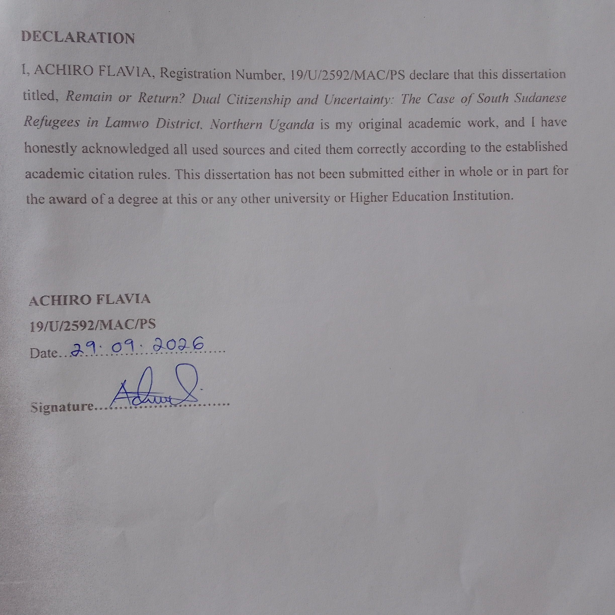

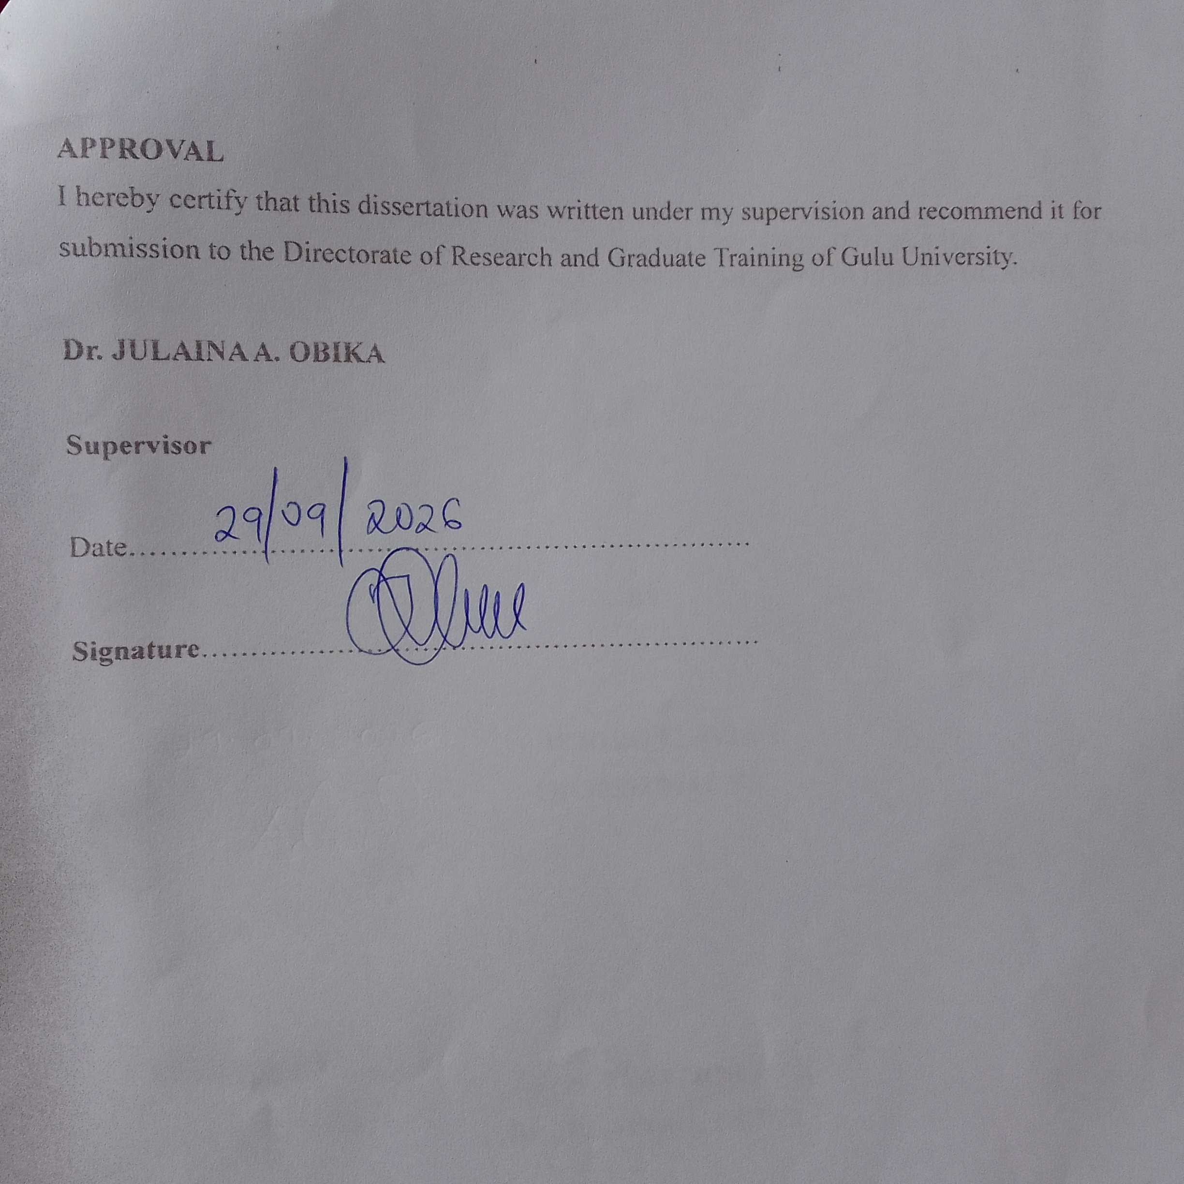

DEDICATION
This work is humbly dedicated to my lovely mother Mrs. Aketo Mary and my father Mr. Ochan David Labeja Luuka for the relentless effort towards my academic pursuit. May God Bless You All.

ACKNOWLEDGEMENTS
I am grateful unto the Almighty God for the awesome life He has given me and courage throughout my academic studies and He who has enabled me to build this dissertation.

I also want to use my humility and take this opportunity to thank the following persons: Exceptional gratitude goes to the vast key informants within Palabek Refugee Settlement specifically the Refugees, Woman Leader, the Refugee Welfare Committee (RWC 3 & 2), UNHCR, OPM and the Immigration office who availed me with the necessary information used in compiling this report.
I am so indebted to Gulu University for providing a platform to pursue my studies in a humbled institution and make me a responsible citizen. I also want to acknowledge the efforts of my supervisor Dr. Julaina A. Obika for the mentorship, guidance, and direction especially during the academic period of my study while at Gulu University not forgetting GUREC as well for the guidance.

I am as well appreciative to my course mates, Achiro Susan, Lanyero Lydia Janet, Karim Hafsa, Amir Jamal, Ajok Brenda, Ochan Johnson and Ochen Emmanuel Peter and others for perusing through my work and permitting the amendments needed.
Noble recognition as well goes to my brothers Ochan Jonathan, Too-lit Eric, Oyilla Jeremiah, Anywar Rogers, my lovely sisters Aloyo Priscilla and Lanyero Jennifer for the love, care, and support that I got during the academic struggle.

Lastly, I wish to send my humble gratitude to my lovely parents Mr. and Mrs. Ochan David Labeja Luuka for the good direction, counselling and financial aid rendered to me since the commencement of my studies.

May the Good Lord Bless You All.

TABLE OF CONTENTS
DECLARATION i
APPROVAL ii
DEDICATION iii
ACKNOWLEDGEMENTS iv
LISTS OF ABBREVIATIONS AND ACRONYMS x
ABSTRACT xi
CHAPTER ONE: INTRODUCTION 1
1.1 INTRODUCTION 1
1.1.1 The Refugee Act of Uganda 4
1.1.2 The Refugee Context in Uganda 5
1.2 Background of study 6
1.2.1 Overview of the South Sudanese Conflict 9
1.3. Statement of the Problem 11
1.4. Purpose of the Study 12
1.5 Conceptual Framework 13
1.6. Theoretical framework 14
1.6.1 The Liberal theory to citizenship 14
1.7 Justification of the study 16
1.8. Significance of the Study 16
1.9. Key Definitions 17
1.10 Structure of the dissertation 17
CHAPTER TWO: LITERATURE REVIEW 19
2.1 INTRODUCTION 19
2.2 The pull and push factors in pursuit of dual citizenship 19
2.3 The perceptions on dual citizenship 24
2.4 Strategizing the Practice of Dual Citizenship 30
CHAPTER THREE: METHODOLOGY 35
3.1 INTRODUCTION 35
3.2 Philosophical Underpinnings: Constructivism 35
3.3 Research approach: Qualitative research 36
3.4 Research design: A case study research design 36
3.5 Scope of the study 36
3.6 Selection of field sites and research participants 37
3.6.1 Overview of Palabek Refugee Settlement 38
3.6.2 Overview of Palabek Ogili sub country in Lamwo district 40
3.6.3 Structure of the Refugee Welfare Committee 40
3.7 Sampling 43
3.7.1 Sampling Strategies 45
3.7.2 Purposive sampling 45
3.7.3 Snowball sampling 46
3.8 Data collection methods and tools 47
3.8.1 Data collection Methods 47
3.8.2 Data collection tools 50
3.9 Data collection procedures 51
3.10 Data Analysis and presentation 52
3.10.1 Data analysis approach 52
3.10.2. Approaches to Thematic analysis 53
3.10.3 Steps employed in qualitative data analysis 54
3.11 Validity 56
3.11.1 Validity in qualitative studies 56
3.11.2 Validity threats to qualitative research and how they were mitigated by the researcher. 57
3.12. Data Management 57
3.13 Ethical Considerations 58
3.14 Limitations of the study 61
3.15 Dissemination plan 61
CHAPTER FOUR: PRESENTATION OF THE RESEARCH FINDINGS 63
4.1 INTRODUCTION 63
4.2 Demographic characteristics of participants 63
4.2.1 Background information of the participants 63
4.2.6 Nationality Status 66
4.2.7 Residence period in Uganda 67
4.2.8 Ethnic group of participants 67
4.3 Presentations of findings according to objectives 68
4.4 Objective 1: Social Pull and Push factors in pursuit for dual citizenship. 70
4.5 Objective 2: Perceptions towards dual citizenship 74
4.6 Objective 3: How the practice of dual citizenship can be strategized. 78
CHAPTER FIVE: DISCUSSIONS OF RESEARCH FINDINGS 82
5.1 INTRODUCTION 82
5.2 The pursuit of dual citizenship 82
5.3 The Perceptions on dual citizenship 90
5.4 Strategizing the practice of dual citizenship 97
CHAPTER SIX: SUMMARY, CONCLUSION AND RECOMMENDATIONS 103
6.1 Introduction 103
6.2 Summary of the findings 103
6.3 Conclusions 105
6.4 Recommendation 106
REFERENCES 108
APPENDIXES 123
Appendix One: OPM Letter 123
Appendix Two: Participants Information Sheet 124
Appendix Three: Consent Forms (Interviews and FGD). (English, Acholi and Arabic) 126
Appendix Four: Focus Group Discussion Guide. 138
Appendix Five: Interview Guide (Refugees) 139
Appendix Six: Interview Guide (Key Informants) 142
Appendix Seven: GUREC Clearance 145
Appendix Eight: IPSS Clearance 147
Appendix Nine: Activity Photos 148

List of Tables
Table 1: RWC and their Roles ..................................................................................................... 42
Table 2: Summary breakdown of participants .............................................................................. 44
Table 3: Key Informants Category ............................................................................................... 45
Table 4: Category of Participants ................................................................................................. 63
Table 5: Participants Age Bracket ................................................................................................ 64
Table 6: Participants Gender ......................................................................................................... 65
Table 7: Marital status of participants .......................................................................................... 66
Table 8: Participants nationality status ......................................................................................... 66
Table 9: Residence period of participants in Uganda ................................................................... 67
Table 10: Ethnic group of participants............................................................................................67
Table 11: Themes and Sub-themes extracted ............................................................................... 68
Table 12: Categorization of codes ................................................................................................ 70

List of Figures
Figure 1: A sketch map of the research area ................................................................................. 39
Figure 2: Map of Uganda showing Palabek Refugee Settlement ................................................. 40
Figure 3: RWC Structure in Palabek Refugee Settlement ............................................................ 42
Figure 4: The Participants Age Bracket ........................................................................................ 65

LISTS OF ABBREVIATIONS AND ACRONYMS

AFRIMAP ____________ Africa Governance Monitoring and Advocacy Project
AU ____________ African Union
BBC _____________British Broadcasting Corporation
ECOWAS _____________ Economic Community of West African States
GOU ______________ Government of Uganda
GU ______________ Gulu University
GUREC ______________ Gulu University Research Ethics Committee
IGAD ____________ Inter-Governmental Authority for Development
ILO ______________ International Law Organization
IOM ______________ International Organization for Migration
IPSS _______________ Institute of Peace and Strategic Studies
MIA _______________ Ministry of Internal Affairs
MPG ______________ Migration Policy Group
NGO ______________ Non-Governmental Organization
OAU ______________ Organization of African Unity
OPM ______________ Office of the Prime Minister
OSJI ______________ Open Society Justice Initiative
PRS ______________ Palabek Refugee Settlement
RLP _______________ Refugee Law Project
RWC ________________ Refugee Welfare Committee
SDG _____________ Sustainable Development Goals
SWAC _______________ Sahel and West Africa Club
UCICA ______________ Uganda Citizenship and Immigration Control Act
UDHR ________________Universal Declaration of Human Rights
UN _______________ United Nations
UNGA _______________ United Nations General Assembly
UNHCR _______________ United High Commissioner for Refugees
USPRRC ________________ Uganda Salesians of Palabek Refugee Resettlement Camp

ABSTRACT
Uganda remains Africa’s largest hosting country for many refugees from different African
States such as South Sudan, The Democratic Republic of Congo, Eritrea, Ethiopia, Rwanda, Burundi, and others with refugees from South Sudan constituting the largest percentage of the total refugee populations. This study and question on Remain or return? Dual citizenship and uncertainty, was carried out in Palabek refugee settlement in Lamwo district, Northern Uganda. The study was guided by three objectives including (a) to examine factors that influence the pursuit for dual citizenship (b) to explore and describe the perceptions of South Sudanese refugees towards dual citizenship and (c) to understand and document how the practice to dual citizenship can be strategized.

A qualitative research approach was employed and data collected over a period of three weeks. A case study design was used with attendant methods being interviews and focus group discussions. Case study research design allowed for an understanding of phenomena in real life situations and for the collection of a great deal of information regarding the topic. Furthermore, the key informants identified for this study were purposively selected and included the Refugees, the Woman Leader, Refugee Welfare Committee 3 & 2, Office of the Prime Minister, United Nations High Commissioner for Refugees and the Immigration office.

The key findings showed that there is inadequate knowledge about dual citizenship amongst the refugees. Another finding was that refugees hardly have access to dual citizenship programs as; some of them have resorted to intermarriage to easily acquire dual citizenship.

To remedy this, the research recommends that awareness on dual citizenship should be introduced in the settlement to enable the refugees know their rights. Secondly, the authorities working in the settlement handling refugee affairs especially OPM and UNHCR should work closely with the refugee local leaders and other organizations advocating for the right to citizenship by refugees. With this partnership, it will help to harmonize the gaps surrounding the right to dual citizenship.

CHAPTER ONE: INTRODUCTION

1.1 INTRODUCTION
Dual citizenship is the lawful acknowledgment of a person by the state in possession of more than one citizenship beneath the constitution of the specific states (Scothorn, 2011). The growth of dual citizenship as well as the consent of a dual citizen’s positionality has been present following the end of World War 2 (Howard, 2005). Positionality depends on how an individual initiates knowledge on the ethics, morals, and significance of citizenship (Nagar, 2007). The legitimate procedures of securing citizenship in every state contrast with national connection of responsibility and entitlements between a citizen and the state, identified as citizenship (Aleinikoff & Klusmeyer, 2001). Citizenship entails the indigenous connection of a person enclosed by the state (Fransman, 2011). Therefore, the acknowledgement and legitimacy of dual citizenship is in conformity with the statutory regulation of a specific country (Maftei, 2015).

The climax of World War 2 facilitated the rise of dual citizenship when more than 60 million individuals were displaced and exiled which changed their social well-being as majority of them accepted and realized that it was common to originate in a single state and perish in the other or live as immigrants in the receiving state before migrating to their home state (Arton, 2019). The end of World War 2 brought diverse transformations that took place in the twentieth century and they included; the decline in international wars, rise of human rights, gender equality and the growth in international migration and intermarriage (Escobar, 2021). These changes left many people who were affected by war undecided on whether to remain in the host country as immigrants through naturalization or go back home as returnees (Martin, 2009).

The rise in dual citizenship following the end of World War 2 has encouraged vast discussions around it (Spiro, 2016). Faist (2008) termed dual citizenship as a possible cause of treason, conspiracy and other destructive activities that are likely to endanger human life and security. To him, intimidation, terror, and human trafficking have all been attributed to the possession of dual citizenship by the different individuals. However, Escobar (2017) argued that dual citizenship is advantageous in a way that an individual is entitled to rights such as dual travelling documents, right to access the state and privilege to occupancy. In addition, it facilitates trans-border movements and promotes economic opportunities back home with enhanced capability of immigrants to transmit remittances to their families and countries of origin (Whitaker, 2011).

Securing dual citizenship in the past was restricted because majority of the individuals believed that it was not permitted, and it came along with legal penalties by the state (Weinmann, 2021). However, in the twentieth century, majority of the population have come to realize that it is achievable to obtain it through legitimate procedures (Manby, 2016). The populations’ consciousness and understanding of dual citizenship around the world have transformed extremely where factors such as internationalism, immigration, human rights, and intermarriages are modifying the entire society with greater likelihood of seeking progress and remunerative avenues (Balakrishnan, 2021). Therefore, understanding the growth of dual citizenship considers the nation as part and parcel of a global network with its personal account of responsibilities and beliefs (Bloemraad, 2004).

In the current years, dual citizenship has come to be extremely recognized and welcomed because of its contributions (Whitaker, 2011). Majority of independent nations in the world currently allow the possession of dual citizenship on account that it promotes healthy relationships and friendly engagements amongst emigrants and their home states rather than causing damage and harm (Tiba, 2017). According to Blatter (2008), acknowledging dual citizenship by the governing body of any nation has been employed as a mechanism for promoting nationwide unity and cooperation in emigration states. He further argued that for a nation to realize its goals, laws surrounding dual citizenship should be considered that would even accommodate refugees living in the host country to prevent its illegal acquisition and allow integration.

The right to obtain citizenship is engulfed by the core constitutional well-being of a nation and there is limited presence of any international body because it has no mandate to control the citizenship placement of an individual but is rather described fully by the civil laws which can be similar or different from each other in terms of laws and policies guiding their citizenship protocols (Saskia, 2003).

Return started in the 1990’s after the end of World War 2 with more than 10 million refugees returning to their home countries (Zetter, 2020). Countries that registered massive return were: Central America, Mozambique, Angola, Rwanda, and others (ibid). The aspect of return has been embedded by UNHCR, States and Intergovernmental organizations as one of the remedies to refugee displacement (Hammond, 2014). The refugee convention states that refugees’ right to return to their home countries is wholly acknowledged and respected in international law and well established in the global human rights protocol (UNHCR, 2020). However, this is only possible through tripartite agreement meaning that three parties must agree. These include: the refugees, the receiving state, and the sending state (Long, 2013).

Approximately, 120 million people were displaced around the globe in 2023 because of political instability, abuse of human rights, persecution among others (UNHCR, 2023). An example is the outbreak of war in South Sudan in 2013 that created displacement and upsurge in the number of refugees mainly settled in Uganda (Centre for Preventive Action, 2023). Return is not an easy option for many refugees especially when they have settled and created social networks in the hosting country (Karooma, 2014). The main goal of return amongst the refugees is to enable them to create new beginnings and establish themselves in their country of origin (UNHCR, 2019). However, there are some circumstances where refugees are reluctant to return home (Chimni, 2004). This is due to the uncertainty within themselves on the conditions back in their country of origin as well as the social networks created with others in the host country UNHCR and OPM (2011) as it is with the South Sudanese refugees in this study. In addition, others also fear to return because of restitution problems (Hammond, 1994). All these fears round to a conclusion that many refugees find dual citizenship as the ideal option for them since it creates new opportunities and facilitates protection as a result of access to rights emanating from the social networks created (ibid).

Despite the introduction of the global compact on refugees and the comprehensive refugee response framework that entail dignified return to the country of origin, the return of refugees has not been fully achieved because of the upsurge in conflict (UNHCR, 2019). The return of many refugees has declined in the current period as many of the refugees find themselves in protracted displacement (Markowitz & Stefansson, 2009). This means that the number of those returning to their country of origin is low and the number of refugees is increasing (Hansen, 2018). The rate of low return has been registered as a result of insufficient aid and return processes by organizations responsible for refugees (Chatty & Mansour, 2011).

Though various mechanisms have been laid to ensure the signing of peace deals between the government and the opposition forces, many South Sudanese refugees still find uncertainty of whether to return to their country of origin or remain in Uganda (Porter & McDonald, 2020). Their decision not to return is mainly due to the comparison between conditions in Uganda and that in South Sudan (ibid). Conditions in Uganda such as political stability, access to land, humanitarian aid and social services have registered a high degree of reluctance to return thus leading to “split return” and “cyclical movements” amongst the refugees (Kaiser, 2010: Porter & McDonald, 2020). In split return, families tend to divide themselves into categories where some go back to the country of origin to establish new beginnings while others remain in the host country (Harpiviken, 2014).

Studies on the South Sudanese refugees show that they initiate their own return and displacement through protocols such as creating a healthy economic environment and social relationships in the host country (Hovil, 2010). In addition, they also conduct back and forth movement which entails making visits to some of their families who remained behind during the war and check on their property such as land (Kaiser, 2010). However, Long (2013) argued that return should not only be looked at as the back-and-forth movement of refugees between the country of asylum and that of their home country but rather a component that entails establishing new beginning and furnishing the bond between the state and the citizens.

1.1.1 The Refugee Act of Uganda
The Refugee Act of Uganda (2006) is a document that was enacted by the government of Uganda to give room for implementation of the (1951) convention on refugee status and its (1967) protocol and as well acknowledge the (2005) constitution of the republic of Uganda (Zakaryan, 2018). In this act, it states the rights of refugees and protocols that must be followed by the government in ensuring that the rights of refugees are respected (ibid). The act covers the following:
- Right to asylum: Under this context, it argues that an individual who qualifies for a refugee status should be received and hosted by Uganda implying that, refugees have the capacity to access Uganda’s territory (Batte, 2020).
- Freedom from persecution: Under this section, it explains that refugees tend to experience violence and persecution during time of war. During war, they flee their country of origin and therefore, it argues that it is the obligation of the host country to protect refugees including their freedom and rights (Gyagenda, 2019). In addition, article 14 of the Universal Declaration of Human Rights states that everyone has a right to seek protection in the host country.
- Application and grant of refugee status: Under this section, any refugee should pass through the refugee eligibility committee which is responsible for interviewing refugees so as to be given refugee status. It also provides the criteria when applying for a refugee status and temporary protection (UNHCR, 2023).

- Naturalization of refugees: Under this section, it provides mechanisms on how an individual can be in position to acquire the citizenship of Uganda. This can be citizenship by birth, registration and naturalization. However, the act provides that refugees can only acquire the citizenship of Uganda by naturalization and registration (UCICA, 2009).

- Voluntary return: Under this section, it provides that refugees’ decision to return to their country of origin is voluntary and the UNHCR is responsible for planning and organizing. However, it argues that states should not forcibly return refugees back to their home country when there are still dangers of conflict and persecution as this act is supported by the regional and global refugee law (1951 Refugee Convention). In addition, article 12 of the African Charter on Human and Peoples Rights states that everyone has a right to leave their host country and return to their country of origin.

1.1.2 The Refugee Context in Uganda
The present refugee settlements in Uganda were initiated by the works of the Office of the Prime Minister in collaboration with partners such as the United Nations High Commissioner for Refugees to provide protection and humanitarian assistance to refugees who fled their home countries due to conflict, violence, persecution, and others (Mulumba & Olema, 2009).
The Directorate for refugees under the guidance of the Office of the Prime Minister is responsible for coordinating administrative matters and non-governmental activities and programs concerning refugees according to the Refugees Act of 2006 (RLP, 2006). Refugees fall under the Directorate of Disaster preparedness in the Office of the Prime Minister whose work is supported with funding mainly from UNHCR which enables it to run logistical and financial activities within and outside the settlement.

Each refugee living in the settlement upon registration with OPM and UNHCR is given a specific piece of land to enable them to establish their own shelter and also carry out subsistence farming (Mulumba & Olema, 2009). Uganda currently has thirteen settlements in the twelve districts with Northern Uganda accommodating one-third of the total refugee population (Galal, 2024). Operating settlements in Uganda currently include: Adjumani, Bidibidi, Nakivaale, Kyangwali, Palorinya, Rhino camp, Nyumanzi, Imvepi, Kyaka I and II, Kiryandongo, Maaji I and II, Oruchinga, Palabek among others (UNHCR, 2023). Each settlement is coordinated by a settlement commandant who is responsible for managing and overseeing refugee concerns. In addition, OPM and the Uganda Police work hand in hand to ensure that security is paramount in the settlement.

1.2 Background of study
In the world today, the recognition of dual citizenship has turned out to be complex as many countries continue to register an upsurge in the number of persons in need of securing it with greater approval by their home States (Spiro, 1997). There has been a significant increase in the number of States across the world now accepting dual citizenship which signifies the need for its incorporation amongst nationals (Arton, 2019). The notion of dual citizenship is presently recognized across the world with suitable and genuine efforts accounting 70% of the latest population (Balakrishnan, 2021). In other words, 100 countries around the globe now permit their citizens to acquire citizenship of other countries without any penalty (World Population Review, 2024).

In Africa, dual citizenship is restricted in many nations (Manby, 2016). According to Escobar (2017), dictatorial leaders tend to regard individuals with dual citizenship as a threat to their nation. In these nations, individuals with dual citizenship have been perceived to be a danger to the realization of the country’s peace and security (Frohlich, 2019). However, other African States such as Ghana have established suitable gateways and policies that enable their nationals to obtain dual citizenship by guaranteeing that their national citizenship policies align with that of the global society thus providing a favourable environment for them (Brubaker, 1992).

Regionally, the African continent is divided into regions, and these include Northern Africa, Central Africa, Southern Africa, East Africa and Western Africa (SWAC, 2017). Therefore, the concept of dual citizenship was discussed according to regions. Note that, dual citizenship is allowed in some of these regions and countries through birth, registration, and naturalization (Manby, 2009).

Northern region: The Northern region comprises of seven countries, and they include Algeria, Egypt, Libya, Mauritania, Morocco, Sahrawi Arab Democratic Republic and Tunisia. Countries that allow dual citizenship are Algeria, Egypt, Morocco, and Tunisia (Morozova, 2023).

Central region: The Central region comprises of nine countries, and they include Burundi, Cameroon, Central African Republic, Chad, Congo, Democratic Republic of Congo, Equatorial Guinea, Gabon, and Sao Tome and Principe. States that accept dual citizenship are Burundi, Central African Republic, Democratic Republic of Congo, Chad and Gabon (Manby, 2009).

Southern region: The Southern region comprises of ten countries, and they include: Angola, Botswana, Lesotho, Malawi, Mozambique, Namibia, South Africa, Swaziland, Zambia, and Zimbabwe. Countries that allow dual citizenship are Angola, South Africa, Zambia, Zimbabwe, and Namibia (Whitaker, 2011). In these states, the protocol for securing dual citizenship entails cooperation between the home state and the second state that an individual intends to acquire citizenship (Spiro, 1997).

Eastern region: The Eastern region comprises of fourteen countries, and they include
Comoros, Djibouti, Ethiopia, Eritrea, Kenya, Madagascar, Mauritius, Rwanda, Seychelles,
Somalia, South Sudan, Sudan, Tanzania, and Uganda. Countries that allow dual citizenship in this region are Djibouti, Kenya, Sudan, South Sudan, Seychelles, Mauritius, Somalia, and Uganda (Manby, 2016).

Western region: The Western region is the largest in Africa comprising of fifteen countries and they include Benin, Burkina Faso, Cape Verde, Cote d Ivoire, Gambia, Ghana, Guinea Bissau, Guinea, Liberia, Mali, Niger, Nigeria, Senegal, Sierra Leone and Togo. Countries that allow dual citizenship in this region are Burkina Faso, Benin, Cape Verde, Gambia, Niger, Nigeria, Ghana, Guinea Bissau, Mali, and Sierra Leone (Frohlich, 2019).

In Uganda, dual citizenship is when an individual is in possession of two different nationalities of which one is being Ugandan (UCICA, 2009). The citizenship body is guided by the laws in the (2005) Constitution of the Republic of Uganda where it permits both citizens and non-citizens to secure dual nationality and clearly spells the appropriate means of obtaining it which include:
- Citizenship by birth; - It means that the person must have been born on the soil of Uganda and one of the parents must belong to any ethnicity inhabiting within the territory of Uganda.
- Citizenship by registration; - In this category, any person eligible for dual nationality is one who has inhabited in Uganda since 1962. It can also be acquired through marriage.
- Citizenship by naturalization; - This is acquired by placing in applications showing intent to acquire nationality of Uganda, but it applies to those who have inhabited in Uganda for more than two decades (Constitution of Uganda, 2005).

For one to acquire dual citizenship of Uganda, they have to follow the established regulations and policies stated in the (2005) Constitution of the Republic of Uganda. In section 19 (b) of the (2005) Constitution of Uganda, it asserts that, an individual intending to secure the citizenship of Uganda has to provide evidence that their States allow them to acquire citizenship of other countries. They should also be in position to provide evidence on their residence status in Uganda, possessing experience on one of the indigenous languages, should not have any criminal records and should not be a refugee.

Even though the (2005) Constitution of Uganda does not allow refugees to attain dual citizenship, this has changed at the settlement level (See RWC 3, 2023). The displacement of the South Sudanese refugees saw their establishment in the settlement which has enhanced the need for dual citizenship (Namusobya, 2018). This is due to the uncertainty amongst the refugees on whether to remain in Uganda or return to South Sudan (UNHCR, 2021). Their establishment in the settlement has made their return to their country-of-origin undecided Hallqvist (2023) and this has enhanced their desire to acquire dual citizenship and remain in the host country rather than returning to South Sudan. Though refugees bear the refugee status, they believe that acquiring dual citizenship is also important as it creates room for new opportunities (Hammond, 1994). This study therefore focused on understanding the uncertainties experienced by the refugees in their choices and decisions to attain dual citizenship or return to South Sudan.

1.2.1 Overview of the South Sudanese Conflict
The South Sudanese conflict is one of the deadly civil wars in the continent of Africa that has lasted for years (Pommier, 2014). This conflict started way back in 2013 between the South Sudanese government and the opposition forces (Koo’s et al., 2014). It erupted because of confrontation between President Salva Kiir and his deputy Riek Machar where the president incriminated his deputy for wanting to overthrow his government (Waal, 2014). Upon learning this accusation, Machar fled to the bush and led his opposition party named SPLM10 into war with the government (Richardson, 2011). The war was also attributed to ethnic differences among the Nuer and the Dinka; Kiir being a Dinka and the leader of the ruling government and Riek being a Nuer and is opposition (Adaku, 2023).

The outbreak of this war led to the massive brutal killings of the civilians and increased violence in the capital of South Sudan that saw majority of the nationals fleeing the country (Howden, 2013). Furthermore, it forced many families to abandon their homes, farms lands and others in search for safety in the neighbouring States such as Uganda, Kenya, and others (Logo, 2021). As the war intensified, it saw the involvement of several peace keeping bodies such as IGAD, African Union, United Nations and others that tried to bring peace between the two parties by engaging them to sign the peace agreement and this was successfully signed in 2015 (Blackings, 2019). Following this agreement, peace was restored in some parts of South Sudan and Kiir reinstated Machar as his deputy and formed a coalition government (BBC, 2020). In addition, an agreement was also signed that all those who were displaced and fled the country during the war were permitted to return to their country of origin (Bradbury et al., 2006).

However, after the conflict, it was estimated that approximately 400,000 civilians lost their lives, more than 4 million people were displaced, and about 2.5 million South Sudanese fled their country of origin (Scheen, 2013). The displacement and migration of the South Sudanese refugees was because of the deadly impact of the civil war accompanied by climate change such as famine (Thielke, 2014).

1.2.2 Brief overview of the South Sudanese Citizenship Law
The notion of citizenship in South Sudan emerged because of amendments in the Sudanese citizenship law following her independence in 2011 (Oystein, 2016). The independence of South Sudan in 2011 paved a way for the acknowledgement of dual citizenship by the South Sudanese government (Manby, 2016). After gaining her independence, the constitution of South Sudan initiated an inclusive approach to the questions around dual citizenship by allowing all individuals who claimed South Sudanese originality and ancestry the right to citizenship irrespective of their race, sex, and citizenship status (Government of South Sudan, 2011). This is in line with the current situations where some African states have made it possible for their citizens in the diaspora to link with their countries of origin and maintain their social, economic, and political positions (Whitaker, 2011). Therefore, an individual’s origin and ethnicity play a significant role in determining the right to citizenship in South Sudan (Frahm, 2016).

The South Sudanese national legislative council is responsible for upholding the South Sudanese citizenship law that permits their citizens and non-citizens to acquire dual citizenship (Vezzadini, 2014). The law entails procedures that suit every individual intending to acquire dual citizenship and they include Citizenship by birth, naturalization and registration (Manby, 2016).
In South Sudan, dual nationals are in position to run public offices and they do not have to renounce their second citizenship given the liberal approach which provides room for both citizens and those in diaspora to participate in the political economy of their country (Manby, 2012).

1.3. Statement of the Problem
Uganda is a hosting country for many refugees from different African States such as South Sudan, The Democratic Republic of Congo, Eritrea, Ethiopia, Rwanda, Burundi, and others with refugees from South Sudan constituting the largest percentage of the total refugee populations (UNHCR, 2026). The effect of the conflict in South Sudan and the devastating impacts of climate change forced many South Sudanese to take refuge in Uganda and establish themselves as refugees (Pommier, 2014). Majority of these refugees live in refugee settlements and their stay is between 10 to 15 years (UNHCR, 2023). Though majority live in the settlement, their life is full of back-and-forth movement between the borders of Uganda and South Sudan (Kaiser, 2010).

Despite the establishment of South Sudanese refugees in the settlement following the effects of war in their country of origin, the need to acquire dual citizenship is on the rise especially amongst those who are not willing to return to South Sudan (Refugee Welfare Committee, 2023). The uncertainty displayed by the South Sudanese refugees has tantamounted into questions of remain in Uganda or return to South Sudan (Sullivan et al., 2023). Most of the refugees are uncertain about when the war will end in their country of origin, uncertain about the safety of their lives and property such as land, houses, and animals as well as their protection upon their return (Sullivan et al., 2023). Therefore, their uncertainty to remain in Uganda or return to South Sudan has enhanced their desire to acquire dual citizenship and stay in Uganda as citizens since majority view it as the ideal solution to questions around their uncertainty.

Therefore, using a qualitative research approach, this study explores the uncertainties experienced by South Sudanese refugees, in particular, in their decisions to either remain in Uganda and attain dual citizenship or return to South Sudan, their country of origin.

1.4. Purpose of the Study
The purpose of this study aimed at understanding the uncertainties experienced by the refugees in their choices and decisions to either remain in Uganda and attain dual citizenship or return to South Sudan, their country of origin.

1.4.1. Objectives of the Study
The objectives of the study were:
- To examine factors that influences the pursuit for dual citizenship.
- To explore and describe the perceptions of South Sudanese refugees towards dual citizenship.
- To understand and document how the practice of dual citizenship can be strategized.

1.4.2. Research Questions
The study was guided by the following research questions:

Objective One
- How does the pursuit of dual citizenship influence South Sudanese refugees’ choices to acquire it?
- How do push and pull factors accelerate the acquisition and adaptation of dual citizenship?

Objective two
- How do the perceptions on dual citizenship by South Sudanese refugees influence their desire to attain it?
- What uncertainties play into decisions around dual citizenship?

Objective three
- What efforts are state and non-state actors employing to ensure that refugees attain access to dual citizenship services in Uganda?
- What strategies are refugees employing to access dual citizenship?

1.5 Conceptual Framework
A Conceptual Framework on remain or return? Dual citizenship and uncertainty.

Independent variable Intervening variable Dependent variable


Refugees position on
dual citizenship

•
Increase in the
naturalisation
rate for
refugees

•
Increased
knowledge
about dual
citizenship

•
Increase in the
enrolment of
dual citizenship

•
Increased
likelihood to
remain/return to in t

•
Increased
likelihood of
intermarriage

Roles of the State and
non
-
State actors

•
Advocacy

•
Awareness

•
Adjustment in
citizenship laws

•
Clear
n
naturalization
protocol

•
Promote gender
equality

P
ush factors

•
Persecution

•
Violation of
human rights

•
Conflict

•
Economic
and
Refugees’ decision
to remain or return

P
ull factors

•
Peace,
security and
protection

•
Political
stability

•
Access to
humanitarian
aid, land,
Legal frameworks

•
Constitutional acts

•
Polic
ies

•
Guidelines

Source: Author

The conceptual framework looked at remain or return: Dual citizenship and uncertainty with a specific focus on Lamwo district, Northern Uganda. Palabek refugee settlement hosts refugees mostly from South Sudan of which some are new entrants to Uganda and others who were inhabitants for a long period of time. The refugees’ uncertainty to either remain or return has been influenced by the push and pull factors. The push factors that affect refugee return to South Sudan include Persecution, Violation of human rights, Conflict, Economic and restitution challenges. The pull factors that influence refugee remain in Uganda and pursue for dual citizenship include Peace, security and protection, Political stability and access to humanitarian aid and other amenities such as land, education, and health care.

However, despite their stay, access to dual citizenship by refugees has proven to be a struggle due to existing policies and acts. Therefore, the refugees called upon the intervention of the state and non-state actors to change their negative perception on dual citizenship and rather advocate for refugees’ rights to dual citizenship to enhance their full social, economic, and political participation in their society they live in. Therefore, there is a mutual relationship between the actors’ roles and the existing policies, as the actors’ roles are influenced by the existing policies. However, the findings on what can and cannot be executed in achieving refugees right to dual citizenship may result to changes in the policies and acts to ensure that suitable practices are implemented in the field of dual citizenship.

In the end, the role of actors is likely to cause change in terms of increased naturalisation rate for refugees, increased knowledge about dual citizenship, increase in the enrolment of dual citizenship and increased likelihood to remain in the host country or return to South Sudan.

1.6. Theoretical framework
I employed the theory below to act as a point of reference in my research findings. This theory was chosen to compare with the findings and the beginning point of the analysis.

1.6.1 The Liberal theory to citizenship
The liberal theory is a moral philosophy founded by John Locke that entails the social contract based on inclusiveness, human rights, and political rights among others (Hashemi, 2009). The theory states that, all individuals are entitled to universal rights, and everyone opts to enjoy equal rights and freedoms (Baubock, 1994). This is line with Schuck (2002) who argued that the right to citizenship ensures that an individual is entitled to freedom and liberty. Meaning, the theory advocates for an inclusive approach that looks at everyone being included in the development of the nation (Rawls, 1999).

Liberalism strongly argues that dual citizenship is a human right which must be respected and protected by the state (Blatter, 2008). This is because the state acts as a servant to the community and it is their responsibility to listen to the plight of its society and act in accordance with their needs and wants (Held, 2006). The acknowledgement of individuals with dual citizenship bridges the gap between the citizens and their government in political systems (Blatter, 2011). In other words, maintaining the connection between the citizens and the state is very important.

The theory also looks at dual citizenship as an important notion that nation states should welcome to fulfil their interest. To them, dual citizenship is vital to the sending states as a means of pursuing their economic interests and to the host country, it encourages naturalization and social integration of refugees (Spiro, 2010). Naturalization of refugees should be made easy especially for those who have stayed for longer years and also those who are currently staying in the settlement to enable them to play their full social, economic and political rights (See Refugee Welfare Committee 3, 2023).

For the liberal practitioners, the tolerance of dual citizenship acts as a pre-requisite for individuals’ free entrance and entry in the political economy of both states Jager (2005) and it also enables them to air out their voices to express their dissatisfaction (Janoski & Gran, 2002). This is in line with Blatter (2008) who stated that an individual with dual citizenship bears the social, economic, political, and legal rights in both countries they have citizenship with.
To the liberals, the tolerance of dual citizenship helps to bridge the gaps in displacement and migration that has been the order of the day in the current trend (Baubock, 2007). When it comes to the South Sudanese refugees, access to dual citizenship is difficult due to their status (Zakaryan, 2020). However, this theory calls for inclusivism as this can cause changes in the policy making of Uganda regarding dual citizenship for the refugees.

To encourage refugee naturalization, it is important to examine their uncertainties experienced in their choices and decisions to either remain in Uganda or return to South Sudan. This theory is important because it links and explains the relationship between dual citizenship and refugees’ uncertainty, dual citizenship and remain/return and the role of the state in improving access to dual citizenship. I used the liberal theory to analyze my study findings and I will compare my results with early findings.

1.7 Justification of the study
To provide findings on the relationship between uncertainty and return/remain and how these two influence refugees’ decisions to attain dual citizenship. This dissertation will provide findings on understanding refugees’ uncertainties on their decisions to remain or return thus leading to the acquisition of dual citizenship or not.

1.8. Significance of the Study
The study will contribute to the field of refugee studies in terms of theory development by providing empirical data regarding return/remain, uncertainty and dual citizenship and its perceptions, practices, and accessibility by refugees in Uganda. Through publications, it is hoped that the findings of this study will provide insights on refugees’ experiences on dual citizenship to state and non-state practitioners advocating for refugees’ rights. This will enable them to identify areas in which they can initiate as a new program for Palabek refugee settlement aimed at fostering development for refugees.

It is also hoped that, after the study and with understanding of the topic, the refugees will be able to understand the context of dual citizenship in relation to its meaning, importance, and the different procedures of acquiring it thus acquainting them with knowledge leading to its easy acquisition. In addition, they will experience the opportunity to have their concerns and voices forwarded to different forums for further discussions.

1.9. Key Definitions
Dual Citizenship is when an individual is a citizen of two different countries (Scothorn, 2011). Folger (2023)-dual citizenship is when a person is a citizen of two countries at the same time. He argues that though majority of countries accept dual citizenship, they have different citizenship laws that differ from each other and methods of attaining it that range from birth, naturalization, and registration. Citizenship is the status where an individual is recognized by the law of the state and has the privilege to enjoy the rights and duties like any other citizen (Mojibayo & Babatunde, 2017). To Sembatya (2021), a citizen is a person who is recognized by the state of belonging and is obliged to respect the laws of the state that offers them protection and safety.

A refugee is a person who intentionally leaves his or her country of origin to go and settle in another country due to circumstances affecting their lives and fear of persecution (UNHCR, 2026).
A settlement is a gazette designed to host migrants from other countries (Krause, 2014). Refugees living in Uganda are mainly settled within the gazette areas that are established within the local communities where they are provided with humanitarian services (OPM, 2023).
A returnee is a person who once fled his or her country and then later resolves to go back to their home country (UNHCR, 2019). A returnee refers to a situation where a refugee willingly decides to return to their country of origin and re-instate themselves as nationals and live dignified lives (IOM, 2022).

Uncertainty refers to the inability to predict outcomes following the lack of knowledge and information about a specific situation (Wheeler, 2020). In the era of conflicts, majority of refugees are still uncertain of whether to return to their home country (Zetter, 2020).

1.10 Structure of the dissertation
This dissertation consists of six chapters. Chapter one entails: the introduction, which covers a brief introduction of dual citizenship, return, refugee context in Uganda, background of study, overview of the South Sudanese conflict, brief overview of the South Sudanese citizenship law, statement of the problem, purpose of the study, objectives of the study, research questions, conceptual framework, theoretical framework, justification of the study, significance of the study and key definitions.

Chapter Two is composed of a review of literature, most of which details an introduction, discussions of the works of authors according to objectives and a brief paragraph highlighting the gaps in the literature and how this study bridged some of these gaps. Chapter Three is the methodology chapter which entails an introduction, philosophical underpinnings, research approach, research design, scope of the study, selection of field sites and research participants, overview of Palabek refugee settlement, overview of Palabek Ogili sub-county, structure of the RWC, sampling, sampling strategies, data collection methods and tools, data collection procedures, data analysis and presentation, data analysis approach, validity, data management, ethical considerations, and limitations of the study.

Chapter Four is a presentation of the research findings. These findings were derived from the field and they mainly represented the demographic characteristics of participants and their voices. The key findings are; there is increased need of dual citizenship amongst the refugees especially the long- term refugees given that they are uncertain about their return to South Sudan. Secondly, most of the refugees lack knowledge about the naturalization processes to citizenship given challenges that they face and are not documented.

Chapter Five discusses the findings against the literature, theoretical and conceptual frameworks. It comprises of what was discovered at the field level and the findings compared to the literature review. It also includes new knowledge from other sources though some are not reflected in the literature review. In addition, it also discusses the main and interesting themes that were derived during the study.
And finally, Chapter Six comprises of the summary, conclusion, and recommendations of the study.

CHAPTER TWO: LITERATURE REVIEW

2.1 INTRODUCTION
Majority of the nation States across the globe have continued to welcome the practice of dual citizenship despite many efforts made to suppress it in the past (Spiro, 1997). Having witnessed its contribution, this has seen many states now adapting the norm of dual citizenship by amending their laws that favour their citizens and non- citizens and others are in the gradual process of acknowledging such developments (Renshon, 2001). This has seen a trend shift in the latter amongst some African States practicing the same and these include Gabon in 1962, Angola in 1991, Rwanda in 1993, Sudan in 1993, Ghana in 2000, Gambia in 2001, Mozambique in 2004, Sierra Leone in 2006 and Uganda in 2009 (Whitaker, 2011). Other African countries such as Egypt, Eritrea and South Africa allow dual citizenship for their nationals on condition that they get permission and clearance by their home Government (Manby, 2010).

Though many nation States continue to accept dual citizenship, some have still maintained their traditional policies of not allowing their nationals to obtain citizenship of other countries following reasons best known to them and these countries include Ethiopia, Eritrea, Guinea, and Tanzania (Manby, 2016). Nevertheless, the global statistics indicate that 78% of countries around the globe now practice dual citizenship Zaka (2026) with 92% in Europe and 52% in Africa (GLOBALCIT Citizenship Law Dataset, 2026).

2.2 The pull and push factors in pursuit of dual citizenship
The thriving of human rights helped in the rise of dual citizenship (Faist & Gerdes, 2008). Following the rise of human rights, many nation States decided to transform their citizenship laws and ensured that the rights of people with dual citizenship were recognized and respected rather than violating them (Spiro, 2010). Though some States adhered to the changes, others decided to maintain their traditional laws by not accepting and recognizing the practice of dual citizenship and to their nationals who acquired it, they were deemed to face legal constraints established by the State (Schuck, 2000). In other words, they were in greater percentage and risk of being disowned by their government (Baubock, 2007). Furthermore, individuals with dual citizenship were sidelined from enjoying certain rights such as civic rights especially at the national level way back in their home country unless they let go off the second citizenship status which limits their ability to play their political rights (Akhilbek et al., 2017).

According to the United Nations Declaration on Human Rights (2019), statelessness had increased amongst immigrants and for it to be eliminated; they declared the enjoyment of human rights by every individual irrespective of their age, race and ethnicity (Gallagher & Giesing, 2017).
Despite the declaration on human rights, this has not been fully achieved as the component of human right is still under threat such as right to citizenship especially amongst refugees creating a gap where right to citizenship of an individual is not respected and provided for in the existing human rights law doctrines thus resulting into statelessness especially in the 21st century (Open Society Initiative, 2005). It should be noted that an estimate of 12 million people around the globe are currently stateless though the component of statelessness has not been given an upper hand especially in the field of human rights agenda (Kristy, 2015).

Nevertheless, Spiro (2010) argued that countries around the globe should welcome and respect the component of human rights because it enhances individual chances to acquire dual citizenship. Note that with the significant growth of human rights, immigrants and partly refugees have got knowledge on global affairs surrounding humanity (Nyanzi, 2022). Therefore, this study addresses the need to create an effective mechanism and framework that ensures that every individual is guaranteed right to citizenship irrespective of their status.

Migration (Aleinikoff & Klusmeyer, 2002). Migration has established itself in the world today as one of the quickest solutions adopted by immigrants and refugees which has seen new changes and experiences coming alongside it (United Nations, 2018). The emergence of civil wars and the prolonged conflict in the Sub-Saharan Africa is mainly one of the leading causes of migration (United Nations, 2019). The civil wars have caused more harm, destruction and displacement of the majority leading to their migration to other safer regions (Dunne & Tian, 2019). Eurostat (2007) stated that many homes, farmlands, and other social amenities tend to be destroyed during the war thus making people to run away from their homes to go and settle in other areas.

In the African continent, the East African region has been increasingly affected by these civil wars together with the regional instability and the number of refugees in Africa has continued to thrive as the effect of the 1994 Rwanda genocide and the persistent re-occurrence of the civil war in both the Democratic Republic of Congo and South Sudan (Sembatya, 2021).
In addition, the massive migration of the South Sudanese refugees into Uganda has been influenced by factors such as mass persecution, violence, and political killings (Akokpari, 1998). However, this migration has seen challenges coming along with it such as statelessness, unaccompanied children and undocumented persons (UNHCR, 2018). Furthermore, Porter & McDonald (2020) argued that refugees’ migration is cyclical, as their movement is intertwined by comparing the conditions in the host country with that of their country of origin.
Despite many scholars writing about forced migration in the refugee context, little research has been conducted regarding refugee decisions to remain or return and how vast factors shape their displacement impacts. Therefore, this study addresses this gap by understanding refugees’ uncertainties and experiences in their choices and decisions to either remain in Uganda and attain dual citizenship or return to South Sudan.

According to Manby (2016), the acknowledgement of gender equality has also enabled the growth of dual citizenship. Women’s participation in the society plays a very significant role in achieving gender equality at all levels of development (Krause, 2014). To attract development in the society, women’s involvement in citizenship programs need to be considered and their participation needs to be supported by the local community and the State at large (Ndidde et al., 2020). The road to independence in South Sudan paved a way for more women to be equipped with power and explore more opportunities such as representation in public service and parliamentary affairs with one-third of the positions held by women (Zoe, 2022). However, with the climax of the civil war in 2018, gender inequality has continued to strive especially in the field of protection, public affairs and citizenship affecting mostly the women (Grabska & Fanjoy, 2015).
In the African continent, most of the women’s position and participation in citizenship related concerns has been affected due to State’s insufficient effort to support them leaving their status to be spearheaded by the local community (Ndidde et al., 2020).

The ability of women to access and be granted citizenship in countries such as South Sudan, Uganda, Tanzania, and Libya continue to be affected because they are taken as inferior sex in the society compared to the men (Manby, 2016). In these countries, the citizenship laws have mostly affected women because, the established doctrines tend to consider men over the women thus affected their participation to take part in decision- making processes related to citizenship (Mathsaka et al., 2019). In other words, the laws in these countries affect women in that they have no right to transmit their citizenship to their children or foreign spouses (Van- Waas & Jaghai, 2019). This means that bearing the right by women to transmit citizenship to their children remains low in most African societies and this has affected their decision to make informed choices about their children’s path to citizenship (Barazi et al., 2019).

However, De- Hart & Van- Oers (2006) argued that giving citizenship should not only be based on gender rather ensuring inclusiveness for both genders. In addition, the formation of the (1997) European convention on citizenship developed doctrines that favour both the males and the females (Hall, 1999). This doctrine ensures that both parents have the right and are in position to transmit their nationality to their children (De- Hart, 2006). Furthermore, the (2005) Uganda constitution also adopted the gender equality concept by stating that both men and women are equal before the law and the communities they live in with equivalent legal, social, political and citizenship rights (Kontinen & Twine, 2020).

Though various laws have been established to enhance women’s rights and promote gender equality, discrimination on women continues to be witnessed in areas such as citizenship (Beninger, 2023). Most women face the wrath of not being given opportunity to express their plight and voices and instead, decisions are made upon them that sometimes affect their social life (Jayasinghe et al., 2020). In addition, little research has been conducted on experiences and challenges faced by women in accessing citizenship. This study therefore highlights the voices of women and suggests strategies on how women’s participation in the citizenship sector can be enhanced.

Explicit discrimination (Manby, 2023). The belonging and identity of an individual in the society is greatly determined by their citizenship status (Askins, 2016). In the global world today, majority of the countries in the world still practice discrimination especially on certain categories of people and they ensure that they do not have access to their countries’ citizenship neither can their young ones (Manby, 2023). The doctrines openly prejudice on basis of religion, ethnicity, race, and language (Alava et al., 2020). For instance, some Muslim dominated African countries such as Morocco, Egypt and Sudan continue to uphold strong discrimination on non-Muslims following their race, ethnicity, and religious dominions (Manby, 2016).

In addition, this discrimination has also affected minority groups of people living in different societies (Mamdani, 2018). Such categories include the immigrants and refugees seeking dual citizenship in the host country (Akhilbek, 2017). Notwithstanding, the strategy employed by some States on whom to benefit and who not to benefit from acquiring their citizenship has affected the practice of dual citizenship in Africa (Sembatya, 2021). This explains the low naturalization rate for non- citizens in the host country (Sanderson, 2023). Therefore, the continued practice of discrimination by some States on certain minority groups is likely to result into disagreements between citizens and non-citizens in the various communities if they are not attended to (Pettit, 2000). In Uganda, many refugees are still unable to acquire dual citizenship because they are believed to be a minority group of people thus causing detrimental impacts on their social life and also enhanced vulnerability (Zakaryan, 2020).
Furthermore, little attention and documentation have been given to the different forms of discrimination that refugees surface in the communities they live together with its implications on their well-being. In the world today, refugees have been discriminated in the field of education, employment, citizenship among others (Ayon, 2015). Therefore, for discrimination to be erased, there should be inclusion of others who possess various ambitions, plans and purposes (Clarke et al., 2014).

Unfavourable naturalization policies: The established naturalization policies by majority of African nations have had negative implications on the vulnerable community especially the refugees (Faist & Pitkanen, 2007). These policies state that any national who acquires citizenship of another country ceases to be a citizen of their home country or disowned by their home government (Spiro, 1997). This norm has been practiced by some African countries such as Ethiopia and Tanzania where they state that their citizens are supposed to bear only single citizenship which is that of their soil as dual citizenship to them raised concerns of insecurity (Manby, 2010). The renunciation of the home citizenship mainly affects immigrants and refugees because their presence in the second country is temporary and many of them are not ready to let go off their home citizenship with fear of being stateless (Ostergaard, 2018). In most cases, nation States welcoming immigrants make naturalization favourable to enable them indirectly to choose one nationality when they are adults with a view of rendering dual citizenship powerless (Faist & Pitkanen, 2007). On grounds where naturalization fails, refugees are compelled to seek resettlement in the third country (Garnier et al., 2018).

Nevertheless, majority of States lately moved from the traditional notion of shedding off the previous citizenship to accommodate the second one (Renshon, 2005). The laws and policies now state that individuals can still uphold their original citizenship even after being naturalized in another country to enable them cement home-state ties (Barry, 2006). However, it should be noted that though refugees and immigrants get the opportunity to be naturalized in the host country, many of them tend to return to their country of origin (Ostergaard, 2018). The refugee act (2006) and other networks clearly spell the appropriate procedures for a refugee to acquire dual citizenship mainly by naturalization and registration.
Furthermore, these networks have employed efforts meant to suppress particularly the refugees from accessing dual citizenship services (Zakaryan, 2018). This, therefore portrays that though Uganda welcomes refugees from different countries, their hope to be incorporated into the Ugandan society like other citizen is limited which affects mostly the long-staying refugees (Hovil, 2016). Nevertheless, Brubaker (1992) argued that for the African States to realize economic growth and development, they must be in position to amend their citizenship laws that align with that of the globe with the aim of promoting human rights and enabling access to citizenship. Despite vast literature on naturalization, little has been documented about barriers associated with the naturalization process amongst refugees. Barriers such as lack of information about naturalization process, high approval rates, education level, language barrier, and others have been given little attention. Therefore, there is need to further explore this area as this research only bridges this gap by highlighting how these barriers can be rectified to ensure effectiveness of the system.

2.3 The perceptions on dual citizenship
Dual citizenship is believed to promote transnational movement of people across territorial States (Faist & Kivisto, 2007). In democratic States, refugees and immigrants possess the right to enter their country of origin at any time and participate in other activities that foster development (Faist, 2000). In the Ugandan context, refugees are given the right to travel within and outside the settlement, as well as across the borders (UNHCR, 2021). Kaiser (2010) argued that the movement of South Sudanese refugees is transpired by the push and pull factors existing both in Uganda and South Sudan and this mobility has been manifested between the borders of northern Uganda settlements and South Sudan in particular. In South Sudan’s fragile State, transnational movement remains a ground plan for the majority thus leading to split families within or outside South Sudan (Porter & McDonald, 2020).
The transnational movement of the South Sudanese refugees is mainly practiced by the males who leave their families in the settlement and later return to South Sudan in search of employment opportunities (Vancluysen, 2021). However, the history of violence, disasters, conflict and COVID-19 have limited the movement alternatives available for most South Sudanese refugees (Murahashi, 2018). The transnational movement of refugees across the borders of Uganda and South Sudan have registered enormous implications on both the local and national laws which have manifested itself to be the centre of discussion amongst refugees’ policy makers (Koser, 2007).
Though most researchers have written literature about the mobility of refugees focusing mainly on their primary and secondary movements, less attention has been given to the navigation experiences and exploitation at the borders in the process of their different movements. This study therefore addresses this gap by focusing on uncertainties experienced by the refugees in their choices and decisions to either remain in Uganda or return to South Sudan.

Dual citizenship enhances overall participation. The commitment and contribution of an individual in the society influences the acknowledgment of their belonging and personality (Yuval, 2006). Faist (2008) noted that persons who hold dual citizenship contribute a lot through social, economic, and political participation. Their social participation in the community increases their chances to be fully accepted by the community and the nation at large and take part in citizenship related concerns Clarke (2014) and their political participation creates an opportunity to be wholly incorporated in the political economy of the State (Schlenker, 2013). In addition, individuals with dual citizenship living overseas contribute economically through remittances sent their families and these remittances in most cases are used for purchasing new land, farming, construction, and others (Ratha et al., 2011).

Despite the fact that many refugees are engaged in social and economic activities, a gap has been registered in the political arena. In other words, majority of them still struggle to participate politically especially in the host country such as engaging in voting activities at both the local and national level thus limiting their full participation (Zakaryan & Antara, 2018). Therefore, it should be noted that whereas a lot of literature has been written about refugees social and economic participation, their political and citizenship participation has been understudied and undocumented in many refugee settlements.
Nevertheless, civil society organizations supporting and advocating for refugee rights to citizenship have had vast projects which need to further be explored to reduce the existing gaps in the citizenship sector.
This study therefore addresses this gap by further exploring the efforts and roles of actors in ensuring that refugee participation is enhanced as well as access to citizenship.

Blatter (2008) asserted that dual citizenship can be employed as a mechanism to strengthen State unification, solidarity, and harmony in emigration countries. Different countries have welcomed dual citizenship with the goal of integrating immigrants and refugees into their society (Lordachi, 2006). In the East African context, Uganda has been accredited as one of the most dedicated countries in providing solidarity to many refugees across the region Solidarity Summit on Refugees (2017) which has increased its potential to host and protect refugees from adjacent countries (Katto et al., 2023). It should be noted that the norm of solidarity has created room for more cooperation amongst the sending and the receiving State and also enabled integration of refugees in the second State (Midtboen, 2015).

Currently, Uganda is a second home to many refugees due to the long-standing civil war in countries such as South Sudan and Democratic Republic of Congo that has led to the loss of lives and their displacement (Momodu, 2019). This positive attitude has not only fostered cultural bonds but also socio-economic cooperation thus, adapting the institution of dual citizenship for economic growth and development (ibid). However, the open-door policy has been affected recently due to the resurface of COVID-19 thus affecting funding for the welfare of the refugees living (UNHCR, 2023). Till date, there is still a gap in funding for refugee operations and this has forced many organizations to cut off some activities to accommodate the little funding (Namakula, 2024). Despite receiving international donations, the financial support is always inadequate to facilitate the needs and welfare of refugees (ibid).

Dual citizenship enhances integration (Hansen, 2023). It should be noted that different nations have employed various strategies that look at facilitating refugees’ integration with the host community (Abdelgadir & Fouka, 2020). Schlenker et al. (2017) argued that immigrants with dual citizenship have integrated into the host community accompanied by living together in harmony. In addition, integration also enables refugees and the host community to practice multi culturalism and encourage mutual relationship (Creatura, 2017).
Integration can be achieved through strategies such as encouraging language and vocational skills training, education, and others (ibid). On occasions where refugees fully integrate in the host community, they may easily acquire permanent residences and sometimes leading to the acquisition of citizenship (Crisp, 2004). However, it should be noted that forced assimilation may encourage conflicts amongst refugees who want to preserve their cultural beliefs and norms (Sardoschau et al., 2022). Therefore, providing a hostility free environment enables refugees to freely integrate with the host community (Tabellini, 2022).

Despite various strategies that have been employed to achieve integration between the refugees, there is still conflict between the refugees and the host communities over the scarce resources (Okiror, 2020). This means that, efforts to successfully bring integration between the refugees and the host community is still a work in progress for many civil society organizations working in the settlement. Therefore, a lot of effort is needed to ensure that refugees and the host community work and live harmoniously in one community (De- Berry & Roberts, 2018).

Dual citizenship enhances access to a variety of services and opportunities (Harvey, 2023). Individuals with dual citizenship are given the privilege to access services from both countries he has citizenship with (Harun, 2018). They are given the opportunity to work in any state, attain education, skills, possess dual travelling documents and move at free will between the two countries (Pitkanen & Kalekin, 2007). Other services also include dual voting rights (Folger, 2024). However, this has led to uneven distribution of resources and services in the society thus promoting inequality. In the Ugandan context, most refugees living in the settlement are allowed to own land, move and work freely (Hall, 2023).
Despite this freedom, many refugees still find difficulties in accessing descent employment, education and other social services (REF, 2019). Most of them are strained by either language barrier, low levels of education, and others. Therefore, there is need to further ensure that all refugees have the ability to access essential services that aim at improving their welfare.
Negative perceptions associated with dual citizenship.
Dual citizenship promotes treason (Faist, 2008). According to Patti (2016), he asserted that individuals with dual citizenship are prone to encouraging and promoting subversive activities that can endanger the human and national security thus hindering economic growth. In other words, their actions are a threat to the State’s democracy, sovereignty, and harmony (Yossi & Pablo, 2019). In addition, they are seen to undermine the State’s stable bilateral relations with other countries (Faist, 2008). An individual having dual citizenship is eligible to treason which is likely to cause conflicts between the sending and the receiving country (ibid). This explains that despite hosting refugees on her land, Uganda remains vigilant and strict in giving citizenship to refugees (Sauti Za Wananchi Survey, 2018). To ensure security, majority of the States employed different strategies to silence dual citizenship (Faist, 2008).
Despite stating that dual citizenship is associated with treason, there are others acts that have taken place under its umbrella such as human trafficking amongst the refugees and this has been understudied.

No loyalty (Gerdes & Faist, 2007). Liberal States termed dual citizenship as a blackmail that tamper with a citizen’s allegiance to both States, they bear citizenship (Spiro, 2016). Schlenker (2016) asserted that States that permit dual citizenship should not be fully assured of allegiance. In other words, majority of the nation States that accept dual citizenship tend to experience loyalty challenges from a dual national (Gallagher & Giesing, 2017). The challenge comes when they refuse to shed off their home citizenship but wants to stay in the second country (Uche, 2018).
Despite having misconception on loyalty amongst dual nationals, few studies have been conducted to determine their level of loyalty between the two countries they hold citizenship with. Therefore, there is need for further literature to be conducted on loyalty of refugees with dual citizenship.

Dual citizenship hinders integration. The desire of refugees to integrate with the host community is dependent on factors such as migration and circular mobility motives (Hovil, 2010). Migrants’ ties with the country of origin and the country of second citizenship are completely complex (Mazzolari, 2009). Faist (2008) stated that, individuals with dual citizenship tend not to mingle with other citizens in the State they bear second citizenship. In other words, they are likely to integrate with people from their home State than with citizens in the second State (Gerdes & Faist, 2008). Note that, when refugees integrate ethnically with those from their home country, they are liable to observing close contact with their home State (Faist et al., 2004). In addition, Fouka et al. (2022) argued that when the local community is labelled with threat and not friendly to the refugees, it becomes difficult for them to adopt the local culture and as well integrate. However, it should be noted that integration in the second country enables refugees and immigrants to be fully accepted into the local community and the nation at large (Mazzolari, 2009). Therefore, for integration to be successful, the acceptance of refugees into the local community should be encouraged amongst the host community as this strategy enhances their ability to peacefully integrate with the host community (Fouka et al., 2022).

Despite registering cases of insufficient integration, few studies and attention have been conducted on the barriers that cause lack of integration between the refugees and the host community. For instance, disintegration has been caused by factors such as language barrier culture, economic challenges among others (Kira, 2023). In addition, little attention has been given to the needs and challenges faced by the host communities. This explains the unending tensions between the refugees and the host community (Okiror, 2020). Therefore, there is also need to bridge the gap by carrying out research in this field of integration between the refugees and the host community.

Insecurity: Individuals in possession of dual citizenship have been looked at as people with malicious thoughts who can endanger the society at any time (Acema, 2023). This is because, their trustworthiness is not guaranteed as they are likely to cause interstate wars through sharing of important data (Stasiulis, 2006). Such individuals are in position to endanger the country’s security and peace more when they possess big positions in the critical sectors of government (Randall & Weil, 2001). In the Uganda and South Sudan context, insecurity has been registered amongst individuals who bear dual citizenship status both within the settlement and at border points (Wani, 2023). This implies that dual citizens have an added advantage to access both countries given the possession of dual travelling documents as well as options to leave the second country at their wish (Mitala, 2023). Therefore, with the intensified security threats around the globe, dual citizenship is likely to expose the weaknesses of both States especially in the political economy thus jeopardizing the nations diplomatic and sovereignty components (Sterian, 2013). This calls for suggestion that, for a State to guarantee security, it should regulate their citizenship laws in accordance with their legislative principles (Deng, 2023).

2.4 Strategizing the Practice of Dual Citizenship
Adjustment in citizenship laws
Citizenship laws in many countries have undergone a process of significant transformation over the last decades (Vink & Baubock, 2013). The shifts in dual citizenship have been as a result of the legal, social and political factors (Bertocchi, 2010). In many countries, the path to citizenship is difficult, long, and costly; the view is that foreign people are discouraged from becoming new citizens (Baubock, 2013). The strict citizenship laws not only affect the immigration policy but also labour markets and welfare programs (Strozzi, 2016). According to Brubaker (1992), he argued that when citizenship laws are adjusted by the government, it gives access to both citizens and non-citizens, and it enables the State to plan beyond its territory. In addition, Mateos (2019) also asserted that changes in citizenship laws enables immigrants to naturalize and gain full civic and political rights in the second State.

Furthermore, changes in a country’s citizenship policies also create institutional openings that individuals may access and use to secure new opportunities for social and physical mobility (Baubock, 2019). Adjustment in citizenship laws can be done by reducing on the number of years that requires one to be eligible to attain citizenship in the second State (Howard, 2009). In addition, waiving off the renunciation requirement for non-citizens encourages the integration of immigrants (Bernitz, 2012). Therefore, re-strategizing the component of dual citizenship looks at adjusting the stringent policies and laws that favour both nationals and non-nationals living in the different communities to ensure for the continued inclusion of emigrants and refugees as part of the nation (Nyamnjoh, 2007).
Despite the cry to adjust citizenship laws as a strategy to enhance access to citizenship programs by refugees, this has still been impossible due to the strict citizenship policies put in place (Zakaryan, 2018). In addition, there is controversy when it comes to citizenship laws surrounding refugees thus creating a gap. For instance, the (2005) constitution of Uganda states that a refugee is not allowed to hold the citizenship of Uganda yet UCICA (2009) states that a refugee can acquire the citizenship of Uganda through naturalization and registration (ibid).This statement portrays that Uganda as a country lacks clear citizenship policies that should be undertaken by refugees to acquire dual citizenship and therefore, this study bridges this gap by suggesting ideologies that can be used by policy makers to ensure that refugees are also served in the citizenship sector.

Promote gender equality
Kontinen (2020) asserted that the promotion of gender equality plays a significant role in ensuring participation and development in the society. To her, both men and women should be looked at as equal people in the society. In the citizenship context, it has been noticed that citizenship laws in most African States tend to sabotage the right of women to transfer their citizenship unto their children (Van- Waas, 2019). In the South Sudan context, Elnaiem (2020) mentioned that most women find difficulty in transferring and securing citizenship for their children and foreign spouses. This means that, the men have more privileges compared to women based on the patriarchy patterns (Krause, 2014).

In addition, women are given little opportunity to participate in decision making as their participation is mainly influenced by their culture (Jayasinghe et al., 2020). For instance, the Dinka women are prohibited from contributing to ideas in front of men (Bekaj & Antara, 2018). This is an indication that the Dinka men are more superior to their women, and this makes them dominate most decision-making spaces leaving women with no room for participation (Jaeckle & Georgskopoulos, 2010). In this paradigm, it is easy for women’s citizenship to remain on the margins and be placed in a passive and sometimes victimized position (Make Mothers Matter, 2023).

The denial to grant women the opportunity to decide on their citizenship status affects their participation in community activities and decision making (Knop & Chikin, 2001). Therefore, African States should guarantee that all persons irrespective of their gender, age, and ethnicity have access and right to citizenship (Bolzendahl & Myers, 2004). Notwithstanding, the gender equality of citizenship should ensure that even married women are granted independent choices to transfer their citizenship to their children and foreign spouses (Sejersen, 2008).
Furthermore, Tushabe (2009) asserted that gender equality can be promoted through the collective efforts of organizations at both the local and national level by working with the government and women’s organizations. This can be done by providing training on leadership skills, women empowerment, and education at the grassroots level and through these programs; women shall be provided with new kinds of spaces of participation especially the rural women who are a significant part of the Ugandan citizenry (Ahimbisibwe, 2020).
Despite the drive to promote gender equality in all sectors of development, women and children continue to suffer in silence due to the existing inequality. Therefore, this study focuses on shining light on ideologies that can enable policy makers and civil society organizations to enhance women’s involvement in sectors such as citizenship.

Ensure a clear naturalization protocol (Bernitz, 2012). Brubaker (1992) asserted that to attract dual citizenship, developing countries should establish clear naturalization protocols that enable non-citizens to attain the right to citizenship. The legislations should cater for and present clear and genuine right to citizenship either by naturalization or birth (Hannum 2016). Goncalo (2016) argued that the acceptance of citizenship should be allowed on ground that an individual is attached to the state either by birth, naturalization or registration. In other words, when administering citizenship to individuals, there should absence of tribal and multicultural selection to ensure comprehensiveness (Manby, 2016).

Nevertheless, it has come to the attention of the society that though some States accept dual citizenship in law, they have still maintained their traditional norms of not granting it to certain categories of people such as refugees (Refugee Law Project, 2015). Therefore, there is need for such countries to align their citizenship policies that accommodate both the citizens and country’s interest (Monforte et al., 2020). In other words, the protocols in place should ensure that citizens are protected by the State and are in position to acquire citizenship of other countries without facing legal constraints (Bialosky, 2015).

Despite the existence of the naturalization policies in place, gaps have resurfaced in these protocols such as the laws and systems in place have not favoured the refugees (Zakaryan, 2018). In other words, there is lack of a clear naturalization policy for refugees making it difficult for them to acquire dual citizenship alongside other challenges such as the costs involved, inadequate information about the naturalization processes and the documentation protocols (RLP, 2017). Therefore, this study gives room to other scholars to investigate some of the experiences and challenges that refugees face in the naturalization processes
.
Advocacy
Advocacy influences an individual’s decision to uphold the obligations and responsibilities of both States (Schuck, 1998). Advocating for dual citizenship involves institutions (Girandou, 2000). Gerdes (2008) argued that, to encourage the advocacy for dual citizenship, the scope of citizenship ceremonies should be widened. Recent developments aimed at improving advocacy on matters affecting refugees saw the gathering of 193 heads of States in New York for the global summit on refugees (UNHCR, 2020). As a result of the meeting, the caucus came up with the global compact that saw distribution of roles amongst entities covering areas of safety and responsibility sharing inclusive of refugees (ibid). With these, States assumed their commitment on matters affecting refugees.
Many civil society organizations carry out projects in the field of education, protection, health, livelihood and others which has seen improvement in the welfare and well-being of many refugees (UNHCR, 2024). Despite the fact that these civil society organizations bear different competencies, important gaps remain that some of these organizations are not mandated, supported and financed to protect the rights of refugees and achieve a robust protection mechanism (Musoke & Sarzin, 2021). In other words, a concrete and institutionalized agenda and voice advocating for refugees rights is missing. Therefore, this study bridges the gap by creating a need for a strong, committed and well-resourced institutions aimed at protecting and advocating refugees’ rights to citizenship.

Promote awareness
Promoting awareness on dual citizenship plays a significant role to understanding citizenship both to the immigrants and the citizens (Vordermeyer, 2012). In addition, this awareness enables the refugees to have adequate knowledge on the meaning and procedures of attaining dual citizenship thus limiting its illegal acquisition (ibid). Many individuals tend not to understand the concept of dual citizenship but when awareness is conducted, this would help them in understanding the element better and enable them to make informed choices on whether to attain it or not (Balta & Altan, 2016).
Furthermore, Faist (2007) asserted that awareness can also be conducted in the form of citizenship education. To him, this would be a tool for enlightening the society and for providing citizens and non-citizens with the capacities, skills and intercultural competencies that are appropriate and necessary for engendering a more inclusive approach to citizenship. To Strozzi (2016), she argued that policy makers should consider encouraging, developing and implementing educational programs across political, social and cultural institutions that would later pave the way for a more enlightened approach to citizenship and its appropriate legislation.

However, most States especially in Africa are strict when it comes to fields such as political and citizenship education (Manby, 2016). For instance, some of the civil society organizations promoting awareness on refugee right to citizenship are limited by the legal frameworks and policies in place thus creating a gap in implementation. These policies ensure that they are protected and respected by everyone meaning; the organizations cannot conduct awareness in such fields especially when the State is against it. Therefore, this study argues that States should develop awareness programs with the participation of refugees focusing on their social contributions with the goal of disseminating positive information about common values and capacity building.

CHAPTER THREE: METHODOLOGY

3.1 INTRODUCTION
This Chapter looks at the specific procedures used to identify, select, process, and analyze the data and phenomenon under study. The research methodology allows the reader to critically evaluate the study's overall validity and reliability and how the data was collected and analysed. This chapter therefore comprised of; the philosophical underpinnings, research approach/paradigm, research design, scope of the study, selection of field sites, participants, overview of Palabek refugee settlement, overview of Palabek Ogili sub-county, structure of the RWC, sampling, sampling strategies, data collection methods and tools, data analysis approaches and presentation, validity, data management, ethical considerations, limitations of the study and a dissemination plan.

3.2 Philosophical Underpinnings: Constructivism
My philosophical stance informed the methodology and provided a context for its logic and criteria. In my study, I adopted the constructivist approach to understand and make sense of my research. Constructivism, also known as interpretivism, argues that learners create knowledge rather than resting on built and existing findings (McLeod, 2024). According to interpretivism, individuals’ knowledge about the society they live in is determined by their communal and civic attitude (Elliot et al., 2000). Instinctive philosophers look at constructivist theory as an empirical method with an aim of illustrating the significance of ideas (Muijs & Reynolds, 2015).
Cey (2011) argued that people seek knowledge on specific phenomena in the society they live in and this makes them create significant meanings of their experiences. I relied mostly on the participants’ opinions and perceptions about dual citizenship, to come up with meaning making ideas in the quest for new knowledge and understanding (cf. Creswell, 1997). By using constructivism, I addressed the process of interaction among participants by focusing on specific contexts to get an understanding of their lived experiences and knowledge. Therefore, I looked for a variety of views and multiplicity of voices, rather than limiting explanation into lesser ideas.

3.3 Research approach: Qualitative research
Qualitative research is one that affirms the use of words rather than numbers in the collection and interpretation of data (Nyamongo, 2001). The aim of qualitative research is to fully probe, digest and explain common events and experiences in the real world (Creswell, 2002). The goal of qualitative research is to search about events, practices, ethics and ideology beneath the study (Tashakkori, 2021). Particularly, it enables the researcher to unveil the needed facts by depending on the information collected from the participants (Denzin, 2011).

A qualitative approach created room for freedom of expression for the participants as well as provided an opportunity to discover unexpected results or unforeseen contextual factors in regard to the problem identified. This study adopted the qualitative research paradigm as the preferred approach given that it sought depth rather than breadth to examine factors that influence the pursuit for dual citizenship, explore and describe the perceptions towards dual citizenship, and understand and document how the practice of dual citizenship can be strategized.

3.4 Research design: A case study research design
Sunaina (2023) defined a research design as a guideline, plan, and strategy of probing to attain responses to research questions under study. Since it was a qualitative study, I employed the case study research design. A case study is an extensive exploration of a particular object such as an individual, associations, event, or phenomenon (Kendra, 2021). Therefore, a case study was ideal for my research because it helped me to understand phenomena in real life situations and allowed for the collection of a great deal of information as well develop ideas that could be explored, in a cyclical fashion by comparing the works of dual citizenship in the past and changes in the twentieth century.

3.5 Scope of the study
The study focused on the South Sudanese refugees who occupy a total population of 97,000 living in Palabek settlement (UNHCR 2026). The settlement mainly hosts 99% of refugees from South Sudan and 1% from the Democratic Republic of Congo (UNHCR, 2026). I chose Palabek refugee settlement because it provides a distinct model for studying South Sudanese displacement and local integration in the refugee context and was the first to host refugees in Lamwo district hailing mainly from South Sudan. Lamwo district is in the extreme Northern part of Uganda, and it is bordered by the Republic of South Sudan in the North, Kitgum in the East and Southeast, Gulu district in the Southwest, Amuru in the West, and Pader district in the South. It was curved out of Kitgum district in the year 2009 by an Act of Parliament of Uganda and operationalized in January 2010.

3.6 Selection of field sites and research participants
This study was conducted in Palabek refugee settlement, Lamwo District accompanied by three objectives and that is to say; to examine factors that influences the pursuit for dual citizenship, to explore and describe the perceptions of South Sudanese refugees towards dual citizenship and lastly, to understand and document how the practice of dual citizenship can be strategized.
Identification of persons for this study involved the process of referrals, sampling, interviews and obtaining information from Office of the Prime Minister officials. The study covered both men and women who were adults and the targeted participants for this study were the refugees (majority) who have lived in Uganda for at least more than 10 years, the Refugee Welfare Committee Three and Two, the Woman Leader, Office of the Prime Minister, United Nations High Commissioner for Refugees and the Immigration office.

Figure 1: A sketch map of the research area
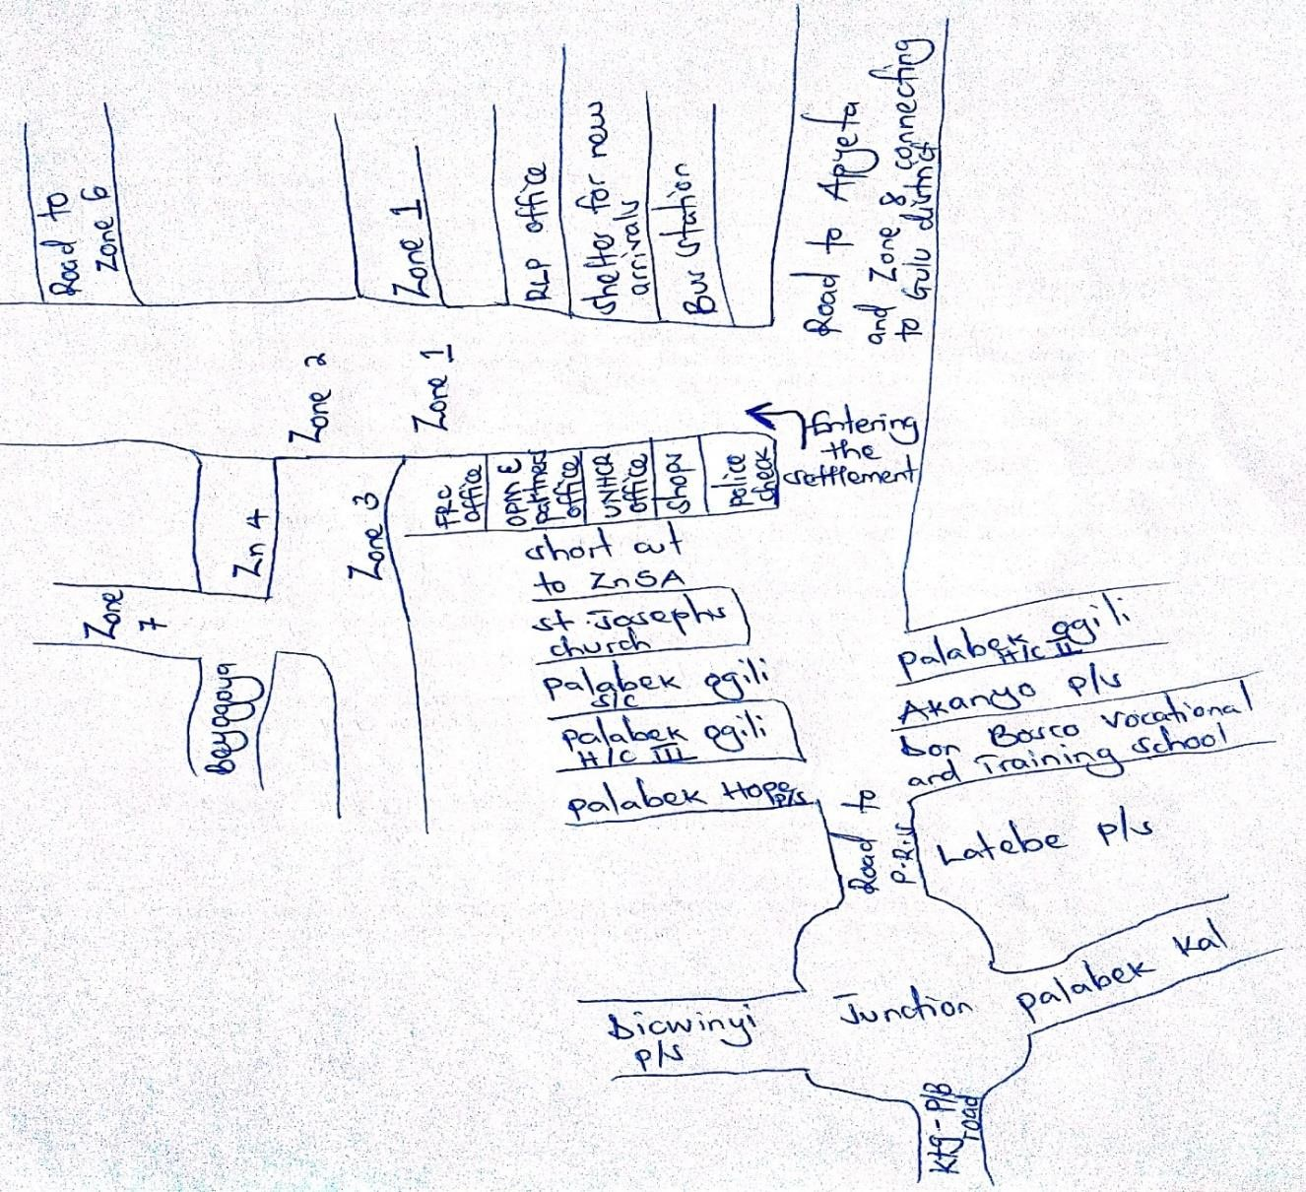
Source: Author

3.6.1 Overview of Palabek Refugee Settlement
Palabek Refugee Settlement is one of the newest refugee settlements in Uganda officially set up in April 2017 to receive new refugees from South Sudan and as well reduce congestion in other larger refugee settlements in Uganda through relocation (UNHCR, 2020). The Palabek refugee settlement began hosting new refugees from South Sudan in 2017 and receiving relocated refugees from Palorinya refugee settlement in the Obongi district in November 2020 where an estimate of 650 vulnerable South Sudanese mostly women and children from the Nuer community were relocated for safety (ibid). This transfer was spearheaded by OPM and the UNHCR and it came as a result of inter-communal clashes between the Nuer and Kuku communities. (OPM, 2020). In addition, the settlement mainly hosts refugees from South Sudan being the largest refugee group and Democratic Republic of Congo being the minority (UNHCR, 2021).
The settlement is part of the land that was given by the host community to host refugees mainly from South Sudan (OPM, 2023). This land was not purchased by the government because it promised the local people that they would benefit from the services rendered to the refugees (Kidega, 2023). The settlement is comprised of eight Zones. The Zones are divided into blocks which comprise of fifty-eight in number (OPM, 2023). The settlement is headed by the RWC Three who is the overseer, the Zone is headed by the RWC Two and the block is headed by the RWC One.

Figure 2: Map of Uganda showing Palabek Refugee Settlement
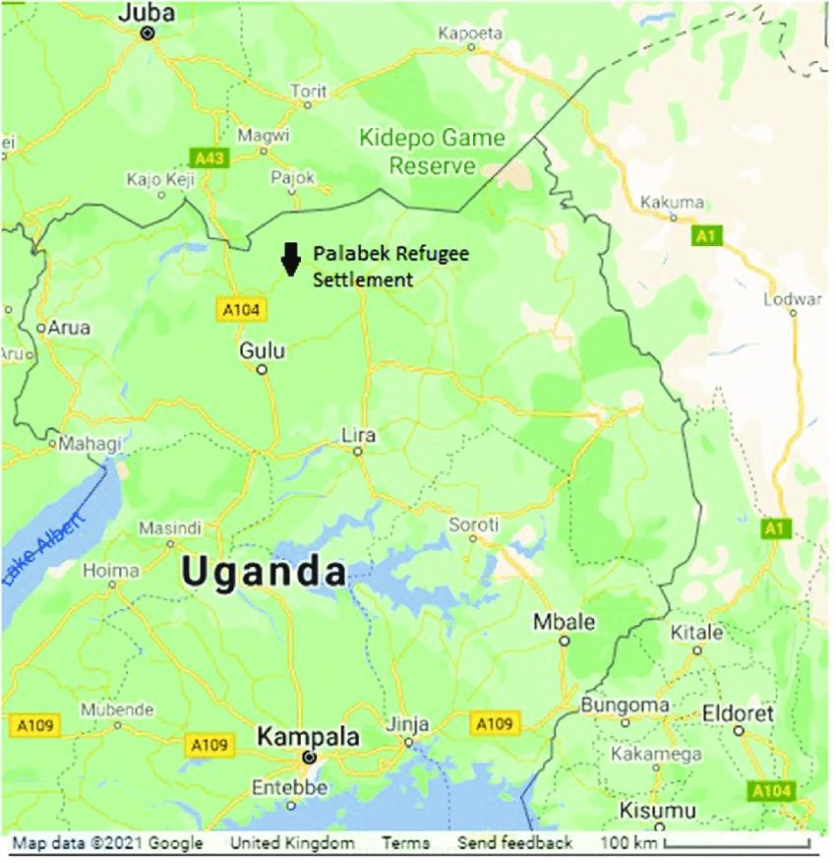
Source: Google map, 2023

3.6.2 Overview of Palabek Ogili sub country in Lamwo district
Palabek Ogili in Lamwo district became a hosting community for refugees from South Sudan in April 2017 (UNHCR, 2018). As of 2024, it had a population of 11,500 people as the host population UBOS (2024) and a total of 97,000 refugees currently living in the refugee settlement (UNHCR, 2026).

Twenty years ago, Palabek Ogili had been associated with the Lord’s Resistance Army war that devastated lives, properties and is still under reconstruction and going through a healing process (See Oyet, 2021). It has also been associated with pervasive land conflicts that continue to exist, thus putting pressure on the natural resource base of its community since the opening of Palabek Refugee Settlement (ibid).

Arguments about competition for scarce resources between the refugees and the host community has led to even greater conflict and environmental depletion, with increased threats to human security and the ecosystem continue to linger in the refugee-host community relationships (See Kidega, 2021). Ideally, Palabek Ogili Sub County is comprised of low-income earners, both host and refugee communities who do casual work to earn a living with the major economic activities being farming and quarrying (See Onek, 2019). There is also high level of intermarriage between the Acholi from Uganda and Acholi from South Sudan living within Palabek Ogili (See Oyet, 2021).

3.6.3 Structure of the Refugee Welfare Committee
The Refugee welfare Committee is a local governance institution created by the Ugandan government and UNHCR in refugee settlements (De Simone, 2022). The Refugee Welfare Committee is composed of elected refugee leaders in the settlement who primarily report to the OPM and UNHCR, but also other actors providing humanitarian services (Hoff, 2019). The RWC operates on three tiers, and these are: the RWC 1, RWC 2, and RWC 3. The lowest is the RWC 1, heading what is usually referred to as a block. The second level is the RWC 2, heading what is referred to as the zone and the RWC 3 presides over the entire settlement. Each RWC runs a committee with various secretaries for sectors such as finance, health, education, environment among others.

The Refugee Welfare Committee is represented by 14 committee members comprising of top to bottom leadership. The RWC’S are elected through democratic elections that are frequently organized by OPM after every two years. RWC I and RWC 2 are voted by secret ballot and the general population, while the RWC 3 is elected by an Electoral College comprising of RWC 1’s and RWC 2’s (De Simone, 2022). All the three tiers play a key role in implementing physical protection and access to justice for refugees in the settlement. In other words, they are the first people to be reported to by the refugees when an issue occurs and it is through them that the communication chain is sparked.

Figure 3: RWC Structure in Palabek Refugee Settlement

RWC III

RWC II

RWC I

Source: De Simone, 2021

Table 1: RWC and their Roles
Position/title | Responsibilities in the community
RWC 3 (chairperson) | Presides all meetings at the council.  Monitors the general administration of the settlement and the zone.
RWC 2 (vice chairpersons) | He/she is the focal person for the disciplinary department in the zone.  He/she oversees children’s affairs.
RWC 1 (general secretaries) | Inform members of occurrences in the settlement.  Keep records and files of correspondence.
The Woman Leader | Oversee programs that are related to women in the settlement.  Advocate and seek support for women from NGO’S.
Secretaries for finance | Keep books of accounts for the council.  Account for council funds.
Secretaries for security | Assist the chairperson, settlement commandants in arresting suspects.  Maintain law and order in the settlement.
Secretaries for women’s affairs | Represent women at zone level meetings.  Monitors and follow up on issues related to gender-based violence at the zonal level
Secretaries for youths and sports | Oversee programs related to youths.  Form youth groups
Secretaries for people with disability and persons with special needs | Oversee programs related to disability and persons with special needs.  Lobby funds for the disabled and persons with special needs.
Secretaries for environment and production | Preserve and protect the environment.  Report natural disaster to relevant NGO’S.
Secretaries for education | Monitor community-based activities in primary and secondary schools.  Advocate for girl child education.
Secretaries for health | Collaborate with health personnel to attain better medical care.  Work hand in hand with village health teams.
Counsel (RWC) | Take part in community development activities.  Attend sessions of the RWC and meetings of the committee
Opinion leaders/advisors | Advise the council on traditional and cultural norms from the country of origin.  Advise and guide the council members on court proceedings and other civil cases.
Source: OPM Refugee Desk, Palabek, 2023

3.7 Sampling
Touvilla (2024) defined it as a collection of persons chosen from a demographic community through established means. Sampling involves the selection of a specific number of individuals to represent the whole community (Bisht, 2023). Aspects such as a suitable research paradigm, standardization and the criterion of absorption should be respected when deciding on the sample size in qualitative studies (Shetty, 2023). The sample size endorsed for a qualitative study is 20-30 participants on the basis that the researcher aims to discover facts about certain events (Rusu, 2020). While choosing my sample size, I considered factors such as methodology to be used, diversity of the target group, study scope and lastly resources and time.

I included a sample of 31 informants comprising of the Refugees, RWC Three and Two, Woman Leader, the Office of the Prime Minister, Immigration office, and the United Nations High Commissioner for Refugees. In the 31 participants’ category, there were eleven key informants and twenty other participants selected. The eleven key informants selected included; One representative from the United Nations High Commissioner for Refugees, one representative from the Office of the Prime Minister, one representative from the Immigration office, Woman Leader, RWC Three and Two and partly five refugees who had some knowledge on dual citizenship. The other twenty participants were specifically refugees, and the targeted number was (10 males and 10 females).

All the key informants were selected on purposive basis. For example, the UNHCR was selected because of its mandate to protect refugees, displaced and stateless persons by advocating for their rights through their activities such as strengthening coordination and accountability to refugees and capacity building of relevant stakeholders in the refugee response. OPM was selected because of its mandate to lead and enhance national response capacity to refugee emergency management through their activities such as receiving and granting asylum to refugees in accordance with both international and national legal frameworks, providing physical protection to refugees, settling refugees granted asylum and implement humanitarian interventions.

The Immigration office was selected because of its mandate to regulate and manage migration, citizenship, and national identification for the country’s security and development through its activities such as facilitating the legal and orderly movement of persons to and from Uganda, processing, verifying and granting Uganda citizenship, and regulating the issuing of national passports.
The RWC was selected because of its mandate to implement physical protection and access to justice for refugees in their communities and lastly, the refugees were selected because they were the main target group of people for the study. I therefore chose a small sample in order to support the depth of case-oriented findings that was vital for my study given that it was purposive, and participants were selected by the virtue of their capacity to provide richly-textured information.

Table 2: Summary breakdown of participants
S/N | Participants category | Number  participants identified |  | of | Sex of participants
1. | The UNHCR | 1 |  |  | Female
2. | The Office of the Prime  Minister | 1 |  |  | Female
3. | The Immigration Office | 1 |  |  | Male
4. | The RWC Three | 1 |  |  | Male
5. | The RWC Two | 1 |  |  | Male
6. | The Woman Leader | 1 |  |  | Female
7. | Refugees (Key  Informants) | 5 |  |  | Three Females and Two Males
8. | Refugee participants | 20 |  |  | Ten Females and Ten Males
 | Total of participants | 30 |  |  | 16 females and 15 males.

3.7.1 Sampling Strategies
Non- probability samples are always appropriate when exploring incidences where circumstances are formed on stories thus selecting cases following their significance (Nikolopoulou, 2022). In the non-probability sample, participants are selected through non- random methods (Williams, 2024). Therefore, under the non- probability sampling, I employed the purposive and snowball sampling according to Bernard (2006).

3.7.2 Purposive sampling
This is where an individual is chosen by the researcher on ground that he or she bears knowledge and understanding on the topic under investigation (Nikolopoulou, 2022). In purposive sampling, a researcher intentionally locates whom to and whom not to take part in the study with the goal of discovering concrete information (Mahmutovic, 2023). Under the purposive sampling, the respondents that were purposively selected for the study included, the Office of the Prime Minister, United Nations High Commissioner for Refugees, Immigration office, Refugee Welfare Committee Three and Two, Woman Leader and partly five refugees.
I employed the above sampling technique because it allowed me to explore specific areas of interest and gather in-depth information by guaranteeing that the participants opinions depict the whole community rather than a small society.

Table 3: Key Informants Category
Key Informants Category | Numbers selected
Office of the Prime Minister | 1
United Nations High Commissioner for Refugees | 1
Immigration office | 1
Refugee Welfare Committee Three | 1
Refugee Welfare Committee Two | 1
Woman Leader | 1
Refugees | 5
Total | 11

3.7.3 Snowball sampling
This is where the researcher identifies participants with similar traits in the community through referrals with the aim of discovering areas of interest under investigation and still uses the selected participants to identify others (Langford & Boyd, 2023). Snowball sampling is a technique employed to discover hidden individuals (Robson & McCartan, 2002). In this case, I identified two participants (refugees) who were believed to have been long staying refugees through referral from the Office of the Prime Minister. I introduced myself to them and told them about my intent to carry out research in the settlement in reference to my topic. I told them that I got permission from OPM to carry out my study in the settlement and requested them to identify other participants who also had knowledge in dual citizenship. I then relied on those initial participants who helped me to identify additional study participants to get divergent views. I chose it because it helped me in accessing a group of able participants for my study thus, able to generate diverse views.

3.8 Data collection methods and tools
Data collection is the process of gathering and evaluating information in a standard procedure which enables one to find results to the established questions (Bhandari, 2023). Though I carried out research in Palabek settlement, I noted that refugees living there spoke different languages. Therefore, during data collection, I worked hand in hand with my research assistant who was multi-linguistic. I collected the information myself together with the aid of my research assistant who doubled as a translator and aided in interpretation during different sessions of fieldwork. I used interviews and focus group discussions as methods and an interview guide and focus group discussions guide as tools for data collection according to Robson & McCartan (2011).

3.8.1 Data collection Methods

Interviews
Interviews are tailored question-answer interactions directed by the interviewer to the interviewee involving subject of common concern and interest (Kvale & Brinkmann, 2009). During interviews, both the interviewer and the interviewee become acquainted with each other (Tegan, 2022). This enables researchers to dig deep into issues of concern which in turn helps in coming up with concrete information about the study under investigation (Rubin & Rubin, 2005). I employed interviews because it created room for collective exploration, expression as well for participants to air out their opinions, motivations and lived experiences which accounted justifications for their actions.

Interviews were conducted to the eleven key informants selected and they included one representative from the United Nations High Commissioner for Refugees, one representative from the Office of the Prime Minister, one representative from Immigration, the Refugee Welfare Committee Three, one Refugee Welfare Committee Two representative, the Woman Leader and five refugees who had some knowledge on dual citizenship. The interviews took place in the respective homes and offices of the key informants on different days and time. The interviews took place at 10:00am, 2:00pm and 4:00pm respectively because the respondents argued that it was a comfortable time for them and it was conducted three times a week. During the interview session, I organized for the meeting together with the aid of my research assistant. In addition, I conducted, moderated, and took notes while my research assistant did the mobilization, translation, and others to ensure that the activity ended smoothly. During interviews, I spent 45 minutes with each participant, and they were compensated through financial rewards of Ugx. 20,000 each. During interviews, I employed both the semi-structured and unstructured interviews during data collection.

A semi-structured interview entails clear and unfolded questions that enable the interviewer to probe question and allow for the emergence of critical responses for the interviewee
(Chana & Knott, 2022). The semi-structured interview was conducted to the key informants of the OPM, UNHCR, Immigration, RWC Three and Two and the Woman Leader by using the interview guide that entailed pre-determined open-ended questions. The key informants were asked questions that were in the interview guide and their task was to respond to the questions and also explain further information details in relation to the questions paused. I employed the semi-structured interviews because it allowed me to probe follow– up questions as it assisted me in getting in–depth information both verbal and nonverbal since it encouraged free interaction between me and the respondents.

Unstructured interviews are important because it gives the interviewee options on whether to answer the questions or not (Bihu, 2020). Unstructured interviews provide opportunities for the discovery of new knowledge and facilitate for the interviewees’ opinions and recommendations because of clear and open questions that gives them the ability to interpret more regarding the topic (Bhasin, 2023). The unstructured interviews were conducted to the five refugees who were identified as key informants as well. The interviews took place in Zone 2, Zone 4 and Zone 5A respectively. The participants were asked questions that were in the interview guide and their task was to respond and explain further in case they had ideas to share. I employed this type of interview because it helped me to explore in detail the respondents’ own perceptions and discover richer and more in-depth information adding useful and interesting responses to the research.

Focus Group Discussions
This is where the interviewer associates him/herself with a selected category of people with the goal of finding out specific information about the topic under study (Eeuwijk, 2017). In other words, focus group discussions are conducted to distinct and compatible individuals who present knowledge and facts on topics specified by the researcher (Tegan, 2022). In focus group discussion, participants are empowered and able to render their own presentations and remarks because it mainly contains participant-researcher interaction and interaction between participants (Parker & Tritter, 2006). I used it because it allowed brainstorming and enabled participants to develop ideas collectively by bringing forward their own priorities and perceptions regarding the study topic.

I conducted two focus group discussions with the refugees consisting of 10 participants each, bringing a total of 20 respondents’ including10 males and 10 female adults who were identified through purposive and snowball sampling. There was a mixture of both males and females per group pertaining of 5 males and 5 females. Since Palabek settlement has different ethnic groups coming from South Sudan, some documents like focus group discussions guide and consent forms were translated into the local languages of Acholi and Arabic respectively (See Appendix three and four). During the focus group discussion, languages used were English, Acholi and Arabic and it took place in Zone Four and Five because these zones are believed to have long-term staying refugees who were transferred from Palorinya refugee settlement in Obongi district.
The focus group discussion took place at different times and days. In Zone 4, it took place on the 30.08.2023 at 2:00pm attracting a total of 10 participants (five males and five females) at the premise of African Inland Church. In Zone 5A, it took place at Salvation Ministry Church on the 31.08.2023 at 2:00pm attracting a total of 10 participants (five males and five females). These focus group discussions mainly took place in the afternoon because, during morning hours, the participants are busy doing garden work.

During the focus group discussions, I organized for the meeting together with the aid of my research assistant, conducted, moderated, and took notes while my research assistant did the mobilization, translation and other assigned tasks. Each participant was compensated through financial rewards of Ugx. 10,000 upon completion of the discussion. I spent 90 minutes with each group participants and this was conducted by asking them questions directly and having a back-and forth discussion.

3.8.2 Data collection tools

Interview guide
Barber (2024) defined it as a set of queries prepared by the interviewer with the aim of enabling him/her attain answers needed during an interview. The interview guides were designed in accordance to research questions so as to provide relevant information for the study. Two interview guides were designed, one for the key informants such as OPM, UNHCR, the Immigration, the Woman leader, RWC Two and Three and the other for the five refugees who were also identified as key informants. These informants were essential for this study because they possessed knowledge regarding refugees’ affairs and had first-hand information on the topic under study. During the interview, I asked the participants’ questions entailed in the interview guide and they were requested to provide answers in their own words since it involved encounters between me and the respondents as well face-to-face interactions.
This helped me to tailor my questions to the interview situation, and to the participants I was interviewing. An interview guide helped me to focus on the topics at hand without limiting respondents to a particular format to ensure consistency and purpose throughout the interview.

Focus Group Discussion guide
This is a ground plan that gives direction to the interviewer on restructuring and organizing a productive focus group discussion (Robson, 2005). It encompasses questions that the interviewer directs to stir up an interaction with the participants with the goal of prompting conversations and giving a platform for participants’ views to be heard in the modest demeanor (Tracy, 2013). Focus group discussion guide ensured that focus group discussions were conducted promptly and efficiently and it helped me to focus on the key points that needed to be discussed. This way, focus groups stayed organized and I got the best out of each discussion. The focus group discussion guide targeted only the refugees, both males and female adults living in the settlement and the focus group discussion took places in Zone Four and Five respectively at different times. In Zone Four, it took place on the 30.08.2023 at 2:00pm attracting a total of 10 participants (five males and five females) at African Inland Church.

In Zone 5A, it took place on the 31.08.2023 at 2:00pm attracting a total of 10 participants (five males and five females) at Salvation Ministry Church. During the focus group discussion, I organized for the meeting together with the aid of my research assistant, conducted, moderated and took notes while my research assistant did the mobilization, translation and others.

3.9 Data collection procedures
This dissertation was presented to the Institute of Peace and Strategic Studies of Gulu University on the 18.3.2023 and later to the Gulu University Research Ethics Committee on the 16.6.2023. With these presentations, I managed to get clearances from both parties to carry out the study (see appendices seven and eight attached). After getting clearance from both Committees, I visited OPM Kampala in the department of refugees on the 2.08.2023 where I applied to the Commissioner of Refugees in the department of refugees to seek permission to conduct research in the settlement. On the 9.08.2023, I was given a clearance letter by the OPM (see appendix one attached). Later on, the 12.08.2023, I travelled to Palabek settlement and on 14.08.2023, I visited the OPM Palabek to also seek for permission to conduct data collection in the settlement of which I also managed to get approved. On the 15.08.2023, I met with my research assistant and the conversation mainly focussed on the aim and goal of my research, how the data would be collected, his roles during the period of fieldwork and the dos and don’ts of the research.

On the 17.08.2023, my research assistant carried out mobilization and this was successfully done and on the 21.08.2023, my research assistant and I made our first move as we managed to interview one male refugee key informant. On the 22.08.2023, my research assistant and I conducted another interview with two female refugee key informants. On the 23.08.2023, my research assistant and I conducted another interview to two key informants, and these were specifically the Woman leader and the RWC Three. On the 24.8.2023, I managed to conduct another set of interviews with the RWC Two of Zone 5A and one representative from UNHCR. On the 25.8.2023, I interviewed two key informants and that was one refugee male and one refugee female. On the 29.8.2023, I managed to conduct one interview with a female key informant from OPM.

On the 30.08.2023, my research assistant and I conducted the first focus group discussion which took place in Zone 4. On the 31.08.2023, we conducted the second focus group discussion which took place in Zone 5. On the 1-2.09.2023, I conducted field trips to bid farewell and thanked all the participants for their generous support towards me during my time of stay with them and informed them of my exit from the field and this made them aware of my departure. On the 3.09.2023, I made my return journey back to Kampala.
Lastly, I held an interview with the Assistant Immigration Officer at the Ministry of Internal Affairs in Kampala on the 26.08.2026. However, my findings were not shared with the participants upon completion of the field work but this shall be done once a comprehensive report has been generated.

3.10 Data Analysis and presentation
Any resolution to conduct data analysis in qualitative research results to outcomes on the set of design employed (Miles & Hubberman, 1994). To ensure the effectiveness of qualitative research, data analysis must be aligned with data collection, and this allows one to increasingly concentrate on examining participants’ views and come up with an authentic report (Coffey & Atkinson, 1996). After the completion of data collection, I commenced data analysis by sorting out the necessary and relevant responses acquired during data collection and came up with essential information regarding the study topic.

3.10.1 Data analysis approach

Qualitative data analysis
Morrill et al. (2000) defined it as the gradual process of investigating and analysing qualitative data to have knowledge on what it demonstrates. Data analysis is conducted alongside data collection (Coffey & Atkinson, 1996). Information collected from the field helps to influence conclusions on the qualitative data analysis procedure which is later used to produce outcomes (Patton, 2002). Reviewing of the outcomes of the data becomes a constant process through the study and the effectiveness of the results involves one having knowledge about their study and findings (Miller & Crabtree, 1999). Interpreting and analysing of qualitative data involve reviewing a variety and big sum of notes to ensure compatibility and enable in the identification of themes (Patton, 2002).

Qualitative data analysis approach examines personal encounters with the goal of discovering and expanding communal attitude and perceptions (Harding, 1998). I employed the qualitative data analysis because it helped me to capture themes and patterns and identify actions needed in relation to research questions and responses. Under the qualitative data analysis, I used the thematic analysis as discussed below.

Thematic analysis
According to Braun et al. (2006), majority of the researchers tend to apply the thematic analysis especially when conducting qualitative research. In the thematic analysis, it involves the process of determining and classifying patterns and themes or ideas in the qualitative data (Braun & Clarke, 2013). Fereday & Muir-Cochrane (2006) described the thematic analysis as the process where researchers tend to look for interesting and compelling themes within the data that answer the specific research questions. Thematic analysis employs the inductive approach of exploring patterns in the data by using the coding practice to generate themes within content through interpreting the word-passage paradigm (Kerryn, 2020). It also entails the examination of repeated themes across the whole text (De Santis & Ugarizza, 2000).

In the thematic analysis, the researcher can relate the meaning of text across their specific settings (Loffe & Yardley, 2004). The use of the thematic analysis approach enables one to examine the participants’ views, encounters and understanding through utilization of the set of interview notes (Caulfield, 2019). I employed the thematic analysis because it helped me to identify patterns and themes in my data particularly from the interviews and focus group discussions notes.

3.10.2. Approaches to Thematic analysis

Inductive approach
According to Caulfield (2019), inductive approach involves understanding the significance and discovering themes within text. In this approach, the researcher determines results by deciding on means to code, what to code and reasons for the re-occurrence of results (Boyatzis, 1998). This is because majority of the codes are obtained from the feedback of the participants’ (Hsieh & Shannon, 2005). In other words, creation of codes in the inductive approach commences at the beginning of data collection meaning that the researcher generates new codes depending on the qualitative data alone (Medelyan, 2019). The inductive approach enables researchers to generate significant themes in the data as well patterns arising and links to ideas on new explorations (Krippendorf, 2004). I employed this approach because it represented the participant’s views that enabled me to identify important themes.

3.10.3 Steps employed in qualitative data analysis
Since I used the thematic analysis for analysing my data, I employed the following steps according to Braun and Clarke (2006).
- Familiarization with the data collected. It is always important for one to have knowledge and understanding about the data they collect to enable them to internalize it before the commencement of interpretation of data (Patton, 2002). Familiarization involves the constant and persistent reviewing of the data collected from the field by employing diverse approaches and connecting them to themes arising (Srivastava & Hopwood, 2009). In other words, one must contemplate and examine through constants reviews to understand the findings (Polit & Becker, 2003). Therefore, possession of concrete information ensures effective conduction of analysis (Bogdan & Biklen, 2006). I conducted familiarization with my data through persistent reading that enabled me to write down notes and thus created room for the rise of significant codes.
- Generating initial codes. To establish an early set of codes, one must consider the interesting elements of the data that seem to be of great significance to the participants (Boyatzis, 1998). Coding involves the process of describing, categorizing and systemizing data to generate distinct and various themes and patterns (Gibbs, 2007). It entails the classification of attitude, certainty, and ideas of a single or greater narratives or supplementary units (Saldana, 2011). In addition, creating initial codes enables one to embody the patterns and significance in the data by establishing valid units (Casttleberry, 2018). I coded my data manually by listing the identified themes under each objective. Each code described the idea or feeling expressed in that part of the text. Assigning codes to words and passages in each response helped me to capture what the response was about thus, enabled me to better analyze and summarize the results of the entire data collection exercise. After coding, I worked systematically through my data, and this helped me to identify and decide on the important themes in my data.
- Identifying and generating themes. The success of qualitative data analysis is dependable on the continuous classification and systematic arrangement of feasible themes (Coffey et al., 1996). Themes tend to identify significant information in the data collected (Larkin & Flowers, 2009). To generate potential themes, I sorted the different codes and put together all the relevant coded data extracted within the themes I identified. One of the techniques that I used for identifying themes was looking at the repetition of interesting words or passages within the data and was re-occurring.
- Grouping codes into themes and reviewing them. This is where researchers’ endeavour that their themes portray what is inclusive in the data collected (Fereday & Muir-Cochrane, 2006). Sandelowski & Leeman (2012) defined a theme as a thread in the data that explains and systemizes achievable remarks and analyses different elements of development. These themes observe patterns that locate significant insights linked to the specific research questions (Braun & Clarke 2006). Attride-Stirling (2001) suggested two levels of themes and these include: the main and the sub-themes. The base code indicates one observation explaining what is inclusive in the sub-code and a sub-code is present below the shield of a theme. To create codes into themes, I employed both the main and sub-theme categories where I fitted together the themes into one or more networks by identifying recurring languages, opinions, and beliefs.
- Integration, interpretation and defining themes. This is when the researcher associates with describing and interpreting each single theme (Castleberry, 2018). Interpreting of themes aids in the explanation of developments and insights that emerge in the data (Braun & Clarke, 2006). Miles et al. (2014) looks at integration and interpretation as recognizing the relevant passages from the themes and argued that for one to be able to generate meaning, they should categorize their data which entails classifying happenings, localities, and the population especially when they possess familiar traits. In addition, conduct comparisons which look at aiding similarities and differences within the data and noting down base codes, sub-codes and trends. During integration and interpretation, I explored codes within and across the themes and these helped me to understand what the data was all about.
- Writing up
This is the final stage in the conduction of the thematic analysis where the researcher concludes the interpretation and analysis of their data (Dye, 2021). Writing up a thematic analysis demands one to have knowledge and understanding of the goal, methods, and the specific research questions (Braun & Clarke, 2013). In addition, it should entail a segment for approaches explaining both the procedures of data collection and thematic analysis (Joffe, 2011). The results segment in most cases explains the emergence and relevance of each theme (Boyatzis, 1998). Finally, my conclusion explained the main takeaways and showed how the analysis answered my research questions.

3.11 Validity
Validity refers to how information received from the participants explain their vivid results amongst homogenous individuals albeit the study population (Blumberg et al., 2005). Validity in research focuses on the relevance of specific approaches needed to test the study units (Maxwell, 2005).

3.11.1 Validity in qualitative studies
According to Bricki & Green (2005), validity takes diverse formats and is usually discussed using different terms. Maxwell (2005) suggested the following to ensure validity and therefore, I discussed qualitative validity by elaborating on each of them.
Transferability: This looks at the use of research findings or results in other settings, and situations (Sesa, 2008). Transferability answers the questions of “to what degree will the study results be used in other settings”? This therefore means that the researcher has no mandate to employ appropriateness and suitability as others tend to do (Klein et al., 1999). To ensure transferability in my study, I was responsible for providing enough details about the setting and context so that readers may be able to assess the applicability of my findings to a specific situation.

Credibility: Credibility refers to the process that ensures firmness and dependence in data interpretation (Maxwell, 2005). According to Patton (2000), the credibility of qualitative studies bases on three components and they include, the application of various approaches for the collection and interpretation of data, accuracy and trustworthiness of the researcher, inductive data analysis and purposive sampling. I ensured credibility of my study through triangulation. Triangulation looks at the application of various methods and procedures to obtain sufficient data (Maxwell & Miller, 2008). Triangulation helped me to minimize individual biases and provided a whole and concrete examination of the study that provided a more thorough explanation.
Trustworthiness: This refers to the degree of determination in approaches used for analysing data to ensure the credibility of a study (Polit & Beck, 2014). During planning, I considered the following ethical principles to ensure trust; ensuring participant confidentiality, security of the data obtained, the principle of confirmability by ensuring that my research study was neutral and not influenced by other factors.

3.11.2 Validity threats to qualitative research and how they were mitigated by the researcher.
Below are some of the validity threats on qualitative studies according to Maxwell (2005) and how they were mitigated.
- Bias. Bias is bound to happen at any stage of one’s research, including before, during and after data collection (Maxwell, 1996). Before my data collection, I experienced bias over the respondents and it came as a result of fear that when it came to citizenship related aspects; refugees tend not to give adequate information due to insecurity purposes. However, this was mitigated by explaining to them the intent of research and also assured them of confidentiality. I also employed the aspect of triangulation that looked at the application of various methods and approaches to ensure the gathering of adequate information (Robson, 2002). Triangulation minimizes the liability to biasness due to the employment of approaches to enable better judgment of the examination that an individual generates (Shikano, 2010).

- Reactivity. This looks at the influence of the researcher on the context or population under investigation (Maxwell, 2005). In other words, it looks at the interaction of the researcher and research participants to each other during the research process. The goal of reactivity in qualitative study is to ensure that one’s research is read and scrutinized by different scholars (Hammersley & Atkinson, 1995). This was mitigated by peer-debriefing where I was given an opportunity to explain and submit my findings at the student presentations at the university. Peer-debriefing helps to examine the study’s credibility and validity (Maxwell, 1992). This strategy provided room for valuable feedback, scrutiny, and the production of better content.

- Confidentiality checks. This looks at keeping important documents away from others where the researcher can only access them (Robson, 2002). This was mitigated by audit trail which involved the process of monitoring and storing of relevant research-related activities, documents and information. These included raw data on interviews, field notes and audio-recordings.

3.12. Data Management
Mardack (2019) defined it as a process of absorbing, keeping, and classifying of information collected by an individual or organization. Data management helped me to minimize errors and increase quality on analysis. According to Patton (2002), data management entails the following in qualitative studies,

- Confidentiality and security issues: One should always consider the security of those being interviewed and their own. Security of both parties is important to avoid the emergence of potential harms that is likely to cause negative impacts on both the researcher and the research participants. It was my responsibility to limit those present during the interview to the specified number and found a private place that was appropriate for discussions to take place. I ensured not to leave transcripts lying around and I made sure that no one accessed materials and data got from the field.
- Translation: Sometimes, there is a lot of mistrust between the interviewer and the interviewee (Bricki & Green, 2015). Participants tend to build a lot of trust on the translator especially when that person is from their community and ethnic group (ibid). It was my responsibility to choose a trained and experienced interpreter who had knowledge in English, Acholi and Arabic thus aided during data collection. During translation, I insisted that my translator explains the questions in detail and not a summary to ensure that the participants clearly understood the questions before they answered them.
- Recording/ Transcribing: A researcher can decide either to copy down responses and important notes at the same time having an interaction with the participants or even record
(Michener, 2015). Before recording any participant’s views, their permission was sought first
by signing a consent form for statement of audio recording and I explained the reason why it was necessary to be recorded. Recording participants’ views helped me to check whether I had recorded their views correctly and for those who refused, I respected their choices and put my audio recorder away. However, it is always recommended that when speaking about crucial and delicate matters, it is unnecessary to record because it might endanger one’s privacy (Hart et al., 2016). In other words, a researcher can continue conversing with the respondents when the recorder has been turned off (Noonan, 2009). It was important to protect the recordings of participants and I did this by creating safely files that were only accessible by me.

3.13 Ethical Considerations
This is the accumulation of values and principles that provide responses of what is moral or immoral in the human and social arena (MacDonald, 2003). Acknowledgement of ethical considerations targets both the individual and society at all levels (Mirza et al., 2023). A study on Remain or Return? Dual citizenship and Uncertainty was an essential topic and therefore some people were fearful to render information. Therefore, I applied the following ethical considerations during data collection according to Anushko & Fisher (2008).

Getting clearance from the IPSS and GUREC: After presentation to the Institute of Peace and Strategic Studies and GUREC, my research was carefully scrutinized by the committee. After careful scrutinization and fulfilling the needs of the committee, I was granted permission and given a clearance letter to conduct data collection. I later presented the letter to OPM Kampala in the department of refugees, and they also cleared me. This letter was then presented to the authorities of Palabek refugee settlement to enable me to have an encounter with the refugees and they also gave me consent.

Informed consent: It involves seeking for the participants’ consent and will to participate in any research they are knowledgeable about (Anushko, 2008). This consent ensures that the selected participants are equipped with valid and reliable information about the study that will later determine their involvement (Huws, 2004). This means that, the identified participant will have the ability and at will provide his or her stand about the topic under discussion (Dench, 2004). During the informed consent process, it involved interaction between me, and the participants and I ensured that comprehensive information was disseminated to them so as to fully understand what they were being asked and that they were informed if there were any potential benefits and negative consequences of their participation.

I also explained what the research was about, why it was being conducted, the level of their participation during the study and how their results would be shared at the climax. In the consent form, I included: the purpose, duration and procedures, the right to withdraw from participation, extent and limits of confidentiality, incentives for participation and an opportunity to ask questions. With this information provided to them, they were well informed about the study and able to participate without being coerced.

The informed consent forms were translated in the languages that the participants understood. The languages included English, Acholi and Arabic (See appendix three). To ensure double checking, the participants’ views were recorded with their permission. Their recordings were protected with maximum confidentiality by creating safety files with passwords which were only accessed by me. The recordings were disposed through shredding since a whole report was generated by the researcher and disseminated to stakeholders.

Beneficence and non-maleficence: this implies the “do no harm policy”. This involves the accreditation to carry out safe and sound research within the communities to serve and safeguard their interest (Creswell, 2002). During research, both the researcher and the participants’ can be harmed in one way or the other. Such harm can involve the psychological, emotional, and physical harm (Winslade, 1992). To avoid the emergence of potential harms, I followed the informed-consent rules, avoided asking questions that revoked past experiences and respected their confidentiality. During the interview, I spent 45 minutes with each participant, and they were compensated through financial rewards after completion of the interview. Participants were gathered in the established community structures where there was minimum noise to ensure smooth flow of the conversation.

Justice and fairness principle
The principle of justice refers to an approach of treating people fairly and equitably with dignity regardless of their age, race, ethnicity, religion and culture (UN Women, 2020). The principle of justice entails research participants right to protection from exploitation (ibid). The principle also states that the questions being directed to the participants should be relevant to the communities participating in the study (Bereket, 2018). In this principle, I applied the distributive justice that looked at ensuring that institutions and participants in the study share benefits in ways that are fair and just. The institutions involved UNHCR, Immigration, and OPM. The other participants included the refugees and their leadership. In this way, I made sure that all participants were treated equally by giving them equal opportunities and compensation for their participation. In addition, I also made sure that this research did not only benefit one zone but at least three zones within the settlement.
Furthermore, the principle of fairness also known as “duty to fair play” ensures that all individuals are equally treated in the society (Markkula centre for applied ethics, 2018). In this principle, the researcher must not exercise authority over the participants and avoid exploitation for personal gains (Ibid). In this paradigm, I ensured that equal participation and respect was guaranteed to all participants before, during and after the study.

Respect for confidentiality:
Confidentiality means that the participants identity and bio data information are hidden in the report of the study (Wiles, 2013). In confidentiality, the participants’ have the right to give their views and reserve greater information as they wish to the person, they choose to give the essential data (Hindu, 2006). In regard to confidentiality, I gave a full explanation to the participants of what would be done with their data and clearly stated the standard of confidentiality in their information sheet. It was therefore essential for me to protect the identity of the person from whom I gathered information from, and I ensured confidentiality by concealing the identity of the participants and storing of important documents such as personal data, signed consent forms and notes got from the participants.

3.14 Limitations of the study
The study did not take into consideration the whole settlement and interviewing all the refugees living in Palabek refugee settlement together with their views as a particular sample was only chosen. Given the fact that the settlement was big; I only focused on the small sample chosen as interviewing the whole settlement was impossible.

This study was carried out only in Palabek refugee settlement. There is also need for this study to be carried out in other settlements of Uganda and as well urban Kampala that are also hosting refugees from other countries and are reluctant to return to their countries of origin.

3.15 Dissemination plan
The dissemination plan is one for disseminating research findings to those who will use the information in practice. It helped me to get the message whether my study was a successful intervention. This information was shared with other stakeholders especially in the field of dual citizenship/citizenship and those working with refugees particularly OPM and UNHCR.
Target audiences:
There are different audiences that were relevant for this project. The major target audience for this dissemination plan included:
- The academic community
- Organizational sector
- Interest-group community/Refugees
Concerning the academic community, these included: researchers from different fields associated with technical institutes and universities working on different projects related to the remain, return, dual citizenship and uncertainty amongst refugees.
In the industry/organisational sector, these included: stakeholders involved in handling refugees’ concerns and affairs (that is OPM and UNHCR). Organizations advocating for refugee rights especially in the field of dual citizenship and in the interest-group community, these included: organization’s working for and with refugees, RWC’s and refugees. After generation of the whole report, dissemination of findings was conducted through dissertations and report sharing and this ensured that all the stakeholders benefitted from this piece of information.

CHAPTER FOUR: PRESENTATION OF THE RESEARCH FINDINGS

4.1 INTRODUCTION
This Chapter presents data in relation to research findings during my three weeks of field work in Palabek refugee settlement on Remain or Return? Dual Citizenship and Uncertainty conducted amongst the South Sudanese refugees in Lamwo district, Northern Uganda from the period of August-September 2023. The Chapter includes the presentation of the demographic characteristics of participants and the presentation of themes and sub-themes according to research objectives.

4.2 Demographic characteristics of participants
The demographic characteristics of participants described the background information of the participants’, category of participants’, age bracket, gender, marital status, nationality status, their residency period in Uganda and their ethnic group or belonging.

4.2.1 Background information of the participants
The study mainly targeted refugees and specific key informants in the refugee field. The key informants targeted were eleven and the refugees were twenty bringing a total of thirty-one participants. The eleven key informants included one representative from the Office of the Prime Minister, one representative from the United Nations High Commissioner for Refugees, one representative from the Immigration Office, Woman Leader, Refugee Welfare Committee Three and Two and five refugees. The other group of participants targeted was the refugees and they were twenty in total. This study targeted both the males and females’ adult participants and their categorization is illustrated in the table below.

4.2.2 Participants Category

Table 4: Category of Participants
Participants category | Number of participants | Sex and frequency of participants |  | Data collection method | Data collection tool | Date of execution
 |  | Males | Females
Key  informants | 11 | 5 | 6 | Interviews | Interview guide | 21-29.  8.2023 & 26.8. 2026
Refugees’ | 20 | 10 | 10 | Focus Group  Discussion | Focus group  discussion guide | 30-  31.8.2023
Total | 30 | 14 | 16

Source: Primary data

From table 4 above, response indicate that the participants were divided into two categories. The categories included the key informants and the refugee participants. In the key informants’ category, there were 11 participants including (5 males and 6 females). In the refugee participants’ category, there were 20 participants who included (10 males and 10 females). Therefore, this study targeted 15 males and 16 females bringing a total to 30 participants. The refugee participants’ category surpassed that of the key informants because this they were the main target group for this study.

4.2.3 Participants’ Age Bracket

Table 5: Participants Age Bracket
Age bracket | Number  participants | of | Sex and frequency of participants under each age bracket
 |  |  | Males | Females
(15-25) years | 6 |  | 3 | 3
(26-59) years | 25 |  | 12 | 13
Total | 31 |  | 15 | 16

The results in table 5 above indicate that 25 participants belonged to the age group of (26-59) years which consisted of (12 males and 13 females). This was followed by the age group of (15-25) years. In this age group, there were 6 participants (3 males and 3 females).
Therefore, this indicates that most participants belonged to the age group of (26-59) years which shows that they are in their productive age and had the ability to respond appropriately to the questions addressed to them.

Figure 4: The Participants Age Bracket

0
5
10
15
20
25
30
(26-59)
Yrs
(15-25)
Yrs
Series 3
Series 2
Series 1

Source: Primary data

4.2.4 Gender

Table 6: Participants Gender
Sex of participants | Frequency
Females | 16
Males | 15
Total | 31

Source: Primary data
From table 6 above, response indicate that the participants were divided into males and females. The number of female participants was 16 and the male participants was 15. The number of females surpassed that of males because this study was purposive in nature given that participants were selected by virtue on their ability to answer questions appropriately.

4.2.5 Marital Status of the Participants.

Table 7: Marital status of participants
Marital Status | Number  participants | of | Sex of participants
Married | 31 |  | Males | Females
Married |  |  | 15 | 16
Total | 31 |  | 15 | 16

Source: Primary data
Table 7 shows that all respondents both males and females are married. These included 15 males and 16 females.

4.2.6 Nationality Status

Table 8: Participants nationality status
Nationality Status | Number of participants | Sex and frequency of participants
South Sudanese | 28 | Males | Females
South Sudanese | 28 | 14 | 14
Ugandan | 3 | 1 | 2
Total | 31 | 15 | 16

Source: Primary data

Table 8 indicate that there were 31 participants in this study (15 males and 16 females). Out of the 31 participants, 28 of them were South Sudanese (14 males and 14 females). This was followed by Ugandans with only 3 participants (1 male and 2 females), and these were amongst the key informants. This therefore indicates that most of the participants for this study were the South Sudanese refugees since they were the target group.

4.2.7 Residence period in Uganda

Table 9: Residence period of participants in Uganda
Nationality  Status | Number of participants | Sex and frequency of participants |  | Residency Period in years | Residency period in Frequency
South  Sudanese | 28 | Males | Females
South  Sudanese | 28 | 14 | 14 | 1-5yrs | 0
South  Sudanese | 28 |  |  | 6-10yrs | 14
South  Sudanese | 28 |  |  | 11-15yrs | 14
South  Sudanese | 28 |  |  | 16yrs and above | 0
Total | 28 | 28 |  |  | 28

Source: Primary data

Table 9 indicate that the residency period targeted only the South Sudanese refugees and they were 28 in total. Out of the 28 participants, there were (14 males and 14 females). In the residency period column, it indicates that 14 refugees have stayed in Uganda for a period of (6-10) years and was followed by 14 refugees who have lived in Uganda for (11-15) years.

4.2.8 Ethnic group of participants
Table 10: Ethnic group of participants
Ethnic group | Number of participants
Acholi | 21 (2 Ugandans, 19 South Sudanese)
Lango (Uganda) | 1
Nuer | 9
Total | 31

Source: Primary data

Table 10 indicate the ethnic groups of participants and these targeted both the key informants and the refugees’ category. Under the category of Acholi, there were 21 participants and under the Nuer, there were 9 and under Lango (Uganda), there was 1 participant only. In addition, 19 participants came from South Sudan and 9 came from Obongi refugee settlement and these were the Neur.

4.3 Presentations of findings according to objectives
Under this section, a variety of themes and sub-themes were generated under each objective and each participant was given a code that represented their identity. Below is a table that shows a summary of themes and sub-themes under each objective and explanation of codes.

Table 11: Themes and Sub-themes extracted
Study Aim and  Objectives | Description | Themes
Overall | Understanding the uncertainties experienced by the refugees in their choices and decisions to either remain in Uganda and attain dual citizenship or return to South Sudan. | All
Objective 1 | To examine factors that influences the pursuit for dual citizenship. | Theme 1: Human Security  Sub-themes:  Political security  Food security  Personal security  Theme 2: Social Justice  Sub-themes:  Gender equality  Patriarchy  Discrimination  Human rights  Emotional distress  Migration

Objective 2: | To explore and describe the perceptions towards dual citizenship. | Theme 3: Human Security  Sub-themes:  Economic Security. Theme 4: Movement Sub-themes:  Movement within Uganda  Movement between borders  Theme 5: Home  Sub-themes:  Kinship  Theme 6: Uncertainty  Sub-themes:  Loss of loved ones  Restitution challenges  Theme 7: Vulnerability Sub-themes:  Insecurity  Lack of allegiance  Treason
Objective 3: | To understand and document how the practice of dual citizenship can be strategized. | Theme 8: Social Inclusion  Sub-themes:  Equity  Participation  Theme 9: Institutional role  Sub-themes:  Adjustment in citizenship laws  Clear naturalization protocol  Advocacy  Awareness  Theme 10: Social Networking  Sub-themes:
Local integration
Intermarriage

Table 12: Categorization of codes
Breakdown of Codes | Explanation of Codes
KIF | Key Informant Female
KIM | Key Informant Male
KIRM | Key Informant Refugee Male
KIRF | Key Informant Refugee Female
Z4RM | Zone 4 Refugee Male
Z4RF | Zone 4 Refugee Female
Z5RM | Zone 5 Refugee Male
Z5RF | Zone 5 Refugee Female

4.4 Objective 1: Social Pull and Push factors in pursuit for dual citizenship.

Theme 1: Human Security
Human security is an approach employed by civil society organizations and States aimed at identifying and addressing challenges that affect people and communities with the goal of achieving their dignity and well-being (United Nations, 2024). Human security is cross-cutting approach in the field of migration, human rights, peace, and humanitarian policy (UN General Assembly, 2012).
Under this theme, there emerged sub-themes of political security, food security and personal security.

Political security
Majority of the participants stated that political security has registered positive effects on their well-being while living in the settlement. They argued that whenever war breaks in South Sudan, their only safest place to run to with their children is Uganda. One of the female participants stressed that:
“In my country, there is outbreak of war at any time. In Uganda, there is absence of war and people live peacefully. While in South Sudan, I couldn’t sleep at night because I had it in mind that war could start at any time whether day or night. But in Uganda, you can sleep and even forget about tomorrow.” (Z5RF5, 31.08.23).

Food security
The participants also argued that during time of war, there is a lot of food insecurity because many farmlands tend to be destroyed which cause hunger, malnutrition, and death amongst the society. A female participant stressed that:
“In the settlement, they give us food items such as beans, posho, cooking oil and others at the end of every month. We use this food to feed our families until the next month approaches. In addition, they give nutritional porridge to malnourished children and pregnant women. This food has really helped us to survive in the settlement” (Z4RF2, 30.08.23).

Another key informant male participant stated that:
“In the settlement, each refugee family is given a piece of land to practice subsistence farming so as to grow their own food. Also, some organizations implementing the livelihood projects have been able to provide us with seeds such as cereals, cassava stems, egg plant seeds and livestock such as chicks, goats, and piglets. These have enabled us to achieve food security” (KIRM2, 24.08.23).

Personal security
One of the female participants stated that:
“During the war, there were massive killings, abduction of young boys, brutal persecution, raping of women and girls and violence. I lost my husband as a result of the killing, and I decided to run into Uganda with my two children. In Uganda, I have found peace and protection. I am more secure from the physical violence and abuse of human rights that exist in South Sudan” (Z4RF5, 30.08.23).

Theme 2: Social Justice
Social justice is an approach that involves the equal distribution of opportunities where everyone’s rights are protected and respected (Grzanka et al., 2020).
Under this theme, there emerged sub-themes of gender equality, patriarchy, discrimination, human rights, and emotional distress.

Gender equality
Gender equality was mostly stressed by the female refugee participants.
A key female informant stated that:
“In South Sudan, women are not allowed to participate in decision making and discuss issues that affect them. This is because the men are looked at as superior people in the society compared to women. We are also not allowed to pass our citizenship to our children and foreign spouses. This practice has hindered our ability to participate in citizenship related matters in the society. But with the coming of gender equality everywhere, this has prompted us to participate in citizenship movement and demand for equality” (KIF2, 22.08.23).

Patriarchy
This looked at male dominance over the women. This point was supported by the males during focus group discussion. A male participant argued that:
“The women and children must follow the lineage of the man when acquiring citizenship. The man will always remain superior and the head of the family. The women must submit to us” (Z4RM5, 30.08.23).

Discrimination
During my study, the participants revealed that they have experienced direct and indirect discrimination especially from the host community. The refugee participants expressed their concern as stated below:
“We refugees continue to face discrimination from the host community members. They call us land grabbers and strangers. They tell us to go back to our country, South Sudan. They do not allow us to collect firewood from their gardens as they continue to call us “Anyanyas” of South Sudan. Maybe they will treat us well when we have citizenship of Uganda” (Z5RF3, 31.08.23)

Human rights
The participants stated that since their coming to the settlement, they have been in position to enjoy their rights as refugees in the economic, social, and cultural realm. A female refugee participant stated as below:
“I lost my husband in the war, and I am now a single mother. However, I have been in position to conduct my small-scale business by selling silver fish, onions, tomatoes, and salt in my zone. This business has enabled my family to survive through hard times because sometimes we use the money earned from it to buy basic needs” (Z4RF5, 30.08.23).

Emotional distress
To the participants’, emotional distress has been manifested in the tiers of psychological, physical and emotional harm. A female refugee key informant stated that:
“27th March 2017 will always remain a fateful day in my life. I was raped by two rebels while my children watched. This is the trauma I have in my life. Sometimes, I feel like committing suicide because I feel ashamed before my children. I have never forgotten this experience my entire life” (Z4RF5, 30.08.23).

Another female refugee participant stated that:
“I think about the things I lost during the war including my husband who was killed before me. I still remember the place located in my compound where he was killed. I cannot go back home because I cannot accommodate what happened. Looking at the place where he was killed is one of the worst memories in my life. I pray that the government of Uganda grants me and my children citizenship because I do not want to go back to South Sudan” (KIRF3, 29.08.23).

4.5 Objective 2: Perceptions towards dual citizenship
From the study, it indicates that the refugees’ perceptions on dual citizenship looked at two sides, that is; the positive and negative aspects and these influenced their desire to either acquire dual citizenship or not, in light to its consequences.

Theme 3: Human Security
Under this theme, only one sub-theme emerged, and it included: the Economic security.

Economic Security
Participants argued that economic security could be in the form of opportunities such as education, employment, and life-giving skills. One of the female participants stated that:
“During the war, most of the facilities such as hospitals, markets, schools and others were destroyed. But when my family and I came into Uganda, we managed to access all these facilities. More so, I was worried about my children’s education but when I realized that there was free education for refugee children, I decided to enrol my children in school. Uganda has a good curriculum, and they teach using English. I want my children to learn English very well so that when we return to South Sudan in the future, they can be able to secure good paying jobs” (Z4RF3, 30.08.23).

Some of the participants also argued that they have been in position to get part time jobs while in the settlement and this has brought change in their lives. A male refugee participant said that:
“I managed to acquire a part time job with some agency while in the settlement. I work as incentive worker under the WASH project. My role is to ensure that I sensitize the community about proper hygiene, health, and sanitation. I am paid 100,000 at the end of every month. This money has enabled me to provide basic needs for my family and save 10,000 in my savings group” (Z5RM1, 31.08.23).

In addition, some of the participants reported that they have been able to receive life giving skills through trainings which has made them self-reliant and create their own jobs. A female participant gave her story as stated below:
“When I arrived in the settlement, I had no work to do. Some organization later came to our zone and said that they wanted to teach us how to make beaded bags, liquid soap, hair dressing and necklaces. I registered my name with the zone leader and after some months, I was successfully taken in. I chose hair dressing because my dream was to own up a saloon. Months later, they started training us and it took six months. After the six months, they graduated us, and we were given start up equipment’s. I was given saloon equipment’s and capital. I am so happy because I now own a saloon and my community members have supported me so much” (Z4RF4, 30.08.23).

Theme 4: Movement
The participants noted that their movement is characterized by circular movements both within and outside the settlement.

Movement within Uganda
One female participant stated that:
“I have my children who are living with my relatives in Kampala. Every month, I get time to go and visit them. Though I am a refugee, I have not faced any challenge when it comes to travelling to Kampala” (KIRF3, 29.08.23).

Movement across borders
The participants revealed that, some of the refugees living in the settlement are engaged in small scale businesses that required them to move back and forth between the borders of South Sudan and Uganda. A female refugee participant stated as below:
“I am a refugee married to a Ugandan. I engage in small scale business around my Zone by selling basic items like soap, salt, cooking oil and sugar. When I realized that there was transnational movement, I decided to get a loan from my village savings group to enable me grow my business. After getting the loan, I took up my business to a larger scale by going to South Sudan to bring in more goods. My shop supplies the community members with any of their basic need’s items. In a month, I make two trips to Elegu. This movement also helps me to check on the status of my family members who did not flee the war” (KIRF1, 22.08.23)

Theme 5: Home
The participants argued that home is where they feel safe and secure from harm. To them, home is where they belong, and their identity is recognized.

Kinship
A female participant stated that:
“I am married to a Ugandan. I now have two homes. One in Uganda and the other, in South Sudan. However, I feel that Uganda is now home for me after spending eight years” (Z4RF2,
30.08.23).

Theme 6: Uncertainty
The participants argued that uncertainty has played a big role when it comes to decisions of either remaining in Uganda or returning to South Sudan.

Loss of loved ones
One male refugee participant stated that:
“I left my country because of war and persecution. The rebels killed my family and I have been left alone. I cannot go back to South Sudan because there is no reason for me of going back there. I lost the people who were precious to me. It is better for me to stay and die in Uganda instead of returning to South Sudan. My humble request is that the government of Uganda grants me citizenship” (KIRM1, 21.08.23).

Restitution challenges
Other participants also expressed their concern about their properties and assets they left in South Sudan. One of the male participants argued that:
“In South Sudan, I was businessman owning big chunks of land, commercial buildings, and cars among others. Right now, I am living in the settlement as a refugee, and I have nothing. So, I do not know whether my property still exists, or they have been taken by those who remained back in South Sudan during the war” (Z4RM3, 30.08.23).

Theme 7: Vulnerability

Insecurity within the settlement
To the participants, many individuals tend to carry out dangerous activities especially when they possess dual citizenship. A female refugee participant argued that:
“We have insecurity within the camp; some of the youths are engaged in theft and fighting. This destabilizes our peace, and we are not happy about it. Even if we take them to police, they are released after a few days. When they come back into the community, we always develop fear” Z5RF4, 31.08.23).

Insecurity across borders
A male refugee participant argued that:
“Because of the high rate of unemployment in the settlement, there are some youths who are engaged in activities like smuggling of goods such as guns from South Sudan. To be security conscious, we reported them to the Zone leader, and he reported them to the big authorities in Palabek. When the smugglers got to realize that the authorities have known them, they run back to South Sudan and settled there. Up to now they are not yet back in our community” (Z5RM2, 31.08.23).

Lack of allegiance
Non allegiance was mainly stressed by the key informants who are leaders. A key informant stated that:
“The allegiance of refugees cannot be guaranteed if they are still living in the settlement because they are deemed to go back to their country of origin when there is ceasefire, therefore, giving them dual citizenship needs to be thought of carefully and enormous consultations have to be conducted. Even with the three durable solutions in place, many refugees still illegally repatriate without the permission of the authorities and when the war sparks again, they come back to safer places like Uganda” (KIF2, 24.08.23).

Treason
One of the key informants stated that:
“In this settlement, we have big people who served in the former government back in our country of origin and they are seeking to be pardoned by the current government. Therefore, there is possibility of passing vital information back home since they do not want to be in exile. This situation creates a likelihood of conflicts between the receiving and the sending State and there is also possibility of levying war against each other in case treason takes place” (Z4RM1,
30.08.23).

4.6 Objective 3: How the practice of dual citizenship can be strategized.

Theme 8: Social Inclusion
Social inclusion is an approach employed by civil society organizations and the government that aim at encouraging full participation of individuals in the society they live through creating access to opportunities, respect for human rights and access to services and resources (Taket, 2022).

Equity
A female participant argued that:
“It is difficult for a woman to transfer their citizenship to their children and foreign spouses. It is only men who are allowed to do so. As a woman, you have no say in deciding the citizenship of your child. Therefore, women should be treated as equal to men and give them opportunity to participate in citizenship related matters” (Z4RF3, 30.08.23).

Participation
The participants also stated that it was important for them to get involved not only in the social and economic activities, but also other activities related to citizenship. Both the male and female participants stated that:
“In the settlement, we have been able to participate in many activities such as livestock, education, WASH, and health. However, we refugees have been denied a chance to participate in citizenship matters. Our participation in citizenship is important because some of us are uncertain of returning to South Sudan. Therefore, there is need to also involve us in such matters” (Z4RM4, 30.08.23.).

Theme 9: Institutional role
These are approaches employed by vital institutions in the society that contribute to the social, political and economic development of people with the right skills and values aimed at making them better and productive members of the community (Dobreva, 2022).

Adjustment of the dual citizenship policies/laws
A female refugee participant stated that:
“The citizenship laws of Uganda are very strict. These laws mainly affect us the refugees. Therefore, when these laws are adjusted, the refugees will have easy access to dual citizenship services thus promoting inclusiveness for all” (KIF1, 23.08.23).

Ensure clear naturalization protocol
To the participants many refugees still get a challenge to easily naturalize.
A key informant stated that:
“The laws of Uganda state that refugees can acquire dual citizenship by mainly registration and naturalization. However, these systems are not effective. Now what is the use of those laws?” (KIM1, 23.08.23)

Advocacy
Majority of the participants stated that advocacy is essential because it helps in uplifting the voices of the marginalized community and addressing injustices. One of the participants argued that:
“OPM and UNHCR should strengthen their partnership with organizations such as refugee law project and other ministries to see that the interests of refugees are also catered for. This is because refugee law project advocates for refugees’ rights to citizenship. They can work together by creating referral pathways for refugees to see that they can have easy access to dual citizenship especially to those who meet the requirements” (Z5RM5, 31.08.23).

The key informants reported that the involvement of the refugee leaders in any activity is important so as to achieving a common goal. A key informant stated that:
“Community leaders are very important people in the community, and you have to work with them if you want to achieve a common goal. More so, they should be engaged in debates and higher forums to discuss refugee plights. This is because they are responsible for mobilizing and disseminating rightful information to the community that can enable them to make informed choices” (KIM2, 23.08.23).

Awareness
The participants argued that awareness enables them to have knowledge about the happenings within the settlement. Both the male and female refugee participants stated that:
“When awareness is conducted by the responsible authorities, the refugees will acquire knowledge about what is being communicated. This information helps us to make informed decisions regarding the issue at hand” (Z4RM2 and Z4RF1, 30.08.23).

The participants also argued that awareness enables them to have access to information. One of the participants stressed that:
“Most of the offices handling citizenship and immigration services are in the urban areas which makes it difficult for us to access because we have no knowledge of their location and the procedures that one takes to acquire the services. They can do this by opening offices and employing personnel in the settlement. Therefore, when the services are brought closer to the refugees, they will have easy access without any impediments” (Z5RF2, 31.08.23)

Theme 10: Social Networking
These networks address complex situations for the improvement of social and productive context as well as risks and threats. In addition, it also looks at the different connections of individuals with families and societies they live in.

Local integration
The participants looked at local integration as cementing their relationship with the host community. A key informants stated that:
“The integration of refugees into the host community has been possible due to the establishment of peace building initiatives. As organizations, we have also organized dialogues and games and at least, there is some change regarding their interaction. These are witnessed during auction days where both refugees and the host community come to trade together and the host community tend to employ the refugees to work as casual workers in their gardens and they are paid in terms of giving them food packages” (KIF3, 29.08.23).

Intermarriage
Another participant stated that their social networking has been successful because of intermarriage. He stated that:
“There is intermarriage between the Acholi of South Sudan and the host community. This is common especially amongst women who lost their husbands during the war and are not ready to return to South Sudan. So, intermarriage is one of the easiest ways for them to attain the citizenship” (KIM2,23.08.23).

CHAPTER FIVE: DISCUSSIONS OF RESEARCH FINDINGS

5.1 INTRODUCTION
This Chapter discusses findings on Remain or Return? Dual Citizenship and Uncertainty: The Case of South Sudanese Refugees in Lamwo District, Northern Uganda with reference to significant literature in chapter two in addition to other sources of information. This chapter is arranged according to the study objectives chronologically. (I), Examining factors that influences the pursuit for dual citizenship. (II), Exploring and describing the perceptions towards dual citizenship and (III), Understanding and documenting how the practice of dual citizenship can be strategized.

5.2 The pursuit of dual citizenship

Human Security
The study findings revealed that most of the refugees living in the settlement came because of migration. The respondents stated that migration into Uganda was because of the push and pull factors. They revealed that the push factors such as conflict, oppression, persecution, and violence are the main indicators to their migration which is in line with Korinek et al. (2025) arguing that migration is defined by a blend of increasing violence leading to displacement. In addition, they also stated pull factors such as political stability, personal security, food security, access to humanitarian aid, and other essentials such as land, education and health care thus enabling their remain in Uganda and this was supported by Akokpari (1998) who asserted that, the high rate of refugees migrating to neighbouring countries has been as a result of pull factors mainly political stability, access to humanitarian aid, and other services. To her, many refugees tend to leave their land to seek for safety which later leads to their displacement. This is also in line with the conceptual framework that states that the presence of push and pull factors play a significant role in refugees’ uncertainty to remain in the host country or return to their country of origin.

In my study findings and discussions with the participants, migration has been the order of the day for many refugees especially during times of war. I revealed that their migration into Uganda was mostly attributed to persecution, political instability, violence, and conflict in South Sudan. In addition, their homes, and other social facilities such as schools, hospitals and markets were destroyed leaving them in abject poverty which conforms to McCarthy (2022) arguing that war disrupts essential amenities that uphold daily life ranging from hospitals, water sources, energy systems and food production. With the underlying conditions at hand, they were forced to migrate into Uganda because of pull factors such as political stability, access to social amenities like schools, hospital among others. In my study, I also noted that the migration of the South Sudanese refugees into Uganda is a “to and fro” movement meaning that, their migration is intertwined which was supported by (Porter & McDonald, 2020). Omata (2024) further argued that this movement is characterised by social, economic and cultural factors. He emphasised that since refugees’ movement is provisional, they in most cases travel to visit relatives, celebrate festivals and assess the political economy of their country. In addition, others conduct the “to and fro” mobility to look for employment and generate income so as to support their families who stayed back in Uganda thus accessing the benefits of both countries to solve daily life challenges (Manji, 2020). However, Tiililkainen et al., (2023) argues that though South Sudanese refugees conduct these mobility, little documentation and attention has been emphasised on the implication of split families.

It should be noted that ever since the outbreak of war in South Sudan, the government of Uganda has showed solidarity to many refugees, asylum seekers and stateless individuals (Reach Initiative 2023). This conforms to Halakhe & Wood (2026) statement arguing that the solidarity of Uganda has come in the form of providing land for refugees to settle and farm, have access to free health care, education, and protection thus enabling them to stay in a peaceful environment (ibid). However, Halakhe (2026) still points out that this solidarity has encountered challenges such as daily increase in the number of refugees, short fall in donor funding and changes in the land tenure system.
In my further discussions with the participants, some argued that Uganda has been a second home to many of them due to the long-standing civil war that led to the loss of lives and their displacement. To them, this solidarity has instead strengthened cooperation between Uganda and South Sudan, and it has helped them to easily integrate into Ugandan societies which conforms to IGAD (2024) arguing that solidarity of Uganda has helped in cementing cordial relationship with South Sudan. This positive attitude has not only fostered cultural bonds but also socio-economic cooperation thus, adapting the institution of dual citizenship for economic growth and development.

Nevertheless, the United Nations High Commissioner for Refugees, Office of the Prime Minister and other humanitarian organizations have played a magnificent effort in establishing the refugees affected by war as well improve on their well-being through offering humanitarian assistance and providing other services (UNHCR, 2026). Despite their contribution, it should also be noted that the UNHCR itself and other organizations depend on international funding and donations to ensure the well-being of refugees (Kisembo & Luyiga, 2026). However, due to the effect of COVID-19 and the competing global crisis, the UNHCR and other partners were affected immensely in terms of funding (UNHCR, 2026). This therefore forced them to cut off some activities that were providing essential services, reduce on the food ratio, other basic items such as soap, salt, and cash given so as to accommodate refugees’ welfare (Halakhe et al., 2026). With this reduction, it forced some of the refugees to return to South Sudan despite the turmoil that still exists with male dominance returning to look for employment and sending remittance back to their families living in Uganda (Le Poidevin, 2026). This was supported by Ocakocon (2020) who argued that refugees always return to their country of origin especially when situations in the settlement become dire to handle and this is what is happening in Palabek settlement.

Furthermore, the food ratio reduction forced some of the refugees to look for employment in the host communities to boost on their food production (UNHCR, 2023). In other words, they offer cheap labour in the gardens of the host communities and in turn, they are given food stuffs such as cassava, sweet potatoes, among others (See RWC, 2023). Others are also forced to sell part of the food items to cater for other needs such as buying soap, salt, sugar and others (ibid). These items are sold to the host communities and business people who come from the neighbouring communities such as Palabek, Kitgum, Gulu and others in exchange for money (See RWC, 2023). This vice has only left many refugees with little to eat in their homes as most of the items are merchandized to the local community and others.

Despite seeking human security in Uganda, I noticed that environmental insecurity is at the peak. Since the coming of refugees to Palabek, the ecosystem has been tampered with where deforestation is the order of the day to establish where to settle and get firewood (Nancy et al., 2025). The depletion and the scarcity in resources have caused conflicts between the refugees and the host community (Action on poverty, 2026). When many agencies saw that the forests are being cleared that would later lead to global warming, many of them resorted to awareness on environmental conservation through the distribution of different tree species mainly eucalyptus and seedlings to the refugees (Rupiny, 2025). In addition, there is celebration of the world environment day Refugee Law Project (2026) thus, these efforts have at least conserved the environment.
Nevertheless, with the consistent push factors that continue to dominate the pull factors, many of the South Sudanese refugees are still indecisive of their return because of uncertainty. This therefore implies that human security plays a vital role in enabling refugees pursue for dual citizenship in the host country due to their uncertainty to return to their country of origin.

Social Justice
The respondents stated that explicit discrimination continues to influence their pursuit for dual citizenship. This assertion is in line with Manby (2023) who states that discrimination continues to dominate the society today and this has acted as a stumbling block in the acquisition of dual citizenship. Mamdani (2018) further clarifies that various minorities of people have faced ill discrimination because of their status in the societies they live. From my findings, the participants revealed that they have continued to receive direct and indirect discrimination especially from the host community in the form of physical abuse, mistreatment and sexual harassment as stated by Ojara (2024) arguing that many refugees continue to face discrimination from the host community in different realms of physical abuse and sexual harassment. However, the liberal theory is against this discrimination as it advocates for an inclusive approach that looks at everyone being included in the development of the nation (Rawls, 1999).
When I asked the participants about the cause of this discrimination, majority argued that it was as a result of scarcity in resources as supported by Refugee Law Project, (2023) arguing that scarcity in resources has hindered refugee-host community relations. When I also had an interaction with a host community member, he argued that when the government was bringing refugees to settle on their land, they were told that they would also get the same services with that of the refugees. However, he further argued that this changed within the shortest time and he emphasized that the problem came with the 70% of services being allocated to the refugees and the 30% to the host community which conforms to Akello (2019) statement arguing that refugee-host relations was affected due to imbalance in the distribution of services.

Furthermore, the participants also revealed that they have been discriminated based on language, culture, religion, race, refugee status and ethnicity as supported by Mamdani (2018) stating that vulnerable groups such as refugees have been discriminated on determinants of language, race, culture, status among others.
From my findings. I noted that this discrimination has only affected refugee- host relations but as well their integration in the host community meaning; there is less peaceful co-existence between the two groups as stated by Betts et al. (2023) conforming that the attitude of the host community towards the refugees greatly influences their integration. In other words, it is easier for refugees to assimilate with their own people who understand their culture rather than with those who do not (Baker & O’Neill, 2022). This therefore indicates that discrimination remains one of the biggest blocks in cementing social relations between the refugees and the host community Schweitzer et al. (2021) and also enabling them to easily access dual citizenship services.

Meanwhile, to put to an end the conflict and discrimination between the refugees and the host community, it has attracted the efforts of OPM, UNHCR and other partner organizations to implement activities that look at harmonizing peace between the two groups UNHCR (2023) and this conforms with Kalin & Scharfenort (2020) statement who argued that successful integration of refugees is possible with community engagement and assistive policies in place. Organizations like the Lutheran World Federation and Office of the Prime Minister have established peace building activities, community dialogues and livelihood projects that have seen uniting both the refugees and the host community (UNHCR, 2023). In addition, OPM and UNHCR also implement the local integration where it looks at incorporating the refugees into the host community (ibid). At least these efforts have fostered refugees-host relations which has also seen them working together in projects such as livelihood and peace building.

Secondly, the respondents argued that gender equality has played an immense role in their pursuit for dual citizenship. This conforms to Manby (2016) who argued that the rise of gender equality is one of the striving factors in the pursuit for dual citizenship. The aspect of gender equality was mainly stressed by the female participants as majority of them stated that their involvement in decision making is important to the development of the nation which was supported by Ndidde et al. (2020). However, this has not been the case as majority of women in the refugee settlements and rural areas continue to face inequality (Krause, 2021). Nevertheless, the Comprehensive Refugee Response Framework (CRRF) is against this inequality as it advocates for social inclusion, empowerment, equality, human rights and gender responsiveness (UNHCR & GoU, 2018). From my findings, I noted that gender equality has not been practiced in some fields such as citizenship. In other words, women face the wrath of being denied some rights and decisions that are made which tend to mainly favour the men over them.

During the focus group discussions, the female participants narrated that in South Sudan, women have no room in decision making as they are considered as a weaker sex which is supported by Marlowe (2022) who argued that women have few decision making powers within the household or land ownership rights as a result of patriarchal culture thus made many of them to be excluded from engaging at any stage of decision making or political participation. The society believes that a woman is meant to do domestic work rather than to participate in the developmental spheres of the nation Yudaya (2020). In addition, majority of the women stated that they have been affected by the citizenship laws that deny them the right to transfer their citizenship to their children and foreign spouses. This conforms to Van- Waas & Jaghai (2019) who argued that most women find difficulty in transferring their citizenship to their children due to patriarchal patterns. In other words, the women and their children have to rely on the citizenship of their husbands, and this is line with Mathsaka et al. (2019) who stated that citizenship is ruled in the favour of men and the women have limited participation in decision making which pushes them at the margin position.

This concludes that women still face a big obstacle regarding citizenship transfer since it is performed on patriarchal basis. When asked what needed to be done, the women argued that gender equality must be promoted especially in the field of citizenship since majority of them are left out of the process. This is line with Kontinen (2020) who stated that men and women should be taken as equal persons in the community and granted equal rights to citizenship. This, therefore, suggests that for the world to be a better place, all men and women should be taken as equal persons in the society to achieve the sustainable development goal of gender equality (The sustainable development goals report, 2025).

Following the above, human rights are one of the key parameters that drive refugees to seek dual citizenship. This conforms to Gerdes & Faist (2008) who concluded that human rights are one of the major factors for the pursuit of dual citizenship in the world today. From my findings, I noted that many refugees have been able to access and enjoy human rights and this has enabled them to live a peaceful and dignified life while in the settlement considering factors such as access to food, clean water, education, livelihood, and health care among others (UNHCR, 2026). Notwithstanding, the participants also argued that access to dual citizenship is a fundamental human right and they ought to enjoy it which is in reference to Spiro (2010) who argued that States should welcome the norm of dual citizenship since it is a human right. This was also supported by the liberal theory which strongly argued that dual citizenship is a human right which must be respected and protected by the State (Blatter, 2008).

However, I noted that though the refugees have been in position to enjoy human rights, majority have been unable to access some of the rights such as dual citizenship rights either through registration or naturalization. This means that the refugees struggle to access dual citizenship while in Uganda due to the policies put in place which in turn affects long-term refugees (Citizenship rights in Africa initiative, 2026). Even when courts or laws state that recognised refugees are legally eligible for naturalization and registration, practical implementation by State immigration is rare and often stalled by political and administrative barriers (ibid). This denial limits their full social and economic participation Weinmann (2021) in a way that they are unable to participate in developmental activities of their society.

Nevertheless, during the focus group discussions, some of the refugees who were uncertain about their return to South Sudan stated that they tend to use their friends and other relatives who are long-term refugees and have acquired dual citizenship through marriage to buy for them land since they lack the national identification of Uganda to do so. Some of them reported that it was and is not safe for them as the documents are not in their names thus has created fear and trust ship issues within themselves. I further noted that the refugees who were buying land and constructing houses are refugees who are uncertain about their return to South Sudan and preferred to establish themselves and settle in Uganda. Therefore, there is need to promote inclusiveness that see refugees being part of a whole community in the different realms of humanity so that it does not only favour the citizens but all individuals irrespective of their age, sex, status, and race as cited by the liberal theory and Gallagher & Giesing (2017) in their statement regarding human rights.

Furthermore, I also noted that the refugees are not allowed to participate in the national elections of Uganda. This is in line with Akhilbek et al. (2017) who argued that many States continue to deny dual nationals and non-citizens their political rights which limits them from engaging in the political affairs of the nation. I revealed that the only political activity that the refugees participate in was their grassroots elections where they elect their leaders on annual basis (OPM, 2025). This election is organized by OPM with the aid of other partner organizations who are involved in planning, organizing, execution and declaration of results, and it is conducted using ballot papers where competent refugee personalities contest and their counterparts elect them as their leaders (ibid).

During the election days, each organization presents two staffs who help in the election processes from day one till the end. In addition, the leaders or candidates also send their agents to different polling stations to ensure that none of their votes are ridged (OPM, 2026). These elections have not only helped the refugees to participate politically but also uplift their voices through their leadership (UNHCR, 2024). These leaders upon successful elections represent the views and voices of the refugees to higher authorities and forums. Therefore, for any State to tap in more opportunities, it must revise on its policies by ensuring that non-citizens and those with dual nationality are also encouraged to participate politically and not only socially and economically (Kwarteng, 2025).

Lastly, the results of my findings indicated that majority of the refugees are undergoing emotional distress following the war and displacement from their country of origin as this was evident in the stories narrated during interviews and focus group discussions and supported by World Health Organisation (2025) that stressed that many refugees experience emotional distress such as anxiety, sadness, hopelessness, fatigue and physical pains. Many of the respondents narrated that at least 1/10 of every household in the settlement has suffered emotional distress due to the loss of their beloved ones, property, homes and businesses and, others have experienced rape, assault, and physical harm which have negatively affected their social well-being which conforms to UNHCR (2024) arguing that many refugees living in the settlement are undergoing emotional distress due to the effects of war.
Due to the adverse effects of the war, it has forced some of the affected victims to have the view of committing suicide as supported by WHO (2025) stating that emotional distress such as depression, anxiety, post traumatic stress disorder (PTSD) and suicide is more common amongst refugees.
To reduce on more risks, I noted that some organizations are championing the fight against emotional distress amongst affected victims through psychosocial support. Organizations such as the Refugee Law Project, UNHCR, Lutheran World Federation, AVSI foundation, Thrive Gulu, International Rescue Committee, Windle International Uganda and Transcultural Psychosocial Organization have been instrumental in coordinating, implementing, supporting, offering counselling services and trainings to victims of emotional distress to ensure that at least they get healing, prevent trauma and reduce risk thus restoring safety in the long run.

In addition, Refugee Law Project has been instrumental in addressing profound harms of war victims especially those who sustained bullets in their bodies and the women who were raped (RLP, 2023). They do this by taking them to different hospitals such as St. Mary’s hospital Lacor in Gulu, St. Joseph’s hospital in Kitgum and other referrals done to Kampala hospitals such as Mulago to get treatment and they make sure that they clear all the patients’ bills (ibid). With these services, suicide cases amongst the refugees have reduced as counselling services continue to be implemented. Furthermore, many partner organizations always come together on the 10th October of every year to celebrate world mental health day with the aim of raising awareness, reducing stigma, encouraging support and advocating for better care (WHO, 2025). With these efforts, many of the refugees have come to understand the context of emotional distress and it has helped in improving their psychosocial well- being (RLP, 2023). Therefore, due to psychological challenges and experiences registered way back home, this has made some of the refugees uncertain of returning but rather stay in Uganda and attain dual citizenship.

5.3 The Perceptions on dual citizenship
Human Security
A respondent with dual citizenship stated that it enhances access to new opportunities. The same was found out by Harvey (2023) who argued that dual citizenship can enable an individual to explore greater opportunities. During my discussion with the participants, a one individual with dual citizenship stated that it has enabled her to tap different opportunities in the form of economic security.
Under the economic security, she stated that she has been in position to pursue employment opportunities with different organizations. I noted that some of the refugees as well have been in position to acquire full and part time jobs within the settlement mainly in the community service department where they have managed to work as incentive workers, village health teams and interpreters (OPM, 2024). Organizations such as Refugee Law Project and Finnish Refugee Council have been very instrumental in awarding full time jobs to refugees compared to other organizations that offer refugees work for a short period of time. These jobs have not only improved their social well-being but also enabled them to earn income that has sustained their families Loiacono & Vargas (2021). In addition, Egeru & Borsboom (2026) argued that refugees have also been able to operate small scale business and retail shops that provide basic items to the community thus acting as a source of income.

In the social realm, they have been in position to access education, health care and clean water. In the refugee settlement, different health centres have been built to offer health services not only to the refugees but also the host community (UNHCR, 2023). The services offered in these health centres include general services, dental, family planning, antenatal, among others (International Rescue Committee, 2025). In addition, the settlement has also been equipped with clean water sources such as taps, motorized water systems and boreholes where refugees get water for general use all provided by the Lutheran World Federation and Salesian Missions (Salesian Mission, 2025). Furthermore, many refugee children have been able to access free education both in primary and secondary section given the vast schools that have been built by the partners organizations and others have acquired scholarships such as the DAFI scholarship program and Mastercard foundation scholars program that have seen many of them joining different universities in Uganda to pursue their education (AVSI, 2024).

However, Opira (2022) argued that many refugees still face a challenge in meeting hidden costs such buying scholastic materials, school uniforms and examination fees. Nevertheless, still Refugee Law Project and Finnish Refugee Council have also been instrumental in imparting adult education programs to many refugees where they are taught both the local and English language (RLP & FRC, 2025). In this program, they are taught how to read, write and speak in the local and English language and it has enabled many to know their rights and speak for themselves as well attain employment opportunities as facilitators in these programs (ibid). Apart from educational and employment opportunities, I also noted that refugees have been able to attain skills and training in life giving projects such as vocational studies and hand craft activities (Atemanke, 2021). In these life-giving skills, they are trained and taught practical skills in various fields such as hair dressing, mechanics, Agriculture, catering, building and construction, tailoring, solar energy installation, and others (LWF & Don Bosco Institute, 2024). At the end of their training, graduates receive formal certification, entrepreneurship support, and placement assistance to help them transition into the workforce (Fr. Andrade, 2023).

Organizations such as Lutheran World Federation and Don Bosco Vocational Training Institute have been very instrumental in the field of life-giving skills and training to the refugees within the settlement (Atemanke, 2021). This was evident with the establishment of Don Bosco Vocational Training Institute located within the settlement area where majority of refugees flock to attain skills and training in different fields since it is free of charge. The outcome of this project is that it has created self-reliance amongst the refugees upon acquiring the skills. All these opportunities have been possible because of the coming of the different organizations to the settlement thus a gateway for refugees to tap various opportunities.

Movement
A one participant with dual citizenship stated that it eases and promotes transnational movements. This conforms to Faist & Kivisto (2007) who argued that dual citizenship can enable an individual to easily access territory and economic sector. During my interaction with the participants, a one respondent with dual citizenship argued that dual citizenship has enabled her to easily move between the borders of Uganda and South Sudan. From my findings, I noted that refugee movement is within, across borders and cyclical in nature which is in line with Porter and McDonald (2020) who argued that mobility remains a ground plan for many refugees as a result of seeking for essential services in the settlements and other areas with the goal of enhancing access to opportunities thus leading to split families within or outside South Sudan (ibid). I revealed that some of the household members maintain their family ties by ensuring that they always make closer contacts with their family members through regular visits and staying close to places where they reside (Komakech, 2026).

In addition, she stated that the transnational movement between the borders of Uganda and South Sudan has enabled her to engage in trade that involves transporting basic goods from South Sudan to Uganda thus helped her in improving the standards of living of her family back in Uganda since the cash given unto them by UNHCR is not enough. During the focus group discussions, the participants revealed that they receive 13, 000 shs. per head for their monthly upkeep and this is the same money they use for buying food. To them, this money is not enough resulting to food insecurity and this has forced some of them to move outside the settlement to look for casual jobs that can add on their income and also this situation has forced most of their husbands to return to South Sudan to look for employment amidst the conflict so that they can be in position to sustain their families back in Uganda and this was supported by Ogeno & O’Bryne ( 2021) stating that food insecurity has resulted to the mobility of refugees in and outside the settlement.
Therefore, the ability of the refugees to move across the borders creates a win-win condition, as they are taxed by the local government thus contributing to the local revenue (Hovil, 2002). Furthermore, I also noted that the trans-national movement of the refugees is not only inspired by the need to trade, but also visit some of their family members they left at home, check on their property, attend to burial celebrations, maintain closer contacts with the people they left at home, and assess the political economy of their country that determines their remain in the host country or return to South Sudan Ogeno & O’Bryne (2021). Notwithstanding, refugees face a lot of navigation challenges during their movement such as border restrictions, harassment, detentions and extortions, rough terrains among others (Biyinzika, 2025). Nevertheless, it should be noted that refugee’s movement between Uganda and South Sudan have been possible because they are still in position to uphold their rights and enjoy the privileges put in place by their home government despite residing in the host country (Kaiser, 2010).

However, when I had an interaction with the UNHCR representative, she stressed that most of the refugees living in the settlement do not get permission when they want to move out of the settlement and their movement is difficult to regulate. This is line with Kaiser (2010) who argued that refugees tend to practice illegal movement between their country of origin and the hosting country. To him, the South Sudanese refugees tend to make visits to their home country though their specific residence and refugee status lies back in Uganda meaning; they strive to make sure that they do not lose the attachment they have created for years with their country of origin and also ensure that they do not lose their refugee status in Uganda. I noted that during the verification period and food/cash distribution days, most of the refugees are present so that they can receive their monthly shares and this was supported by studies carried out by World Peace foundation (2026). Therefore, the refugees tend to visit their country of origin and sometimes stay there for sometime and they always come back when it is time for food and cash distribution (Omata, 2024). This means that they are free to enter and exit the settlement at any time which threatens the country’s security.

In addition, I also noted that the mobility of the refugees descends on two forms. For instance, I noted that majority of the refugees living in the settlement are attracted by the different conditions and other opportunities outside the settlement and this was supported by Vancluysen (2021) who argued that refugees are attracted by opportunities outside the settlement. This therefore means that the context of displacement will remain the prevailing form of movement (Van-Hear, 2003). I also noted that most of the men and other extended families tend to make decisions on when and where to locate Vancluysen (2021). This means that women do not have the paramount powers and authority given that they do not have access to family gatherings and these might result into the breakup of family ties. It also weakens one of the durable solutions which are voluntary repatriation. Therefore, regulating refugees’ movement outside the settlement has proven to be a challenge to the authorities in Palabek refugee settlement despite giving them the freedom of movement (UNHCR, 2023).

Home
The respondents narrated that since the outbreak of war in their country of origin, Uganda has been their second home where they have sought and continue to seek refuge because they noted that it is a hospitable country that welcomes everyone irrespective of their age, status, ethnicity and race and this was supported by Kisakye (2024). To them, they have been able to live in a peaceful country where they do not experience the rage of war that has led to their displacement and affected their well-being. The respondents argued that home is where their belonging and identity is acknowledged which is line with Mogensen & Obika forthcoming; Porter (2020) who stated that home is a dynamic place and space within which various processes of identity, belonging and settlement take place. However, Carver & Ruach (2020) argued that this is only possible when refugees accept to adapt, challenge and nurture new situations as they prepare for their homecoming.

In addition, I noted that some of the refugees have opted to have two homes or having one foot at each border which is also in line with (cf. Bakewell, 2020). I noted that the scenario of having two homes is being practiced by the women who lost their husbands during the war and are uncertain of their well-being upon their return to South Sudan as this was evident with the intermarriages that are taking place between the Acholi of Uganda and that of South Sudan. Therefore, acquiring dual citizenship is a backup that in case where situations fail, they have a shoulder to lean on in terms of residence. Others argued that home is where they feel connected to their ancestral roots.
During focus group discussions, the participants further argued that South Sudan is where they come from and it is where they belong. some of them argued that though they are able to acquire dual citizenship through marriage, they will always maintain close attachment with South Sudan. This is in line with Warner (1994) who argued that any individual is attached to a land of ancestry, and it is where their identity lies. This was supported by Gupta & Ferguson (1998) who argued that the aspect of home tends to always remain in the memory of the refugees and immigrants as a unifying factor. These memories of home also act as a powerful force for their return (Taylor, 2015). Therefore, the perspective of home is a project which involves different processes leading to the reestablishment of displaced people (Lambo, 2012).

Vulnerability
A one participant with dual citizenship stated that it is associated with insecurity and other subversive acts. She noted that insecurity within the settlement and across borders is on the rise due to the mobility of refugees. This was supported by Acema (2023) who termed duals citizens as a threat to the State. From my findings, I noted that individuals with dual citizenship are associated with activities that bring about insecurity both within and outside the settlement as supported by Wani (2023) and these activities include theft and smuggling of goods between the borders of Uganda and South Sudan (ibid). In addition, some of the refugees commit crimes in Uganda and then later run back to South Sudan to seek safety because of fear to be imprisoned thus making it difficult to follow them leaving the victim with no justice served which forfeits cooperation between an individual and the law in existence (Mitala, 2023).

Therefore, the factor of insecurity remains a challenge as some of the refugees are involved in activities that endanger the community (See RWC, 2023). However, to curb the insecurity within and outside the settlement, security personnel’s have been employed at border points and cooperation has also been strengthened between the security operatives of Uganda and South Sudan (Wani 2023).

The participants also revealed that dual citizenship presented the element of treason. They stressed that an individual having dual citizenship is eligible to treason which is likely to cause conflicts between the sending and the receiving country. This conforms to Faist (2008) who asserted that dual citizens are a centre of treason and other radical activities. To him, treason tends to destabilize States’ bilateral relations. From my findings, the participants stated that some individuals living in the settlement are ex-soldiers seeking to be pardoned by the current government so that upon their return to South Sudan, they can adopt a free life just like any civilian. Therefore, this makes them liable to taking back information in favour of being forgiven way back home. Upon this controversy, it destabilizes States’ ties and cooperation in case treason occurs which is supported by Yossi & Pablo (2019) stating that their actions are a threat to the State’s democracy, sovereignty, and harmony. This explains that despite hosting refugees on her land, Uganda remains vigilant and strict in giving citizenship to refugees (Sauti Za Wananchi Survey, 2018).

In addition, they also mentioned that some of the refugees have been victims of human trafficking with the aim of promising them resettlement in the third country (UNHCR, 2024). However, with the increased rate of terrorism and human trafficking around the world, some States have become strict when administering dual citizenship to non-citizens (Komakech, 2026). Also, the UNHCR and OPM have come out as the only agencies that accord resettlement programs to refugees as well provide authentic travel documents (UNHCR, 2024). Therefore, to ensure the security and durability of cooperation, majority of the States employed different strategies to silence dual citizenship since many of them look at it as intention to inflict harm (Faist, 2008).

Furthermore, a respondent with dual citizenship argued that it presented the element of no allegiance. This conforms to Faist (2007) findings who asserted that lack of allegiance is associated with dual citizens. He further stated that, when an individual bears two citizenships, it is difficult to guarantee their loyalty especially to the host country. From my findings, I noted that majority of the refugees are attached to their home country than the hosting country. When I asked them about their degree of allegiance, majority of them argued that they pay more allegiance to their country of origin which is South Sudan because it is where they belong and that Uganda is only a second home to them. This was supported by Uche (2018) who explained that it is always difficult for an immigrant or refugee to let go of their home citizenship. This is an indication that though refugees are granted dual citizenship, their allegiance should not be guaranteed because majority cannot accept to let go off their home citizenship and adopt that of the second state. This is in line with Gallagher & Giesing (2007) statements who noted that many States find it difficult to get assurance of loyalty from immigrants and non-citizens.
This explains why some States are hesitant to give dual citizenship to immigrants and refugees living in their country.
Others also argued that allegiance is difficult to assure especially when an individual possess public office. To them, an individual is likely to leak important information to the enemy which sometimes leads to interstate conflicts. This explains Leitner and Ehrkamp (2006) point who argued that the political loyalty of a dual citizen is difficult to lean on especially by the second State. The refusal to give dual citizens public positions in government sectors is still being upheld by majority of States because of little confirmation of their loyalty (Folger et al., 2023). Therefore, for allegiance of a dual citizen to be fully recognized by a particular State, a person must be familiar with and accept the ethics and beliefs of that country with an aim of displaying obligation and commitment alongside other citizens (Hailbronner & David, 2003).

In addition, I also noted that majority of the refugees tend to apply the rules of law of their country of origin while living in the settlement. For instance, in the context of South Sudan, it is lawful to possess a gun but in Uganda, it is not allowed and the refugees have it mind that it is legal for them to do it in Uganda. This speaks the reasons why sometimes they find themselves in crimes that they are not prepared for. However, Refugee Law Project continues to conduct community policing amongst the refugees to ensure that they are acquainted with the different laws, roles and responsibilities while living in Uganda (RLP, 2025).

5.4 Strategizing the practice of dual citizenship
Social Inclusion
The need to promote gender equality and equity was mostly emphasized by the women during focus group discussions. During my interaction with the female participants, majority of them stated that the South Sudanese law does not favour them in relation to citizenship decisions as it is conducted on patriarchal patterns. This was supported by Kontinen (2020) who emphasized that for the society to realize development, there is need to involve the women in the process of decision making. From my findings, I noted that women face a lot of challenges in citizenship related decisions. For instance, most women face a challenge of not being in position to transfer their citizenship to their children or foreign spouses which is in accordance with Van- Waas (2019) stating that women face difficulty in citizenship transfer especially to their children and foreign spouses. This is because the citizenship laws tend to sabotage the right of women and instead favour the men meaning that citizenship is issued based on patriarchy and the women must rely on the citizenship of their husbands which is supported by Krause (2014) stating that the men have more privileges compared to women.

This denial limits their participation in citizenship decision-making and other development processes. However, when I had a discussion with the female participants, they argued that gender equality should be encouraged in the citizenship sector which gives them the right, freedom and equity to transfer their citizenship to their children which is also supported by Sejersen (2008) who noted that giving dual citizenship should be based on gender equality and that women should also be given the right to pass their citizenship to the children and spouses. Therefore, the promotion of gender equality looks at the collective efforts of partner organizations through providing training and education to enlighten women empowerment which is in line with Ahimbisibwe (2020) who stated that for gender equality to be achieved, a combined cooperation is needed. This wraps up that for the world to be a better place, there is need for women to as well be represented in decision making that would see the achievement of the sustainable development goal of gender equality by 2030 (Profeta, 2017).

Institutional role
According to the conceptual framework, there is a mutual relationship between the actors’ roles and the existing policies, as the actors’ roles are influenced by the existing policies. The participants stated that adjustments in the citizenship laws of Uganda would pave a way for them to easily attain dual citizenship. They stated that Uganda should adjust its citizenship laws to enable refugees have access to dual citizenship services and enhance on their ability to play their obligations. This was supported by Vink & Baubock (2013) who argued that adjustment in citizenship laws enables refugees and immigrants to have easy access to dual citizenship.
From my findings, it revealed that most of the refugees struggle to attain dual citizenship because of the strict laws placed on citizenship as supported by (Komakech, 2026). However, it should be noted that these laws have affected refugees social, economic, and political participation in the societies they live which is in line with Strozzi (2016) statement that the restriction on dual citizenship amongst immigrants not only affect the immigration policy but also labour markets, welfare programs and demographic trends.

When I asked the participants about the adjustments they needed, they argued that the number of years for one to acquire dual citizenship of Uganda is high and therefore argued that reducing on the number of years would be beneficial to them which is in accordance to Howard (2009) who asserted that reducing on the number of years that requires one to be eligible to attain citizenship in the second State would increase on the enrolment for dual citizenship. In the Ugandan context, for a refugee or immigrant to be able to acquire dual citizenship mainly through naturalization, they must have stayed in the country for twenty years. In addition, through registration which requires one to have stayed in the country for more than ten years. Therefore, this rounds up that adjustment in the citizenship laws would pave a way for eligible refugees to attain dual citizenship which agrees with Mateos (2019) who asserted that changes in citizenship laws enables immigrants to naturalize and gain full civic and political rights in the second State. Nevertheless, this leaves a task to the policy makers that for them to increase refugee participation in the society, citizenship laws need to be justified by ensuring inclusiveness of everyone as noted by (Nyamnjoh, 2007).

Secondly, a clear naturalization protocol should be aligned to enable the eligible refugees to acquire dual citizenship as this was supported by Brubaker (1992) who asserted that States should establish clear naturalization procedures to ensure that it also benefits the non-citizens and immigrants. During my interaction with the respondents, they said that the process of naturalization is costly and tiresome and I noted that there is absence of a clear naturalization system that ensures that eligible refugees have easy access to dual citizenship as supported by Zakaryan (2021) who argued that Uganda lacks a clear naturalization protocol for eligible refugees. Furthermore, some of them narrated that they have tried to apply for Ugandan citizenship by registration thus have proven to be a struggle for them. However, according to the liberal theory, naturalization of migrants and refugees should be made easy especially for those who are eligible to enable them to play their full social, economic and political rights (Spiro, 2010).

In addition, the participants asserted that Uganda should award citizenship to those eligible either by naturalization or registration without discrimination which is in line with Goncalo (2016) who argued that, the acceptance of citizenship should be allowed on ground that an individual is attached to the State either by birth, naturalization, or registration. This therefore means that States should stick to their mandate of respecting their citizenship laws so that it serves the interest of both parties.

Thirdly, some of the respondents argued that advocacy can enable eligible refugees to have access to dual citizenship services. To them, the lack of advocacy on dual citizenship at the settlement has put them in the position of ignorance. In addition, they asserted that advocacy should involve the participation of the refugee leadership structure such as the refugee leaders as supported by UNHCR (2023) arguing that advocacy should not be a single effort but also contribution of other non-state actors such as the refugee leadership to ensure that positive results are registered. In addition, they noted that bringing the services closer to them can be used as a steppingstone towards advocacy. When advocacy is conducted at the settlement level about dual citizenship, the rate of naturalization and registration will increase as many refugees will know that their rights are protected by the State (See RWC, 2023). This was supported by Gerdes (2008) who noted that for the scope of citizenship to be widened, there is need for more advocacies.
However, despite the fact that organizations such as Refugee Law Project have tried to advocate for refugees’ right to dual citizenship through profiling proper documentation and also working with the immigration body and courts of law, their struggle has not germinated till date as their efforts are limited by the State laws.

Lastly, the participants revealed that the practice of awareness plays a very important role in making them know about dual citizenship. This was supported by Vordermeyer (2012) who argued that awareness plays a significant role in enabling the society to understand the context of dual citizenship. From my findings, it revealed that majority of the refugees living in the settlement have no or inadequate knowledge about the concept of dual citizenship and this comes because of lack of its awareness, sensitization and implementation about the program. However, during my discussions with the key informants especially the refugee leaders, I noted that some of them have ideas and are aware about the concept of dual citizenship. When I asked how they acquired knowledge about it, they argued that they have been in position to attend different forums and following their positions and roles in the society, they have received plights from some refugees seeking to attain dual citizenship especially those intending to remain in Uganda.

To the refugee’s leaders, they have forwarded this matter to the relevant authorities handling refugee concerns and are waiting for their decision regarding it. Therefore, this leaves a task to the actors that it needs the collective efforts of both the State and non-state actors to implement programs that impart citizenship education and enable refugees to acquire knowledge about dual citizenship which is in line with Faist (2007) statement on the importance of citizenship education to citizens, non-citizens and immigrants.

Social Networking
The respondents noted that access to dual citizenship can be achieved through social networking and this was supported by Abdelgadir & Fouka (2020) who argued that social networking can be achieved when nations lay out strategies that look at uniting both the refugees and the host community. From my findings, I noted that some of the refugees are employed to do farm work in the gardens of the host community and later they are paid in the form of food package such as sweet potatoes, cassava, and others. In addition, some of the host community members also lease land to the refugees to practice farming where they pay 50.000 per year. Furthermore, their social networking has been successful through intermarriages with the Acholi tribe dominating and this has facilitated them to learn each other’s cultures and have two homes; that is Uganda and South Sudan (See RWC, 2023). In other words, they keep one leg in Uganda and the other in South Sudan. There is intermarriage taking place between the Acholi from Uganda and Acholi from South Sudan due to factors such as resource and livelihood sharing, social and cultural integration, and shared environments and proximity. This kind of social networking has helped to improve on integration between the two groups.

However, the integration of the refugees into the host community has registered little success due to the conflict over resources. In addition, I also noted that refugees have faced integration challenges within themselves and this was evident with the inter-tribal conflicts between the Dinka and Nuer which have seen the loss of lives and destruction of property. The Nuer accuse the Dinka of being the noble cause of instability in South Sudan and vice versa and at the end of the day, hatred was developed thus leading to conflict. Nevertheless, this inter-tribal conflict has seen the collective effort of UNHCR and OPM with the aim of establishing harmony through dialogues, peace building activities and establishing separate Zones for them. The Dinka reside in Zone 6 while the Nuer stay in Zone 5. These strategies have at least reduced on the inter-tribal conflicts between the two tribes and in some way promoted social networking between them. Therefore, more effort is needed in place that looks at creating a peaceful co-existence between the refugees and the host community as well as amongst the refugees themselves.

CHAPTER SIX: SUMMARY, CONCLUSION AND RECOMMENDATIONS

6.1 Introduction
This marks the last chapter of my dissertation with summaries of my main findings on Remain or Return? Dual citizenship and uncertainty. In addition, it entails the major conclusions drawn by the study and recommendations of the study results.

6.2 Summary of the findings
The study on Remain or Return? Dual citizenship and uncertainty took place in Palabek refugee settlement in Lamwo district, Northern Uganda. The study being qualitative in nature was conducted from the 14th August to 2nd September 2023 in a period of three weeks. The qualitative research was designed to get in-depth insights about the topic that was being researched about. The target group for this study was mainly the South Sudanese refugees together with other key informants who were purposely identified and they included OPM, UNHCR, Woman Leader, the RWC 3 and 2 and Immigration. The main methods of data collection employed were interviews and focus group discussions. My research based on three objectives as stated; (1), to examine factors that influences the pursuit for dual citizenship. (2), to explore and describe the perceptions towards dual citizenship and (3), to understand and document how the practice to dual citizenship can be strategized.

The pursuit of dual citizenship
During the study, major factors were identified in regard to the pursuit of dual citizenship, and they included: Political security, Food security and Personal security under human security and Migration, Human Rights, Patriachy, Gender Equality and Emotional Distress under social justice. The factor of migration was highly stressed by the refugees as it was associated with the push and pull factors. The push factors are some of the aspects that led to their displacement from their country and the pull factors enticed them to move to safer places such as Uganda. Therefore, pull factors such as political stability, access to humanitarian aid and social amenities are some of factors that have made many refugees indecisive of returning to their country of origin but rather stay in Uganda. In addition, emotional distress was also stressed as one of the factors that influenced the pursuit for dual citizenship as it was associated with physical, psychological, and emotional harm. The harm has triggered some of the affected victims to have a view of committing suicide and others are undecisive of their return due to the experiences of the conflict.
Another factor that influenced the pursuit of dual citizenship was the aspect of gender equality. This point was highly stressed by the women since many of them stated that they have been left out of citizenship processes. However, the need to promote gender equality in citizenship was not welcomed by the males as many of them stressed that men are the heads of the family and not women.

The perceptions towards dual citizenship
The study established both positive and negative perceptions towards dual citizenship. These were categorized under themes of: economic security under human security, movement, home, uncertainty and vulnerability. The perception of economic security and life opportunities was highly stressed by the participants by stating that many refugees living in the settlement have had various opportunities such as employment, education, and life-giving skills. These opportunities have helped to shape their social well-being, pursue more opportunities as well as enabled them to firmly establish themselves in the settlement and pursue dual citizenship while in Uganda.
Another perception was movement. Movement is the order of the day for most refugees living in the settlement as they tend to practice it within, outside the settlement and between the borders of Uganda and South Sudan. Most of them conduct transnational movement to engage in trade and others go to visit their loved ones who remained back home.

The other perception was uncertainty that was characterized with the loss of loved ones and restitution challenges as majority of the participants stressed that they are not aware of the status of their property back home. In addition, dual citizenship was also associated with some vulnerability such as insecurity, treason, and lack of allegiance. Insecurity was registered amongst refugees as some of them tend to commit crimes and later run back to South Sudan. This means that they have free exit and entrance into Uganda which undermines the State’s security.

Strategizing the practice of dual citizenship
The strategies suggested were categorized under social inclusion, institutional roles, and social networking. Under the institutional roles, these included adjustment in the citizenship laws, ensuring a clear naturalization protocol, awareness, advocacy, and promotion of gender equality. Under social inclusion, they included equity and participation, and under social networking, it entailed local integration, and intermarriage. It should be noted that the strict laws on dual citizenship mainly affect the refugees because they are not in position to access its services. This limits their social, economic, and political participation in the different societies they live in. Therefore, adjustment in the laws would enable eligible refugees to easily naturalize accompanied by ensuring clear naturalization protocols. In addition, awareness and advocacy are important in that they enable the refugees to have access to information and as well claim for their rights. Social inclusion was also stressed as this promotes the culture of inclusiveness where all categories of people are involved. However, the practice of dual citizenship is still difficult for many refugees as the laws and policies in place act as a stumbling block.

6.3 Conclusions
Despite the establishment of refugees in the settlement following the effects of war in their country of origin, the need to acquire dual citizenship is on the rise especially amongst those who are not willing to return to South Sudan. The uncertainty displayed by the South Sudanese refugees has tantamounted into questions of remain in Uganda or return to South Sudan. Their desire to remain in Uganda is driven by the need to gain protection from the government citing fear of persecution and violence. Others also expressed their uncertainty about South Sudan’s political atmosphere and restitution challenges upon return due to speculation that they have been occupied by those who remained back home, and this has made many refugees unable to make decisions on whether to remain or return.

However, their effort to attain dual citizenship has registered low success. This comes because of the strict policies that have been placed on the refugees in the field of citizenship forcing them to engage into intermarriages as the easiest way of securing dual citizenship. The intermarriage is mainly practiced by those who have made their decision to remain in Uganda and establish themselves as part of the Ugandan society. The restriction of dual citizenship on refugees has also registered a detrimental impact especially on their ability to play a full economic, social, and political role in their communities. Nevertheless, awareness and advocacy were needed. This is because most of the refugees have no or inadequate knowledge about dual citizenship.

Though the government introduced the naturalization strategy that ensures that eligible refugees acquire dual citizenship, this has not been active. This implies that that system is in place but does not work. Therefore, it is important for the government of Uganda to consider long-term refugees who have met the requirements to be in position to acquire dual citizenship as stressed by Zakaryan (2018) by examining the uncertainties experienced by the refugees in their decisions to either remain in Uganda or return to South Sudan, their country of origin.
This approach will enable policy makers to initiate programs that will see that refugees who are not willing to return to their country of origin have access to dual citizenship and it will also enhance refugees’ rights on their ability to play a full economic, social, and political role and as well promote their equal participation and access to opportunities in the society.

This is because refugees play a tremendous contribution through financial aid and developments from the different humanitarian agencies that are also beneficial to the host community (See Onek, 2021). In addition, the presence of refugees has attracted the construction of roads, schools, vocational institutes, and health facilities which are also accessed by the host community thus, promoting their social well-being, economic growth and transformation (See Atim, 2021).

6.4 Recommendation
There is need for the government of Uganda to work closely with organizations such as Refugee Law project that advocate for the right to dual citizenship of refugees. This is because some of the refugees file complaints to these organizations when they go to their offices for their matters to be forwarded to higher authorities. Therefore, advocating for the rights of eligible refugees to access dual citizenship enables them to claim consular rights knowing that they will be supported by the State.

Conduct awareness sessions about dual citizenship in the settlement. This is because many refugees lack or have inadequate knowledge about it and the different procedures of attaining it. The lack of knowledge about dual citizenship has made them fall victims of corruption in the hands of the host community who promise them easy ways, but they end up losing their money. Therefore, the awareness will instill them with the right information.

There is also need for OPM and UNHCR to engage the Refugee Welfare Committee members and involve them in higher forums to discuss the concerns of refugees. This is because they play a vital role in representing the voices of refugees to higher authorities to ensure that matters affecting refugees are put into consideration.

Establishment of dual citizenship programs in the settlement. This involves employment of personnel and opening of offices in the refugee settlement that enables refugees to have access to information regarding citizenship. .

I also recommend that the government of Uganda establishes a clear naturalization policy for the eligible refugees to acquire dual citizenship. This is because most of the refugees’ do not know the processes of naturalization and the few who know about it said it is costly, tiresome, and needs vast documentation. This strategy will enable the refugees to streamline their needs and make informed decisions of whether to return or remain thus making it easier for them to naturalize in Uganda.

REFERENCES
Abdelgadir, A., & Fouka, V. (2020). Political Secularism and Muslim Integration in The West: Assessing the Effects of The French Headscarf Ban. Vol. 114. (pp. 707-723). United Kingdom, Cambridge University Press.
Acema, R. (2023). South Sudan: Ugandan Authorities Blame Border Insecurity on Multiple Citizenships. Daily Monitor Publications. Kampala, Uganda.
Adaku, A. (2023). Ethnicity And Sexual Violence in The Conflict Of South Sudan. International Journal of Sociology and Anthropology Research.Vol.9 (pp.25-35). Publication Of the European Centre for Research Training and Development, Department of Sociology, University of Port Harcourt, Rivers State, Nigeria.
Ahimbisibwe, K., Ndidde, A., & Kontinen, T. (2020). Participatory Methodology in Exploring Citizenships: A Critical Process. In Practices of Citizenship in East Africa: Perspectives from Philosophical Pragmatism (pp 159–176). London: Routledge: Sage Publications Limited.
Akello, A.A. (2019). The Rationale of Land Tension between Refugee-Host Community. (pp1-3). International Institute of Social Studies. Hague, Netherlands.
Akhilbek, B., Aidana, O., Alua, I., & Joshua, C. (2017). International And Legal Aspects of Citizenship on The Basis of Analysis of The Legislation in Kazakhstan and Great Britain. Media: Culture And Public Relations. (pp. 72-84). Department Of the Theory and History of State and Law, Constitutional and Administrative Law. Al-Farabi Kazakh National University, Almaty, Republic of Kazakhstan and Law School, Middlesex University, London, United Kingdom.
Akokpari, J. K. (1998). The State, Refugees, And Migration in Sub-Saharan Africa. Vol.36(2). (pp 212-234). Department Of Political and Administrative Studies, The National University of Lesotho. Blackwell Publishers Ltd. Oxford, United Kingdom.
Alava, H., & Kontinen, H. (2022). At The Intersection of Instrumentalism, Understanding, And Critique: Reflection on Development Research on Citizenship in Uganda. (pp 298-308). Nordic Journal of African Studies. Bloomsbury Academic Publishers, Finland.
Aleinikoff, T. A., & Klusmeyer, D. (2001). Plural Nationality: Facing The Future in A Migratory World. In Citizenship Today, Global Perspectives and Practices. (pp 411-411). Carnegie Endowment for International Peace Publishers, Washington, DC.
Aleinikoff, T. A., & Klusmeyer, D. (2002). Citizenship Policies for An Age of Migration. (pp 1-120). Migration Policy Institute. Carnegie Endowment for International Peace Publishers. Washington, DC.
Anushko, A., & Fisher, C. (2008). Research Ethics in Social Science: The Sage Handbook of Social Research Methods. (pp 95). Sage Publications Limited: London.
Askins, K. (2016). Emotional Citizenry: Everyday Geographies of Befriending, Belonging, And Intercultural Encounter. (pp 515-527). Transactions of the Institute of British Geographers. Glasgow, United Kingdom.
Baker, S., & O’Neill, K. (2022). Refugee Integration in East Africa: Challenges and Opportunities.
Bakewell, O. (2008). Research Beyond the Categories: The Importance of Policy Irrelevant Research into Forced Migration. vol. 21. (pp 432-453). Journal Of Refugee Studies. Cambridge University Press: Oxford.
Balta, E., & Altan, O. (2016). Strategic Citizens of America: Transnational Inequalities and Transformation of Citizenship. (pp 939-957) University of Political Science and International Relations. Istanbul, Turkey.
Barazi, A., & Tucker, J. (2017). Understanding Statelessness. Challenging The Disunity of Statelessness in The Middle East and North Africa: (pp 87-101). Tilburg University. Earthscan Publishers. Routledge: London.
Barry, K. (2006). Home and Away: The Construction of Citizenship in An Emigration Context. (pp 6-13) New York University Law Review. New York University Law School, Public Law Research Paper.
Baubock, R. (2007). The Trade-Off Between Transnational Citizenship and Political Autonomy. In Thomas Faist, Peter Kivisto (Eds). Dual Citizenship in Global Perspective: From Unitary to Multiple Citizenship. (pp 69-91). Palgrave Macmillan Publishers. Basingstoke (Hampshire)/New York.
Baubock, R. (2019). Genuine Links and Useful Passports: Evaluating Strategic Uses of Citizenship. (pp 1015-1026). Journal of Ethnic and Migration Studies. Informa Publishers Ltd, United Kingdom.
Bekaj, A., & Antara, L. (2018). Political Participation of Refugees: Bridging the Gaps. (pp 23-88). International Institute for Democracy and Electoral Assistance Publications. Stockholm, Sweden.
Beninger, C., & Manjoo, R. (2023). The Impact of Gender Discrimination on Statelessness: Causes, Consequences and Legal Responses. (pp 17-40). African Human Mobility Review. University Of Cape Town, South Africa.
Berkovitch, N. (1999). The Emergence and Transformation of The International Women’s Movement in Constructing World Culture: International Non-Governmental Organizations Since 1875. (pp 100-126). Stanford University Press, California: United States.
Bernard, H. R. (2006). Research Methods in Anthropology (4th Ed): Qualitative and Quantitative Approaches. (pp 1-824). Altamira press. A division of Rowman and Littlefield Publishers, Inc. Lanham. Oxford: England.
Bernard, H. R., & Ryan, G. W. (2006). Techniques To Identify Themes in Qualitative Data. Field Methods, (pp 85-109). University Of Florida, USA.
Bernitz, H. (2012). Country Report: Sweden. EUDO Citizenship Observatory. European University Institute: Badia Fiesolana, Italy.
Bertocchi, G., & Strozzi, C. (2010). The Evolution of Citizenship: Economic and Institutional Determinants. Vol.53 (pp 95-136). The Journal of Law and Economics: University of Modena. Italy.
Betts, A., Omata, N., Sterck, O., Stierna, F. M. (2023). Refugees Welcome? Inter-group Interaction and Host Community Attitude Formation. Vol.161. University of Oxford, Oxford Department of International Dcelopment, United Kingdom.
Blatter, J. (2008). Dual Citizenship and Democracy. Working Paper Series “Global Governance and Democracy”. (pp 1-42). Department Of Political Science, Social Science Research Network. University Of Lucerne, Switzerland.
Bloemraad, I. (2004). Who Claims Dual Citizenship? The Limits of Post-Nationalism, And the Possibilities of Transnationalism, And the Persistence of Traditional Citizenship. vol. 38. (pp 389). The International Migration Review.
Bogdan, R. C., & Biklen, S. K. (2006). Qualitative Research for Education: An Introduction to Theory and Methods (5th Ed.). (pp-58-78). University Of Michigan. Allyn & Bacon Publishers: Boston.
Bolzendahl, C., & Myers, D. (2004). Feminist Attitudes and Support for Gender Equality: Opinion Change in Women and Men. Vol 83 (pp 759-790). Sociology, Political Science. Cambridge University Press.
Boyatzis, R. E. (1998). Transforming Qualitative Information: Thematic Analysis and Code Development (1st Ed). (pp 29-64). Case Western Reserve University. Sage publications. Thousand Oaks: California:
Bradbury, M., Ryle, J., & Medley, M. (2006). Local Peace Processes in Sudan: A Baseline Study. (pp 5-85). UK Government Department for International Development. Rift Valley Institute. Khartoum, Sudan.
Braun, V., & Clarke, V. (2006). Using Thematic Analysis in Psychology. Qualitative Research in Psychology. vol 3 (pp 77-101). Taylor and Francis group ltd. Routledge: England.
Braun, V., & Clarke, V. (2013). Teaching Thematic Analysis: Overcoming Challenges and Developing Strategies for Effective Learning. (pp 120-123). The British psychological society: United Kingdom.
Bricki, N., & Green, J. (2015). A Guide to Using Qualitative Research Methodology. (pp 228). https://fieldresearch.msf.org/handle/10144/84230.
Brubaker, W. R. (1992). Citizenship And Nationhood in France and Germany. (pp 245-265). American Journal of Sociology. Harvard University Press. Cambridge, MA. Centre for Immigration Studies: Washington, Dc.
Cey, T. (2011). Moving Towards Constructivist Classrooms. University of Saskatchewan. Saskatoon
Chimni, B. S. (2004). From Resettlement to Involuntary Repatriation: Towards A Critical History of Durable Solutions to Refugee Problems. (pp 55-73). Refugee Survey Quarterly. UNHCR Working paper 2. New Delhi, India.
Clarke, J., Coll, E., & Neveu, C. (2014). Disputing Citizenship (1st Ed). (pp 9-169). Bristol University Press. Bristol: United Kingdom.
Coffey, A., & Atkinson, P. (1996). Making Sense of Qualitative Data: Complementary Research Strategies. (pp 26-53). Sage Publications: Thousand oaks. London.
Conklin, W. (2014). Statelessness: The Enigma of The International Community. Studies in International Law. (Pp 299-302). Bloomsbury publishing, London: England.
Creswell, J. W. (1997). Qualitative Inquiry and Research Design: Choosing Among Five Traditions. (2nd Ed). (pp 1-230). Sage Publications Ltd. Thousand Oaks, CA.
Creswell, J. W. (2002). Educational Research: Planning, conducting and Evaluating Quantitative and Qualitative Research. (pp 146-166). Pearson Education Publishers: London. De Castro, F., & Moulin, C. (2007). Nationhood And Citizenship: From Producing States to Enacting Rights. (pp 36-46). Edgar publishers Ltd. Camberley, United Kingdom.
De Hart, B., & Oers, R. V. (2006). European Trends in Nationality Law. In R. Baubock, E. Ersboll, K., & H. Waldrauch (Eds.), Acquisition and Loss of Nationality. Policies and trends in 15 European countries. (pp 317-357). Amsterdam University Press: Amsterdam.
De Simone, S. (2021). Refugee Welfare Councils as Spaces of Local Citizenship Production: The Case of Adjumani district, Uganda. (pp 33-52). School of International Studies, University of Trento, Italy.
Denzin, N. K., & Lincoln, Y. S. (2011). The Sage Handbook of Qualitative Research (4th Ed). (pp 290-306). Sage publications Ltd. Thousand Oaks, CA.
Dunne, J. P., & Tian, N. (2019). Costs Of Civil Wars and Fragile States in Africa. vol 23. (pp 1220-1237). Review of Development Economics. Wiley Blackwell publications. New Jersey:
Edinburg University Law School. Badia Fiesolana: Italy.
Eeuwijk, V., & Angehrn, P. (2017). How To Conduct a Focus Group Discussion: Methodological Manual. (Pp 1-15). University of Basel. Basel: Switzerland.
Elliot, S. N., Kratochwill, T. R., Littlefield, C. J., & Travers, J. (2000). Educational Psychology: Effective Teaching: Effective Learning (3rd Ed.). (pp 529-550). McGraw-Hill College: Boston.
Elnaiem, M. E. (2020). Sudanese Mother Wins Citizenship for Her Children After Seven Years Legal Struggle. UNHCR.org. Geneva, Switzerland: United Nations High Commissioner for Refugees. Khartoum, Sudan.
Escobar, C. (2017). Migration And Franchise Expansion in Latin America. (pp1-16). Global citizenship observatory (GLOBALCIT). Robert Schuman Centre for Advanced Studies.
Eurostat. (2007). Statistical Portrait of The European Union. Luxembourg: Office For Official Publications of The European Communities.
Faist, T. (2000). The Volume and Dynamics of International Migration and Transnational Social Spaces. (pp 793). Oxford University Press: Oxford.
Faist, T. (2007). Dual Citizenship in Europe: From Nationhood to Societal Integration (1st Ed). (pp 77-171). Ashgate Publishing Ltd. Routledge: London.
Faist, T., & Gerdes, J. (2008). Dual Citizenship in An Age of Mobility. (pp 73-79). Delivering Citizenship: The Transatlantic Council of Migration. Migration Policy Institute.
Faist, T., & Kivisto, P. (2007). Dual Citizenship on Global Perspective: From Unitary to Multiple Citizenship (Migration, Minorities and Citizenship). (pp 1-35). Palgrave Macmillan Publishers. Hound mills: United Kingdom.
Faist, T., Gerdes, J., & Rieple, B. (2004). Dual Citizenship as A Path-Dependent Process. (pp 913-934). International Migration Review. Sage Publications. Thousand Oaks: California.
Fereday, J., & Muir-Cochrane, E. (2006). Demonstrating Rigor Using Thematic Analysis: A Hybrid Approach of Inductive and Deductive Coding and Theme Development. Vol 5. (pp 80-92) International Journal of Qualitative Methods. International Institute for Qualitative Methodology, University of Alberta. Edmonton: Canada.
Fonte, J. (2005). Dual allegiance: A Challenge to Immigration Reform and Patriotic Assimilation. (pp 1-26). Hudson Institute: Washington, D.C.
Fransman, L. (2011). Dual Citizenship in The Relationship India-Europe: Fransman’s British Nationality Law (3rd Ed.). (pp 2-12). Bloomsbury Publishers: West Sussex, London. Gallagher, T. K., & Giesing, Y. (2017). Dual Citizenship in the EU. (pp 43-47). Leibniz Institute for Economic Research. University of Munich: Germany.
Garnier, A., Jubilut, L., & Sandvik, K. (2018). Introduction: Refugee Resettlement as Humanitarian Governance (1st Ed). Vol 38. (pp 1-30). Berghahn books: New York.
Gauba, O. (2003). An Introduction to Political Theory (4th Ed.). Macmillan Publishers Ltd. New Delhi: India.
Gerdes, J., & Faist, T. (2007). Varying Views on Democracy, Rights, Duties, And Membership: The Politics of Dual Citizenship in European Immigration States In: Faist T, Kivisto, P, (Eds). Dual Citizenship in Global Perspective: From Unitary to Multiple Citizenship. (pp 135-158). Palgrave Macmillan. Hound mills: United Kingdom.
Government of Uganda & UNHCR. (2023). Uganda Refugee Response Plan, Protection Dashboard. Kampala, Uganda.
Guest, G., Kathleen, M., & Emily, E. N. (2012). Introduction To Applied Thematic Analysis. (pp-2-21). Sage publications. Thousand Oaks: California.
Hailbronner, K., & David, M. (2003). Rights And Duties of Dual Nationals: Changing Concepts and Attitudes. In Evolution and Prospects. (pp 3-19). Kluwer Law International. The Hague: Netherlands.
Hall, S. (1999). South Sudan’s Decades of Displacement: Understanding Return and Questioning Reintegration. Samuel Hall Stories. (pp 12-76). Research And Evidence Facility Consortium: London.
Hammersley, M., & Atkinson, P. (1995). Ethnography: Principles In Practice Research Methods, Sociological Theory and Ethnography (2ndEd.). (pp 323-323). Psychology press. Routledge: London.
Hammond, l (1999). Examining The Discourse of Repatriation: Towards A More Proactive Theory of Return Migration in Black, R & Koser, K (Eds). The End of The Refugee Cycle? Refugee Repatriation and Reconstruction. (pp 227-244). Berghahn Books: Oxford.
Hannum, H. (2016). The Human Right to Citizenship: Reinvigorating Human Rights for The Twenty- First Century. (pp 13-58). Oxford University Press: Oxford.
Hansen, R & Weil, P. (2001): Towards A European Nationality. Citizenship, Immigration and Nationality Law in the EU. vol 39 (pp 555). Palgrave Macmillan Publishers Limited: Basingstoke, UK.
Hansen, R., & Olsen, J. (2023). Identity And Belonging: Emotional Assimilation in Two Immigrant Communities in Germany. Journal of International Migration and Integration. vol 24 (pp 1795-1815). Palgrave Macmillan: Basingstoke, UK.
Hoff, K (2019). The Ugandan Refugee Model Under Pressure: Protection and Justice in Refugee Settlements. Website https: llmambo.hypotheses.org/1503.
Hovil, L. (2016) Refugees, Conflict and The Search for Belonging: Citizenship Rights in Africa Initiative. (pp 17-189). The International Refugee Rights Initiative: Geneva. Palgrave Macmillan Publishers: UK.
Hovil, L., (2010). Hoping For Peace, Afraid of War: The Dilemmas of Repatriation and belonging on The Borders of Uganda And South Sudan. Research Paper 196. (pp 1-31). Policy Development and Evaluation Service. New Issues in Refugee Research Series. Geneva.
Howard, M. M. (2005) Variation in Dual Citizenship Policies in The Countries of the EU. International Migration Review. vol 39. (pp 697-720). Sage publications. Thousand Oaks: CA
Howden, D. (2013). South Sudan: The State That Fell Apart in a Week. The Guardian.org. Juba, South Sudan.
Hsieh, H. F., & Shannon, S. (2005). Three Approaches to Qualitative Content Analysis. (pp 1277-1288). Sage publications, Thousand Oaks: CA.
IOM, (2022). South Sudan-Mobility Tracking Round. World Migration Report: Geneva. Http://Worldmigrationreprt.Iom.Int/Wmr-2022.
Jaeckle, T., & Georgskopoulos, A. (2010). Conflict Discourse Among Sudanese Dinka Refugees: Implications for Cross-Cultural Analysis and Resolution. vol 2 (pp57-87). Journal of Alternative Perspectives in Social Sciences. Nova Southeastern University, Florida: USA. Jayasinghe, N., Khatun, M., & Okwii, M. (2020). Women Leading Locally: Exploring Women’s Leadership in Humanitarian Action in Bangladesh And South Sudan. Ashroy Foundation. Oxfam America. Bangladesh, South Asia. South Sudan, East Africa.
Joffe, H. (2011). Thematic Analysis in Haper, D & Thompson, A, R. (Eds.). Qualitative Research Methods in Mental Health and Psychotherapy. (pp 209-223). A Guide for Students and Practitioners. John Wiley and Sons Ltd: Hoboken.
Kaiser, T. (2010). Dispersal, Division and Diversification: Durable Solutions and Sudanese Refugees in Uganda. vol 4. (pp 44-60). Journal Of East African Studies. Department Of Development Studies, School of Oriental and African Studies: London.
Kalin, W., & Scharfenort, A. (2020). Refugee Adaptability: Policy Frameworks and Community Engagement. (pp 1-20). Refugee Survey Quarterly. Vol 39.
Klein, J., & Wasserstein, W. M. (1999). Predictive Validity of The Locus of Control Test in Selection of School Administrators. vol 38. (pp 7-24). Journal of Educational Administrators. MCB Up Ltd Press: Swiss.
Kontinen, T., & Twine, H. B (2020). NGO Legitimacy as A Continuous Negotiation Process: Fostering Good Citizenship in Western Uganda: Uganda. vol 31. (pp 352-367). Nordic Journal of African Studies: Denmark.
Koos, C., & Gutschke, T. (2014). South Sudan Newest War: When Two Old Men Divide the Nations. (pp 2-8). The German Institute for Global and Area Studies. GIGA Focus International. Hamburg: Germany.
Krause, U. (2014). Analysis Of Empowerment of Refugee Women in Camps and Settlements. vol 4. (pp 29-54). Journal Of International Displacement. Otto-Von-Guericke University of Magdeburg, Germany.
Krause, U. (2021). Difficult Life in the Refugee Camp: Gender, Violence, and Coping in Uganda.
Krippendorf, K. (2004). Content Analysis: An Introduction to Its Methodology. (2nd Ed). vol 15 (pp 392-394). Sage Publications, Thousand Oaks: CA.
Kvale, S., & Brinkmann, S. (2009). Interviews: Learning The Craft of Qualitative Research Interviewing. Interviews: An Introduction to Qualitative Research Interviewing. (2ndEd.). (pp 180-187). Sage publications: Los Angeles.
Kwarteng, A. K, (2025). Empowering the Ghanaian Diaspora: The Case for Constitutional Reforms
Leitner, H., & Ehrkamp, P. (2006). Rethinking Immigration and Citizenship: New Spaces of Migrant Transnationalism and belonging. vol 38 (pp 1591-1597). A. Pion Ltd: London.
Logo, K. H. (2021). The Political Stakes of Displacement In South Sudan. (pp 3-17). Arnold Bergstraesser Institute. Deutsche Stiftung German Foundation for Peace Research: Germany.
Loiacono, f.& Vargas, S.M. (2021). Improving Labour Market Opportunities for Refugees in Uganda. Working Paper.
Lordachi, C. (2006). Dual Citizenship in Post-Communist Central and Eastern Europe: Regional Integration and Inter-Ethnic Tensions. (pp 105-139). Slavic Research Centre. Hokkaido University: Japan.
Maftei, J. (2015). Some Aspects of Citizenship from The Perspective of International Law. Succession Of States in Respect of Treaties. vol 10. (pp 225-233). European Integration Realities and Perspectives. Proceedings. Danubius University, Romania.
Mamdani, M. (2018). Citizen And Subject: Contemporary Africa and The Legacy of Late Colonialism. vol 16. (pp 282-286). International Journal of Constitutional Law. Princeton University Press: Princeton.
Manby, B. (2009). Struggles For Citizenship in Africa. vol 47. (pp 1-250). International African Institute. Zed Books: London and New York.
Manby, B. (2010). Citizenship Law in Africa: A Comparative Study. (pp 1-128). African Minds Publishers: New York.
Manby, B. (2016). Citizenship Law in Africa: A Comparative Study. (3rd Ed). (pp 1-113). African Minds Publishers: New York.
Manby, B. (2023). Is Litigation in African States Establishing a Right to Dual Citizenship? Global Citizenship Observatory: European University Institute. Cape Town: South Africa.
Markowitz, F. (2009). Homecomings: Unsettling Paths of Return. (pp 216-217). Migration And Refugee Studies. Lanham, Oxford: England.
Martin, D. (1999). New Rules on Dual Nationality for A Democratizing Globe: Between Rejection and Embrace. Georgetown Immigration Law. Berghahn Books: New York.
Mathsaka, N., Oldfield, S., Salo, E., & Schlyter, A. (2019). In Bodies and Home: Gendering Citizenship in Southern African Cities. vol 30. (pp 37-51). Urban Planning Institute of The Republic of Slovenia. Urbani: Izziv.
Maxwell, J. A. (1992). Understanding And Validity in Qualitative Research. vol 62. (pp 279300). Harvard Educational Review-Harvard Education Publishing Group, Cambridge: Massachusetts.
Maxwell, J. A. (2005). Qualitative Research Design: An Interactive Approach (2ndEd.). vol 10 (pp 214-253). Sage Publications. Thousand Oaks: CA.
Maxwell, J. A., & Miller, B. A. (2008). Categorizing And Connecting Strategies in Qualitative Data Analysis: Handbook of Emergent Methods. (pp. 461–477). Guilford Press: New York.
Mazzolari, F. (2009). Dual Citizenship Rights: Do They Make More and Better Citizens? IZA Discussion Papers 3008. vol 46. (pp 169-191). Institute Of Labor Economics. Springer Publishers: New York.
McLeod, S. (2024). Constructivism Learning: Theory And Philosophy of Education. Psychology: Harvard University Press: Harvard.
Midtboen, A, H. (2015). Citizenship, Integration and The Quest for Social Cohesion: Nationality Reform in The Scandinavian Countries. vol 3. (Pp 1-3). Comparative Migration Studies. Springer International Publishers: New York.
Miles, M. B., & Hubberman, A. M. (1994). Qualitative Data Analysis: An Expanded Source Book. (2nd ed). (pp 10-12). Sage publications: Thousand Oaks: CA.
Miller, W. L., & Crabtree, B. F. (1999). Depth Interviewing: Doing Qualitative Research. (pp 89-107). Sage Publications. Thousand Oaks: CA.
Mirza, H., Fouzi, B., & Mirza, C. (2023). Ethical Considerations in Qualitative Research: vol 11 (pp 441-449). Summary Guidelines for Novice Social Science Researchers. University of Eloued. Algeria.
Mojibayo, F., & Babatunde, A. (2017). Crisis Of Citizenship and Nationhood in Africa: Reflections on Hegemony and The State. (pp 61-71). American Research Institute for Policy Development. University Of Lagos. Nigeria.
Muijs, D., & Reynolds, D. (2015). Effective Teaching: Evidence And Practice. (3rdEd). (pp 52-85). Sage Publications: London.
Murahashi, I. (2018). “Reorganizing Family to Secure Livelihoods: Coping Strategies of South Sudanese Refugees in Uganda”. In Diversification and Reorganization of Family in Uganda and Kenya: A Cross-Cultural Analysis. Eds. W. Shinno. Shirashi & C.M. Mpanyu, (pp 15-25). Research Institute for Languages and Cultures of Asia and Africa. Tokyo University of Foreign Studies. Tokyo.
Nagar, R., & Geiger, S. (2007). “Reflexivity, Positionality and Identity in Feminist Fieldwork: Beyond the Impasse”, In Politics and Practice in Economic Geography (2nd Ed). (pp 267-278).
Nancy, S., Alidri, A., Okello, S., & Reynolds, S. (2025). Climate Refugees and Forced Migration: Emerging Refugee Questions in Lamwo District in Northern Uganda. (pp 426-444) African Journal of Climate Change and Resource Sustainability.Vol.4
Ndidde, A., Ahimbisibwe, K. F., & Kontinen, T. (2020). Gendered Citizenship in Rural Uganda: Localized Executive and Active. In Practices of Citizenship in East Africa: Perspectives from Philosophical Pragmatism. (pp 105–120). Sage Publications. Routledge:
Nyamnjoh, F. (2007). From Bounded to Flexible Citizenship: Lessons from Africa. Citizenship Studies. vol 11. (pp 73–82). Taylor and Francis group. Routledge: London.
Nyamongo, I., Nkwi, P., & Ryan, G. (2001). Field Research into Social-Cultural Issues: Methodological Guidelines. (pp 2-40). International Centre for Applied Sciences, Research and Training/UNFPA. Yaoundé, Cameroon: Africa.
Okiror, S. (2020). Uganda Calls in Troops as Violence Flares Between and Locals. The Guardian.
Omata, N., & Gidron, Y. (2024), Returning to Fund Refugeehood: Dispersal and Survival Between
Ostergaard-Nielson, E. (2008). Dual Citizenship: Policy Trends and Political Participation in EU Member States (pp 4-12). University Of Barcelona, Spain.
Oystein, H. R. (2016). A History Of South Sudan: From Slavery to Independence. (pp 431-432).
Parker, A., & Tritter, J. (2007). Focus Group Methods and Methodology: Current Practice and Recent Debate. vol 29 (pp23-37). International Journal of Research and Method in Education.
Patti, T, L. (2016). Democracies And the Power to Revoke Citizenship. vol 30. (pp 73-91). Cambridge University Press: England.
Patton, M. Q. (1990). Qualitative Evaluation and Research Methods (2nd Ed.). (pp 532-532). Sage publications. Thousand Oaks: CA.
Patton, M. Q. (2002). Qualitative Research and Evaluation Methods (3rd Ed). vol 1. (pp 261-283). Sage publications. Thousand Oaks: CA. Peace Research Institute: Oslo. Cambridge University Press.
Pettit, P. (2000). Minority Claims Under Two Conceptions of Democracy: Political Theory and The Rights of Indigenous People. (pp 198-215). Cambridge University Press. Cambridge: England.
Pitkanen, P., & Kalekin, D. (2007). Multiple State Membership and Citizenship in The Era of Transnational Migration. (Ist Ed). vol 24 (pp 191-192). Sense Publishers: Rotterdam and Taipei.
Pommier, A. (2014). The Security of South Sudanese Refugees in Uganda: Assessing the Physical Security Implications of Ethnic Conflict-Induced Displacement. Independent Study Project Collection. Georgetown University: Washington DC.
Porter, H., & McDonald, A. (2020). The Politics of Return: Understanding Trajectories of Displacement and the Complex Dynamics of Return in Central and East Africa. vol. 33. (pp 640-662). Journal of refugee studies. Oxford university press: United Kingdom.
Profeta, P. (2017). Gender Equality in Decision Making Positions; The Efficiency Gains. (pp34-37). Bacconi university, Milan, Italy.
Ratha, D & Plaza, S. (2011). Diaspora For Development in Africa. vol 1 (pp 1-44). KNOMAD Trust Fund. World Bank Publications. Washington, DC.
Refugee data finder. Geneva: UNHCR -The UN Refugee Agency: (2024).
Refugee Law Project. (2023). Redefining Our Relationship with Nature. Working Paper.
Renshon, S. A. (2001). “Dual Citizenship and American National Identity”. (pp 5-33).
Renshon, S. A. (2005). Reforming Dual Citizenship in The United States: Integrating Immigrants into The American National Community. vol 21. (pp 100-120). Cambridge University Press: New York.
Richardson, T. (2011). Pastoral Violence in Jonglei, South Sudan. (pp 656-673). Inventory of Conflict and Environment Institute. Oxfam International, South Sudan.
RLP, (2006). Critique of the Refugee Act 2006 (Online). Available: Http://Www. Refugee Law project. Org/Files/Working Papers/RLP.
Robson, C. (2002). Real World Research: A Resource for Social Scientists and Practioner- Researchers (2nd Ed.). (pp 3-511). Blackwell Publishers Limited. Oxford, UK.
Robson, C., & McCartan, K. (2011). Real World Research. pp (3-506). John Wiley & Sons Publishers Ltd. West Sussex, United Kingdom.
Rubin, H. J., & Rubin. I. S. (2005). Qualitative Interviewing- The Art of Hearing Data. (2nd Ed). (pp 113-117). Sage Publications Limited, Thousand Oaks, London: New York. Saskia, S. (2003). The Repositioning of Citizenship: Emergent Subjects and Spaces for Politics. vol 46. (pp 4-22). The New Centennial Review: Berkeley Journal of Sociology. Michigan State University Press: USA. Berkeley Journal of Sociology.
Rupiny, O.D. (2025). Assessing the Socioeconomic Benefits of Landscape Restoration Measures in Refugee Settlements: A case of Palabek refugee settlement in Northern Uganda. Makerere University, Kampala.
Schlenker, A. (2016). Divided Loyalty? Identification And Political Participation of Dual Citizens in Switzerland. vol 8. (pp 517-546). European Political Science Review. Cambridge University Press: England.
Schlenker, A., & Blatter, J. (2013). Conceptualizing And Evaluating New Forms of Citizenship Between Nationalism and Cosmopolitanism. (pp 1091-1116). University of Lucerne, Switzerland.
Schlenker, A., Blatter, J., & Birka, L. (2017). Practicing Transnational Citizenship: Dual Nationality and Simultaneous Political Involvement Among Emigrants. vol 43. (pp 418-440). Journal of Ethics and Migration Studies: University of Lucerne, Switzerland.
Schuck, P. (2000). Citizens, Strangers and In-Between: Citizenship in Federal Systems. vol 48 (pp 195-226). The American Journal of Comparative Law: Oxford University Press. United Kingdom.
Schuck, P. H. (1998). Citizens, Strangers and In-Betweens: Essays on Immigration and Citizenship. vol 18. (pp 247-249). Westview Press. New York.
Schuck, P. H. (2002). Plural Citizenship in Dual Nationality: Social Rights and Federal Citizenship in The United States and Europe: The Reinvention of Citizenship. New York: Berghahn Books Publishers: New York.
Schweitzer, R., Greenslade, J.H., & Kagee, A. (2021). Attitudes Towards Refugees: The Role of Personal Experience and Social Context. (pp 123-145) Journal of Refugee Studies.
Sejersen, B. T. (2008). I Vow to Thee My Country-The Expansion of Dual Citizenship in the 21st Century, International Migration Review. vol 42 (pp 523-549). Wiley and Sons Publications Ltd. England.
Sembatya, A. (2021). Dual Citizenship: A Comparatives Study of Kenya and Uganda. University Of Potsdam (pp 1-180). Bradenburg. Germany.
Spiro, P. J. (2010). Dual Citizenship as A Human Right. vol 8. (pp 111-130). International Journal of Constitutional Law. Oxford University Press: UK.
Spiro, P.J. (1997). Dual Nationality and The Meaning of Citizenship: Beyond Citizenship: American Identity After Globalization. vol 46. (pp 1411-1485). Emory Law Review: Atlanta.
Spiro, P.J. (2016). A Home in two Countries: The Past and Future of Dual Citizenship. (pp 191-194). New York University Press Publications: New York.
Stasiulis, D. K. (2006). International Migration, Rights and the Decline of Actually Existing Liberal Democracy: New Community. vol 23 (pp 197-214). Journal of Ethnic and Migration Studies. Carleton University Press: Ottawa.
Strang, A., & Ager, A. (2008). Understanding Integration: A Conceptual Framework: Journal of Refugee Studies. vol 21. (pp 166-191). Cambridge University Press: Oxford.
Strozzi, C. (2016). The Changing Nature of Citizenship Legislation. (Pp 322-322). IZA. World Of Labor, Institute of Labor Economics. University Of Modena: Italy.
Sullivan. D., & Halakhe. B. (2023). “Return to a Displaced Nation: The Sudan Crisis and South Sudanese Returnees. Francis and Taylor Publishers. South Sudan, Africa.
Tashakkori, A., & Teddlie, C. (2021). Sage Handbook of Mixed Methods in Social and Behavioural Research. (pp 241-271). Sage Publications. Thousand Oaks: CA.
to Allow Dual Citizens in Politics. Citizenship Rights in Africa Initiative.
Tushabe, C. (2009). The Autonomy of Ugandan Women’s Organizations: How It Matters Creating and Maintaining a Dependable Democracy: vol 6. (pp 45-59). Journal of Transnational Women’s Studies. Journal of Transnational Women’s Studies.
Uche, I. (2018). Dual Citizenship. A Divided Loyalty: (pp 35-40). A Case Study of Immigrants with Dual Citizenship in Malmo: University of Malmo, Sweden.
Uganda and Soth Sudan. Vol. 51, Journal of Ethnic and Migration Studies.
Uganda Citizenship and Immigration Control Act. (2009).
UNHCR. (2017). Handbook On Protection of Stateless Persons
UNHCR. (2023). Uganda Factsheet on Refugees
UNHCR. (2018). Convention and Protocol Relating to the Status of Refugees
UNHCR. (2021). South Sudan: Overview Of Spontaneous Refugee Returns. UNHCR: New York (available at https://reliefweb.int/report/South Sudan-UNHCR.
UNHCR. (2024). Uganda: Refugee Policy Review Framework. International Development Association. Window For Host Communities and Refugees: Uganda.
United States.
Van- hear, N. (2003). New Issues in Refugee Research. From Durable Solutions to Transnational Relations: Home and Exile Among Refugee Diasporas, (Working Paper No. 83). UNHCR Evaluation and Policy Analysis Unit. Geneva: UNHCR.
Van- Waas., & Jaghai, S. (2019). All Citizens Are Created Equal, But Some Are More Equal Than Others. (pp 413-430). Institute on Statelessness and Inclusion. Eindhoven, The Netherlands.
Vancluysen, S. (2021). Deconstructing Borders: Mobility Strategies of South Sudanese Refugees in Northern Uganda. vol 22. (pp 20-35). Institute of Development Policy, University of Antwerp, Antwerp, Belgium.
Vezzadini, E. (2014). Creating Foreigners: Sudanese Citizenship Laws and State Desire for Ethnic Nationality. (3rd Ed.) (pp 177-195). African Politics. Paris, France.
Vink, M., & Baubock, R. (2013). Citizenship Configurations: Analysing the Multiple Purposes of Citizenship Regimes in Europe. vol 11. (pp 621-648). Comparative European Politics. European University Institute. San Domenico Di Fiesole, Italy.
Waal, A. (2014). When Kleptocracy Becomes Insolvent: Brute Causes of the Civil War in South Sudan. vol 113. (pp 347-369). Georgetown University. Oxford University Press. Oxford: England.
Weinmann, M. (2021). Barriers To Naturalization: How Dual Citizenship Restrictions Impede Full Membership. vol. 60 (5) (pp237-251). Federal Institute for Population Research. Wiesbaden, Germany.
Whitaker, B. E. (2011). The Politics of Home: Dual Citizenship and the African Diaspora. Vol 45. (Pp 755-783). International Migration Review. University Of North Carolina. Centre For Migration Studies. Charlotte: New York.
Yossi, H., & Pablo, M. (2019). Strategic Citizenship: Negotiating Membership in the Age of Dual Nationality: vol.45. (Pp 843-857). Journal of Ethnic and Migration Studies.
Yuval, D (2006). Belonging and the Politics of Belonging. Patterns of Prejudice. vol.40. (pp 197-213). University of East London: United Kingdom. Taylor and Francis Publications: United Kingdom.
Zakaryan, T. (2018). Political Participation of Refugees: The Case of Congolese and South Sudanese Refuges in Uganda. (pp7-26). International IDEA Publications. Stockholm: Sweden.
Zakaryan, T. (2020). Report On Citizenship Law: Uganda. (pp1-19). Global Citizenship Observatory. Robert Schuman Centre for Advanced Studies in Collaboration with Edinburg University Law School.
Zetter, R. (2020). Refugees And Their Return Home: Unsettling Matters. (pp 7-22). Journal of Refugee Studies. Oxford Department of International Development. Refugee Studies Centre. University of oxford: United Kingdom.

APPENDIXES

Appendix One: OPM Letter
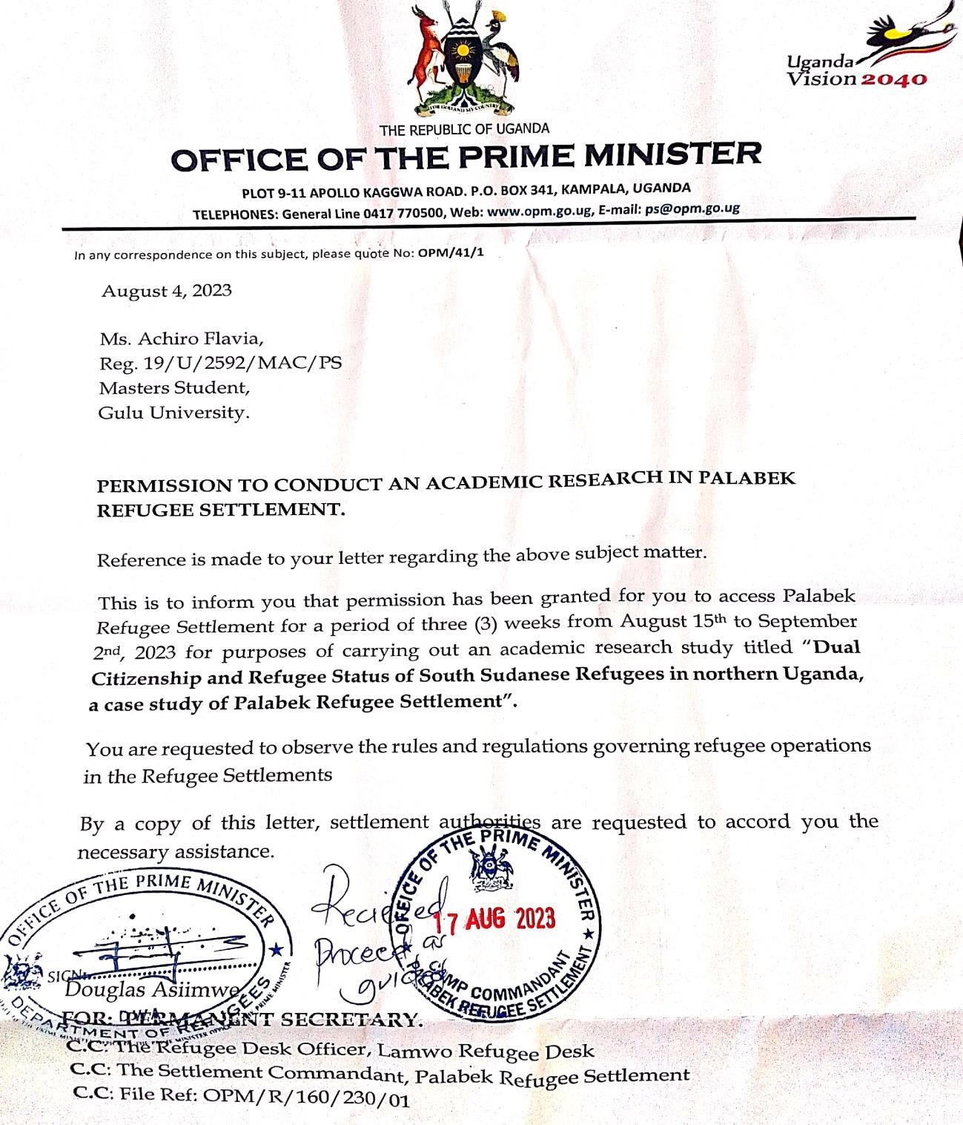

Appendix Two: Participants Information Sheet
Code | Sex | Role | Location
KIM1 | M | RWC III | Palabek
KIM2 | M | RWC II | Palabek
KIM3 | M | Assistant Immigration Officer (Ministry of Internal Affairs. | Kampala
KIF1 | F | Woman Leader | Palabek
KIF2 | F | Protection Associate, UNHCR | Palabek
KIF3 | F | Community Service Officer, OPM. | Palabek
KIRM1 | M | Refugee | Palabek
KIRM2 | M | Refugee | Palabek
KIRF1 | F | Refugee | Palabek
KIRF2 | F | Refugee | Palabek
KIRF3 | F | Refugee | Palabek
Z4RF1 | F | Refugee | Palabek
Z4RF2 | F | Refugee | Palabek
Z4RF3 | F | Refugee | Palabek
Z4RF4 | F | Refugee | Palabek
Z4RF5 | F | Refugee | Palabek
Z4RM1 | M | Refugee | Palabek
Z4RM2 | M | Refugee | Palabek
Z4RM3 | M | Refugee | Palabek
Z4RM4 | M | Refugee | Palabek
Z4RM5 | M | Refugee | Palabek
Z5RF1 | F | Refugee | Palabek
Z5RF2 | F | Refugee | Palabek
Z5RF3 | F | Refugee | Palabek
Z5RF4 | F | Refugee | Palabek
Z5RF5 | F | Refugee | Palabek
Z5RM1 | M | Refugee | Palabek
Z5RM2 | M | Refugee | Palabek
Z5RM3 | M | Refugee | Palabek
Z5RM4 | M | Refugee | Palabek
Z5RM5 | M | Refugee | Palabek

Appendix Three: Consent Forms (Interviews and FGD). (English, Acholi and Arabic)

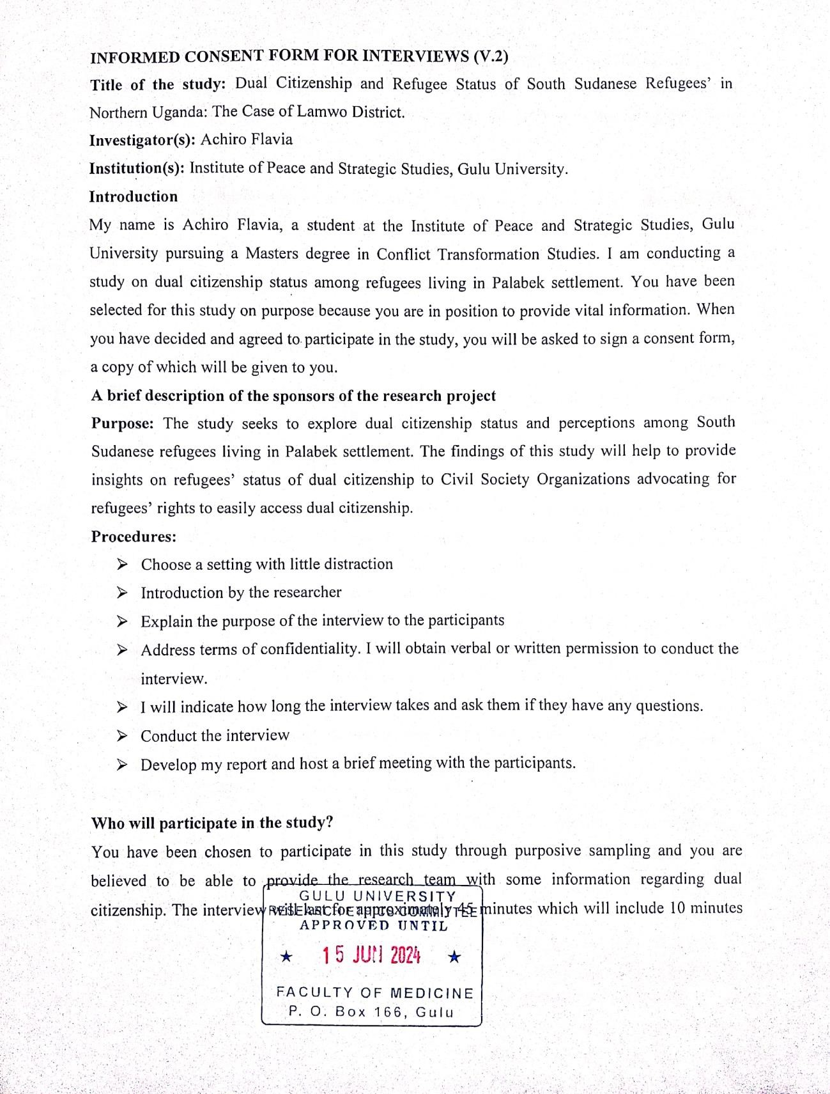
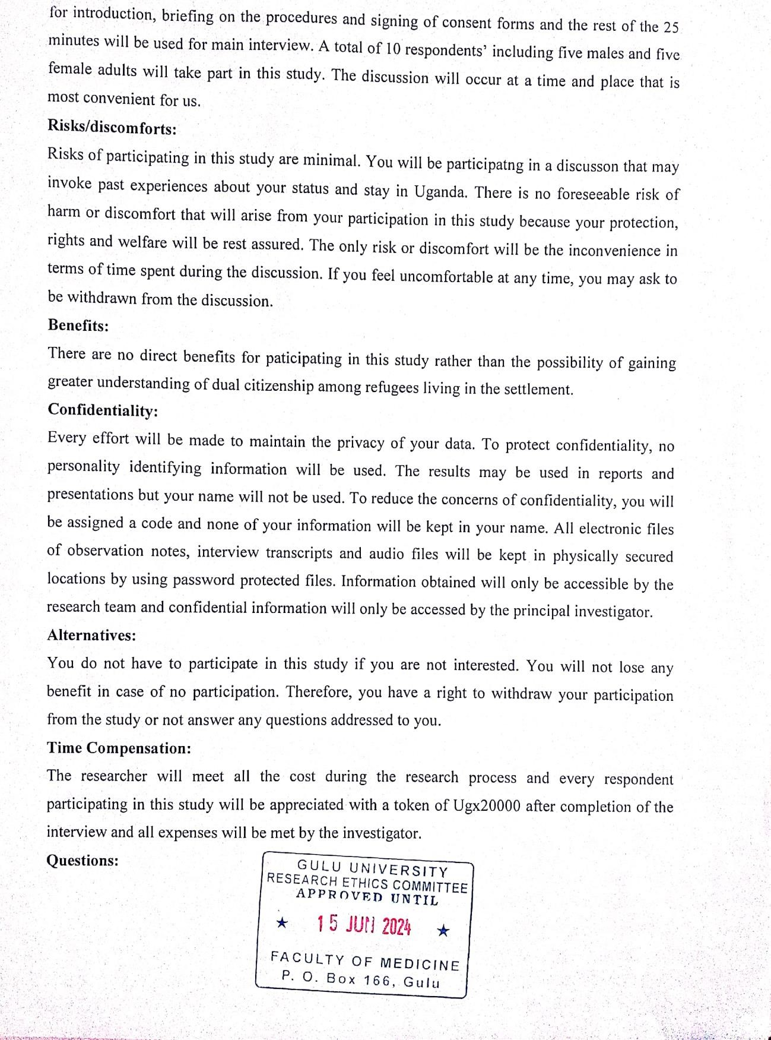
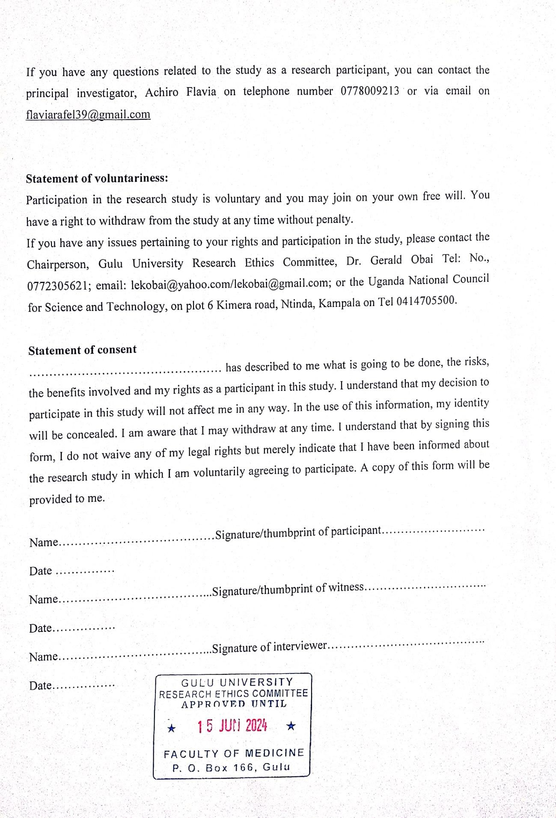
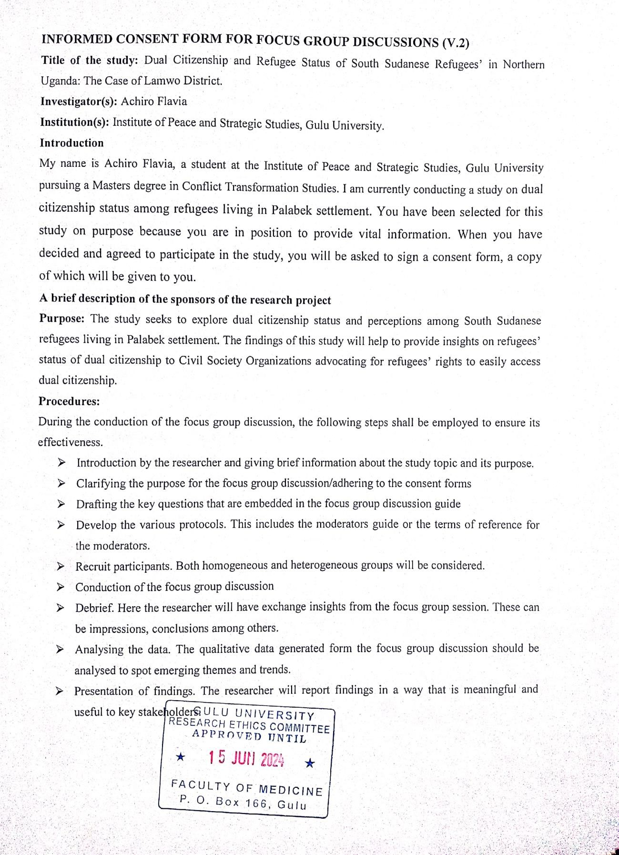
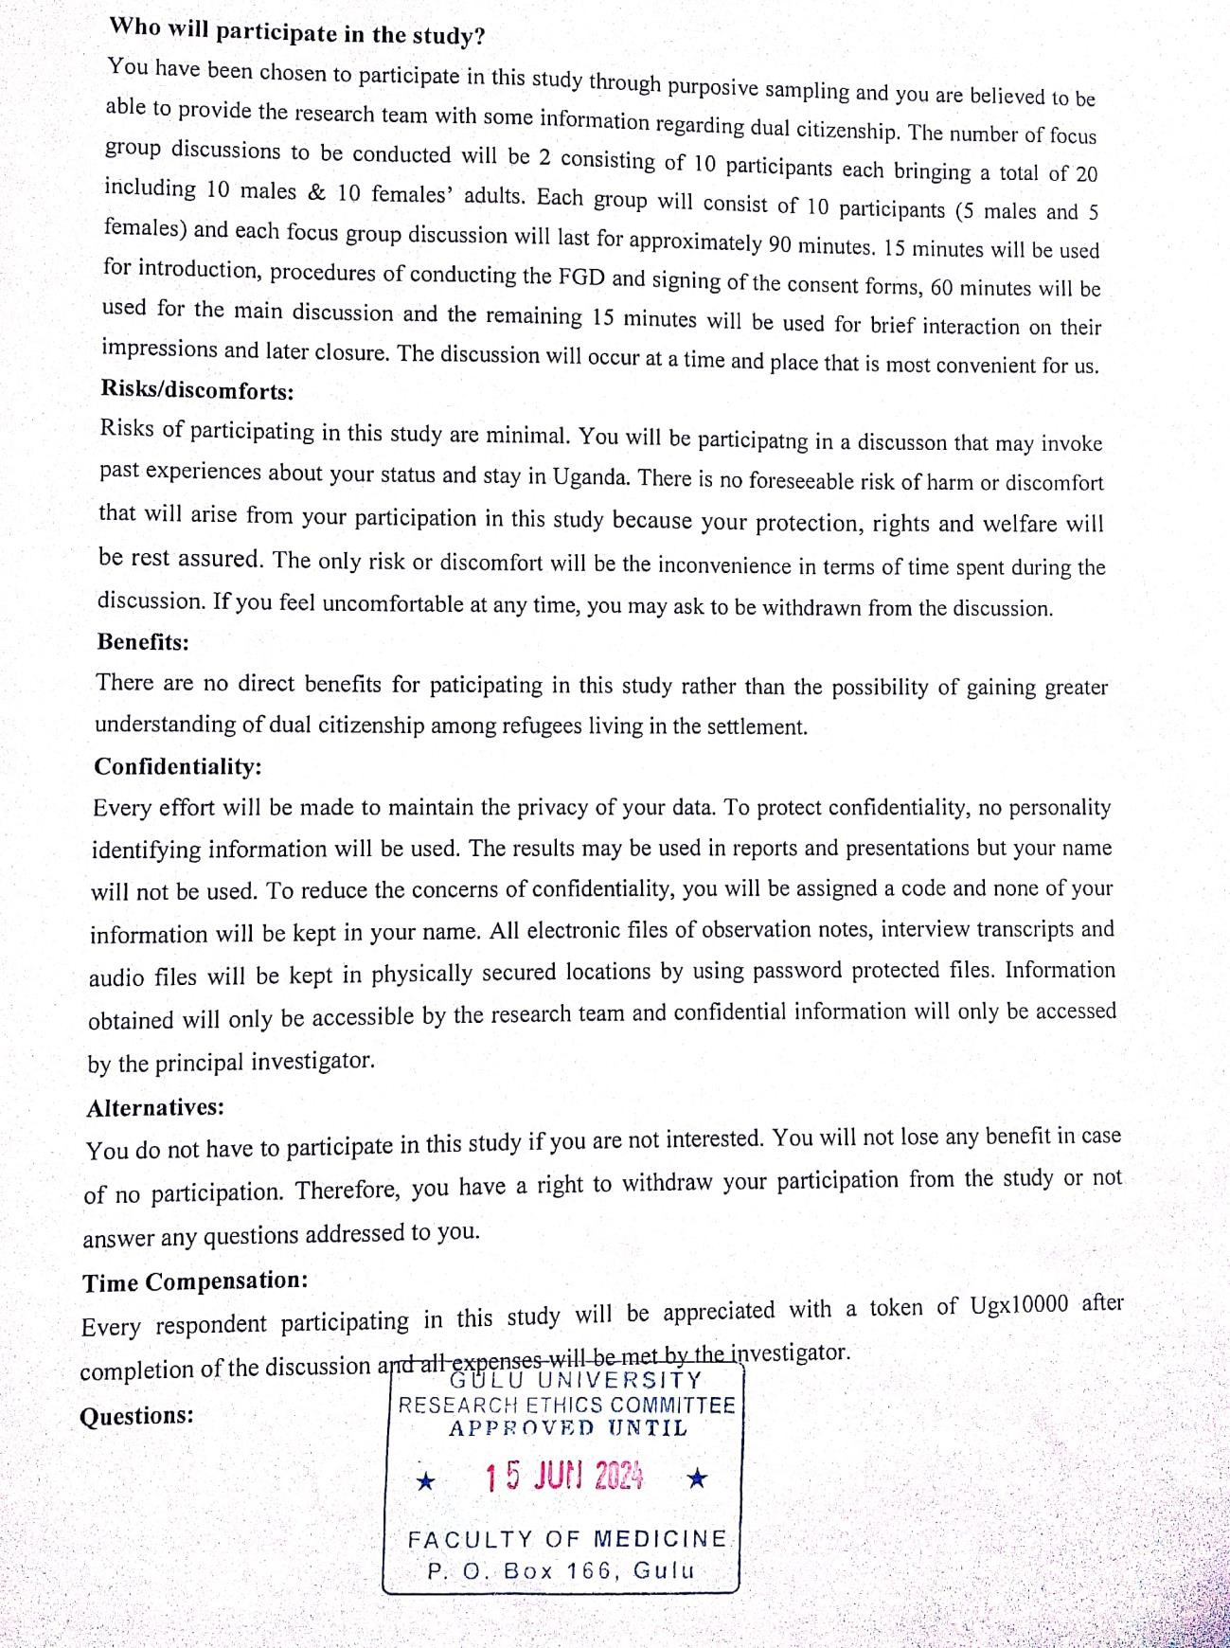
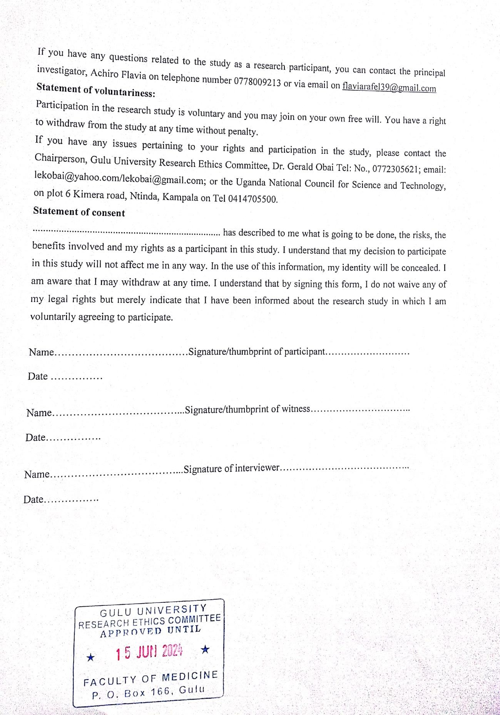
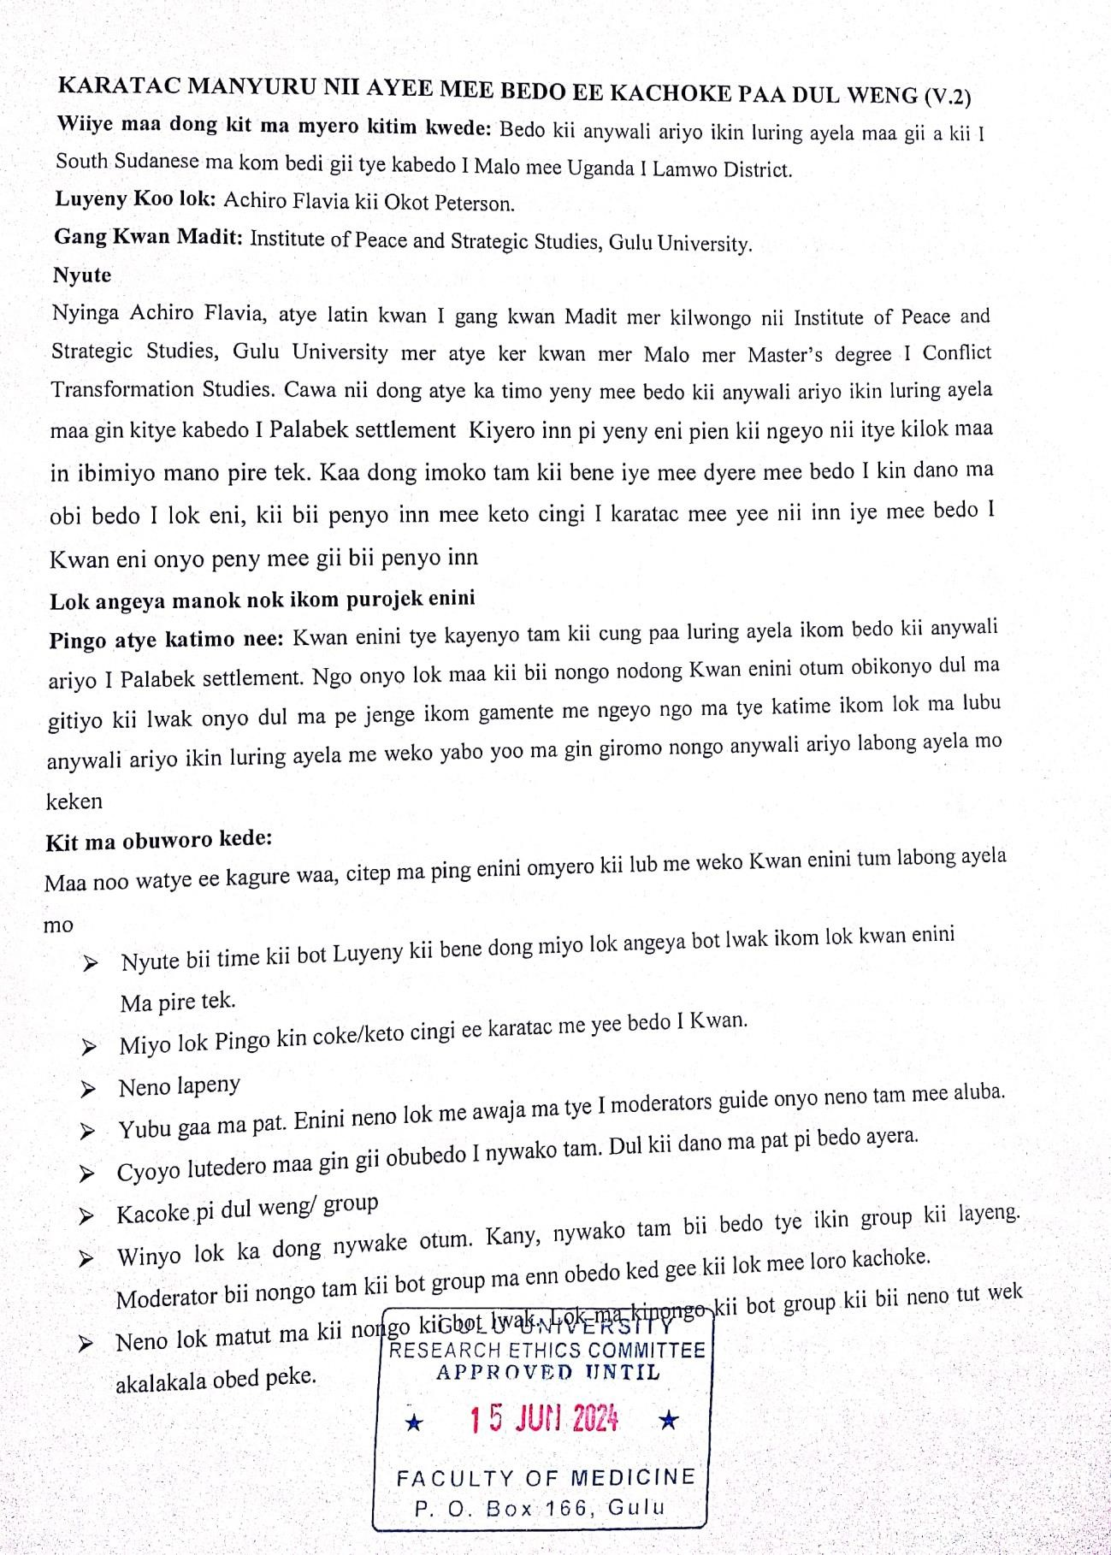
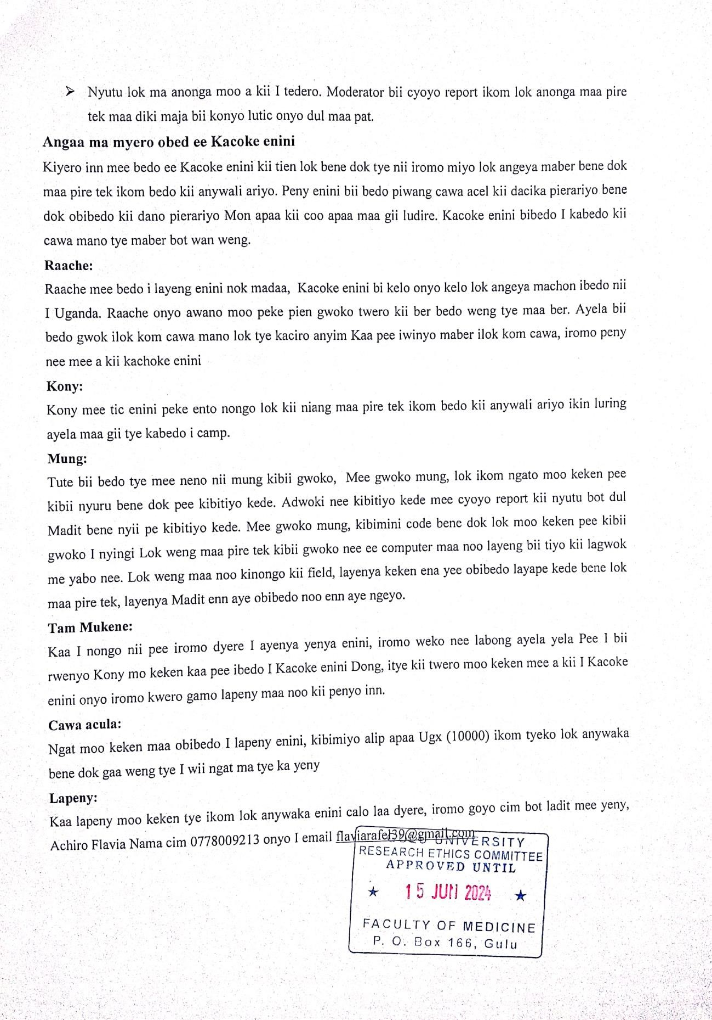
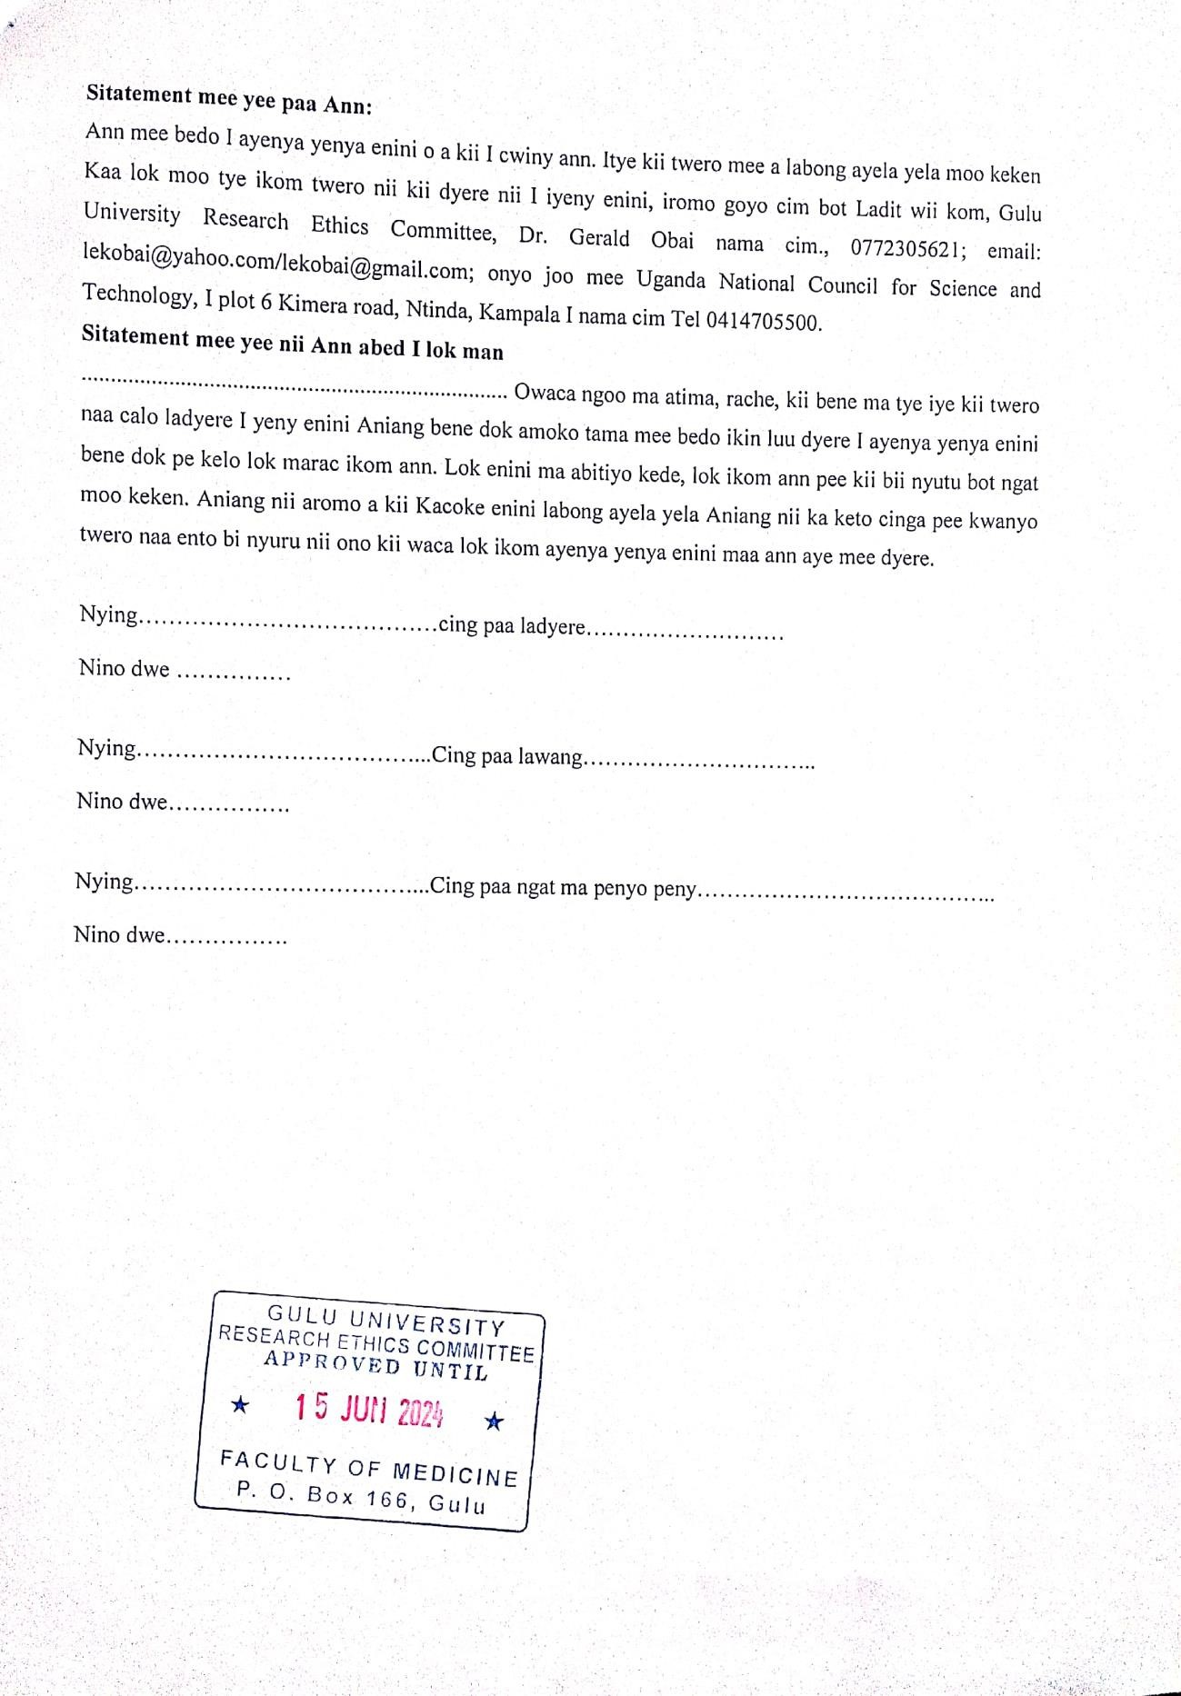
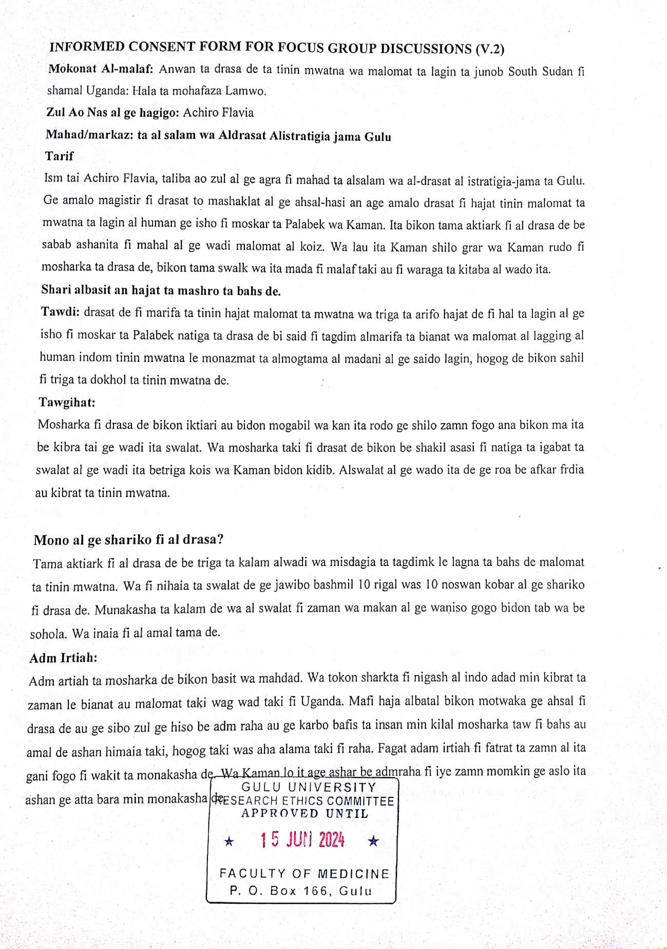
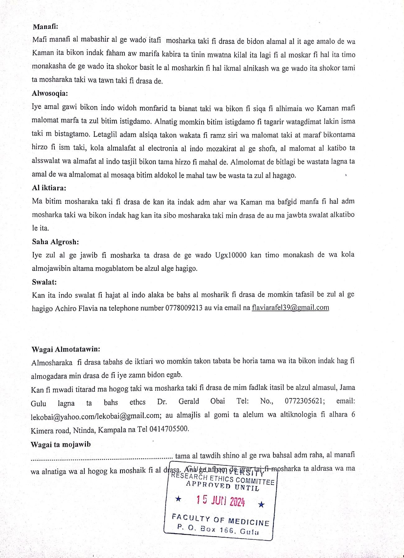
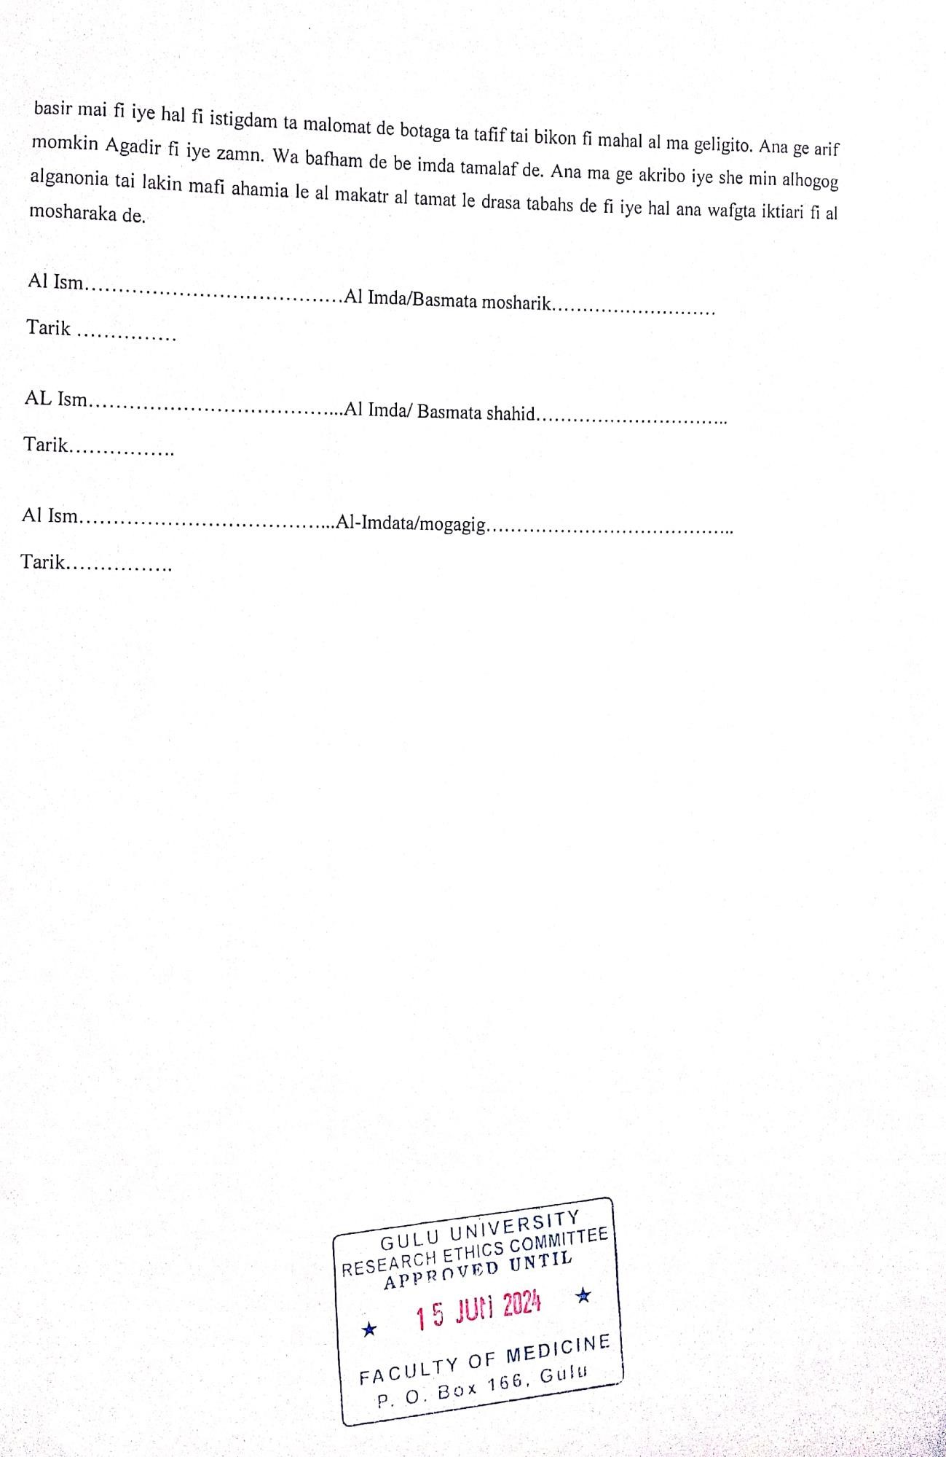

Appendix Four: Focus Group Discussion Guide.
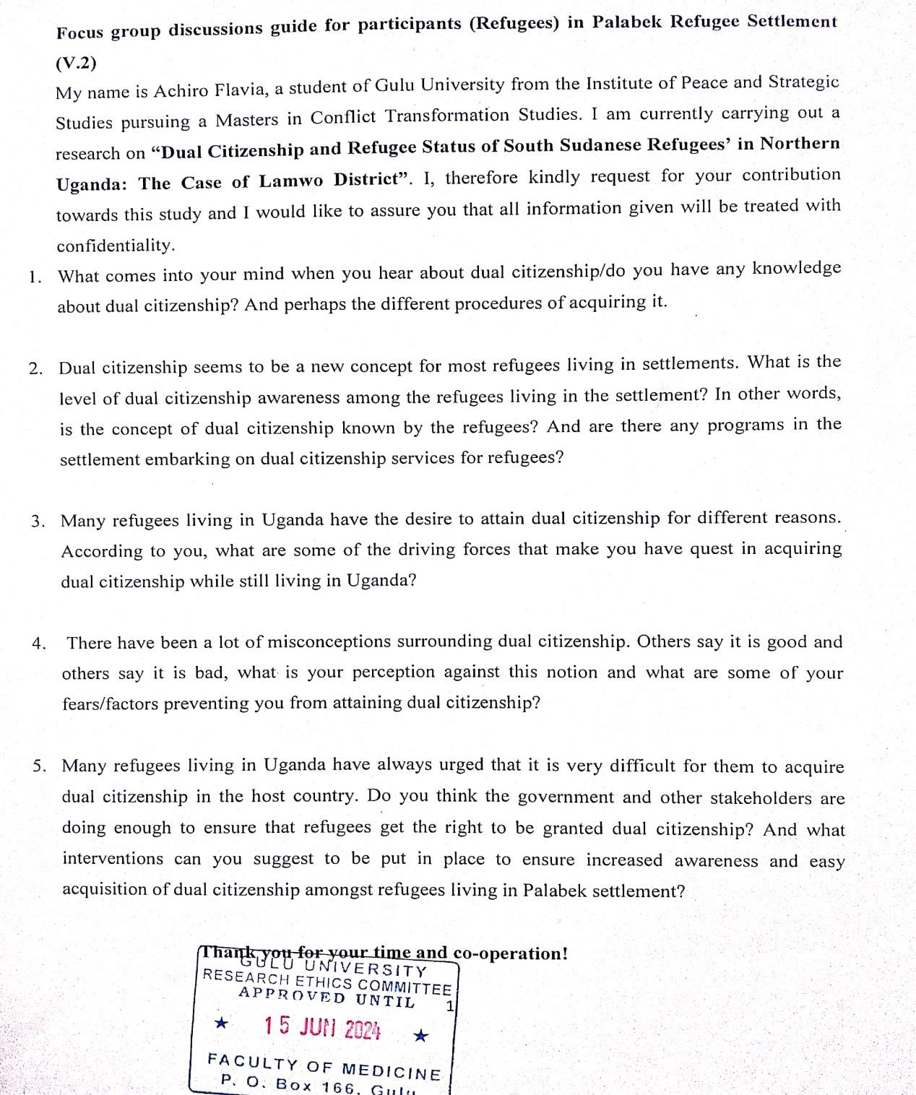

Appendix Five: Interview Guide (Refugees)
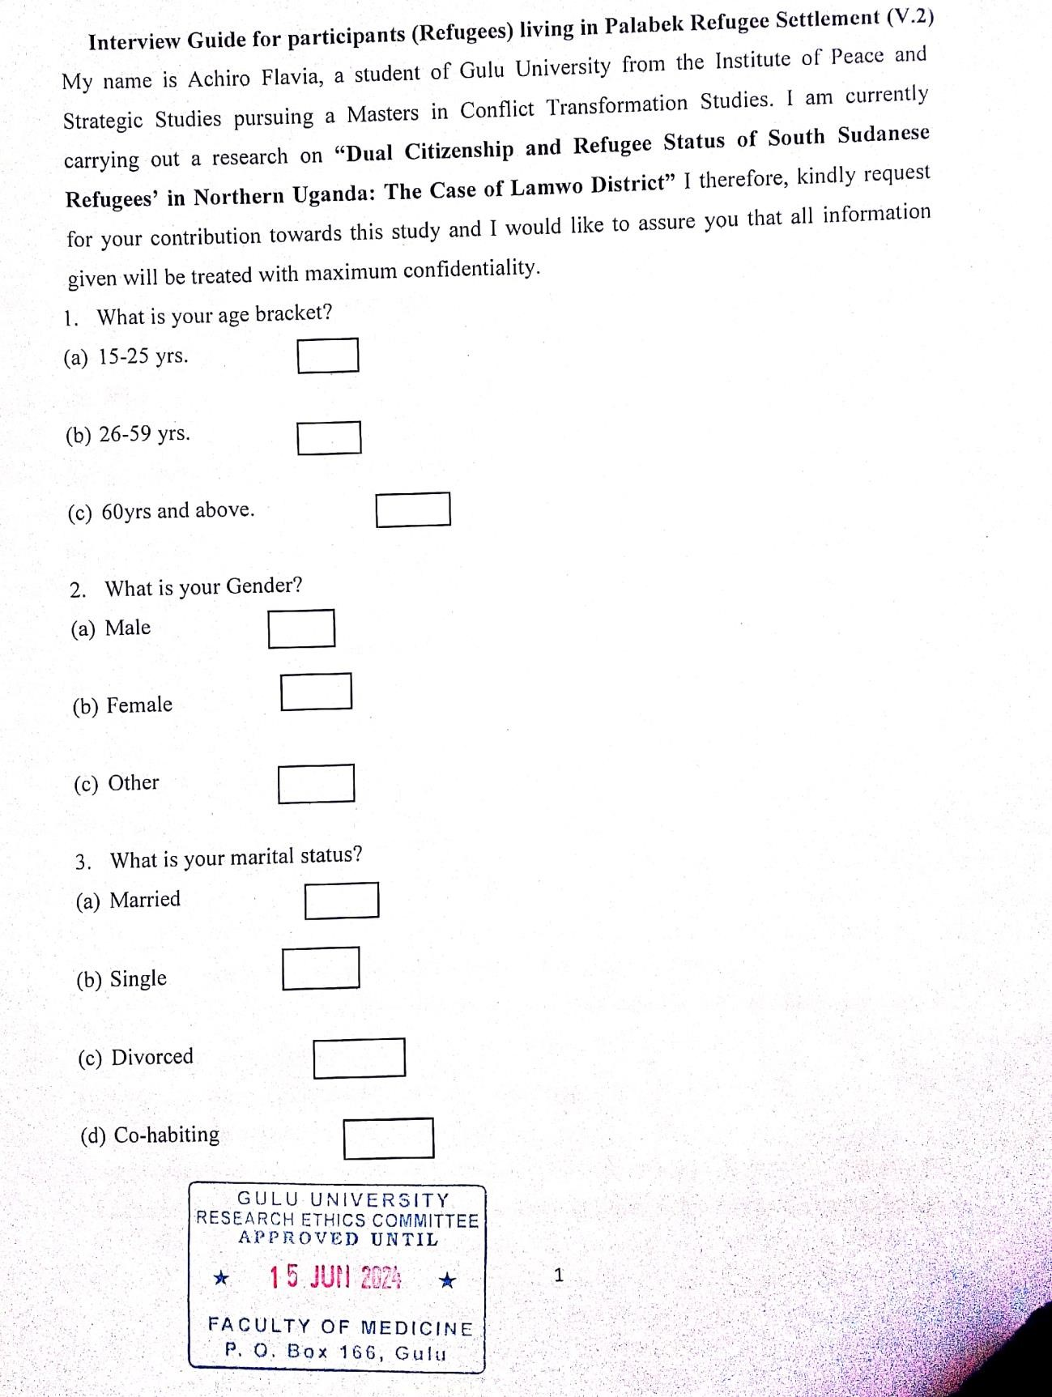
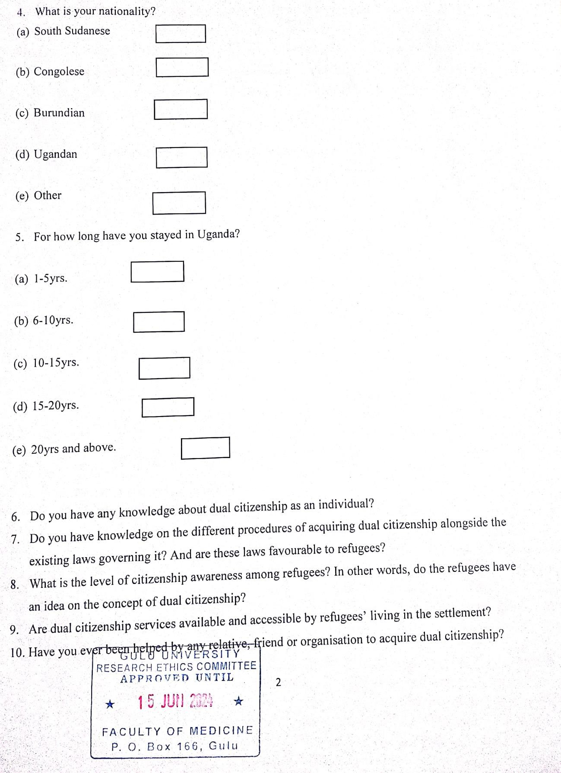
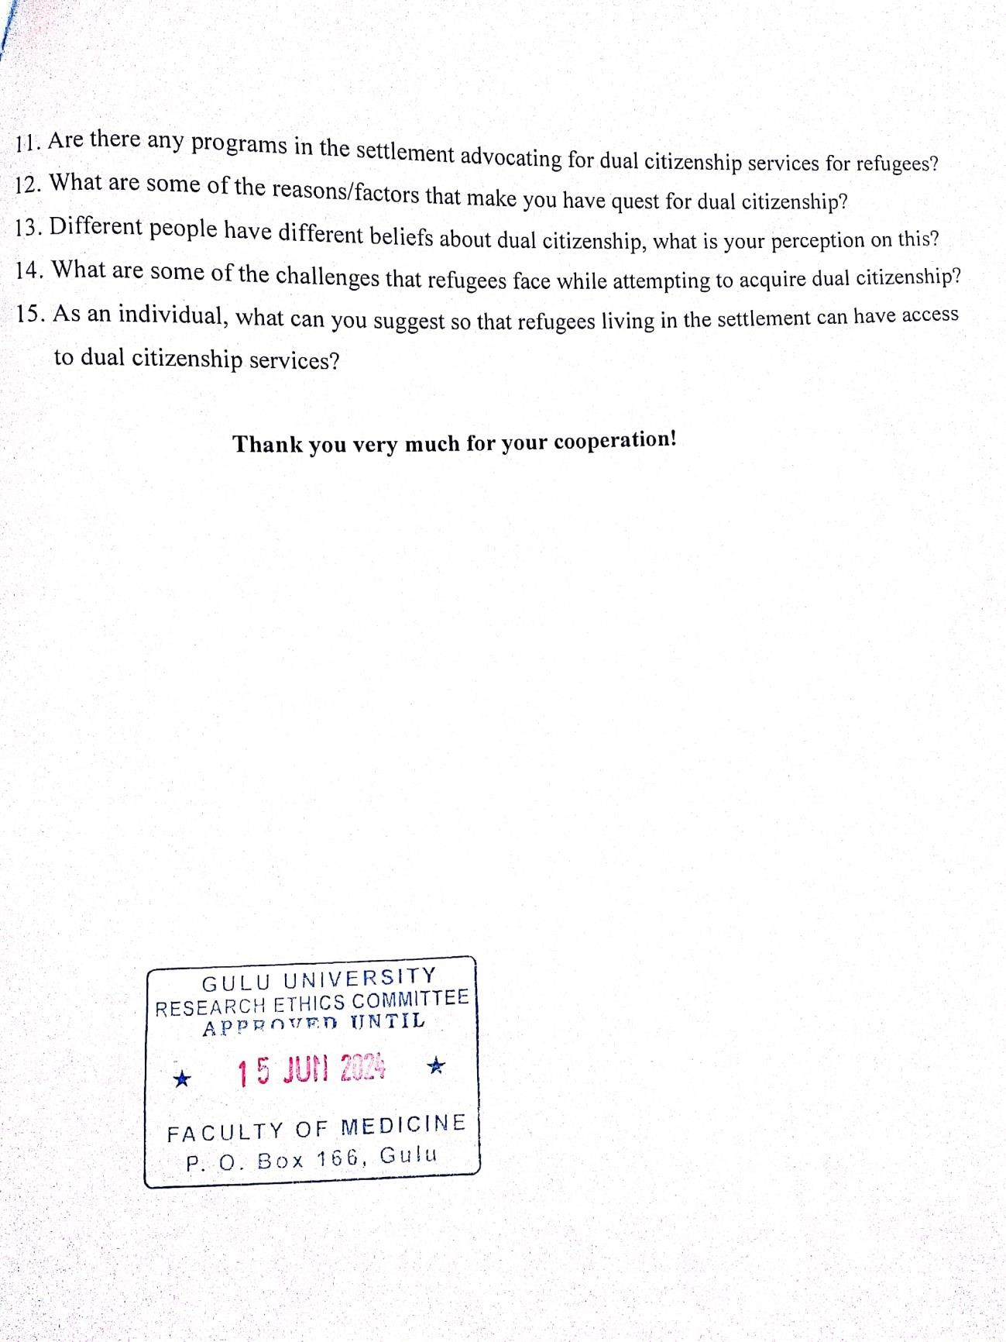

Appendix Six: Interview Guide (Key Informants)
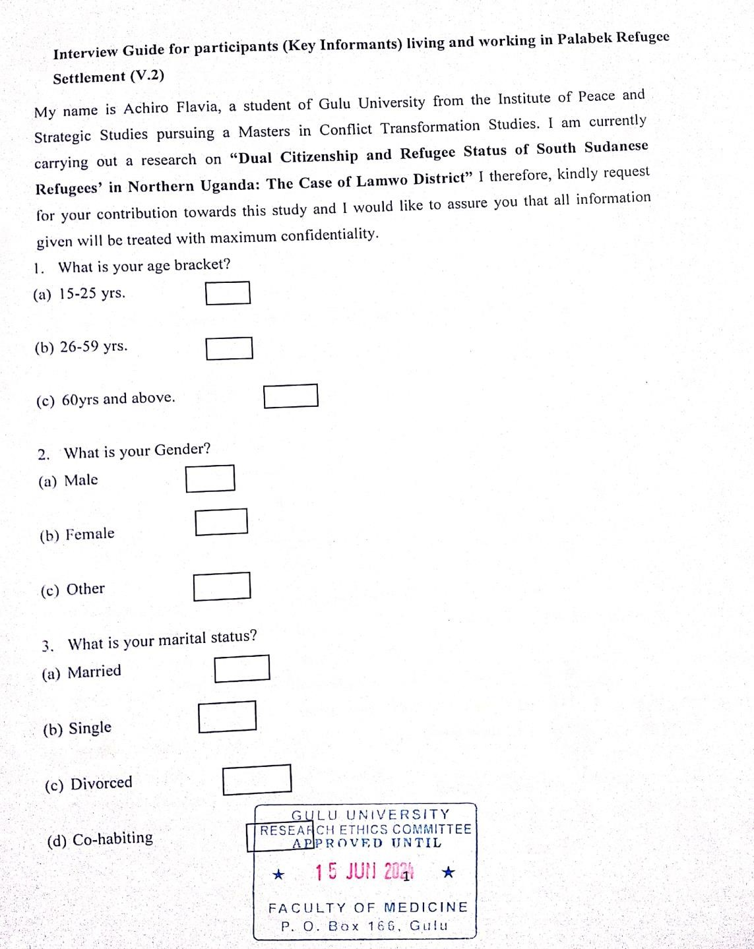
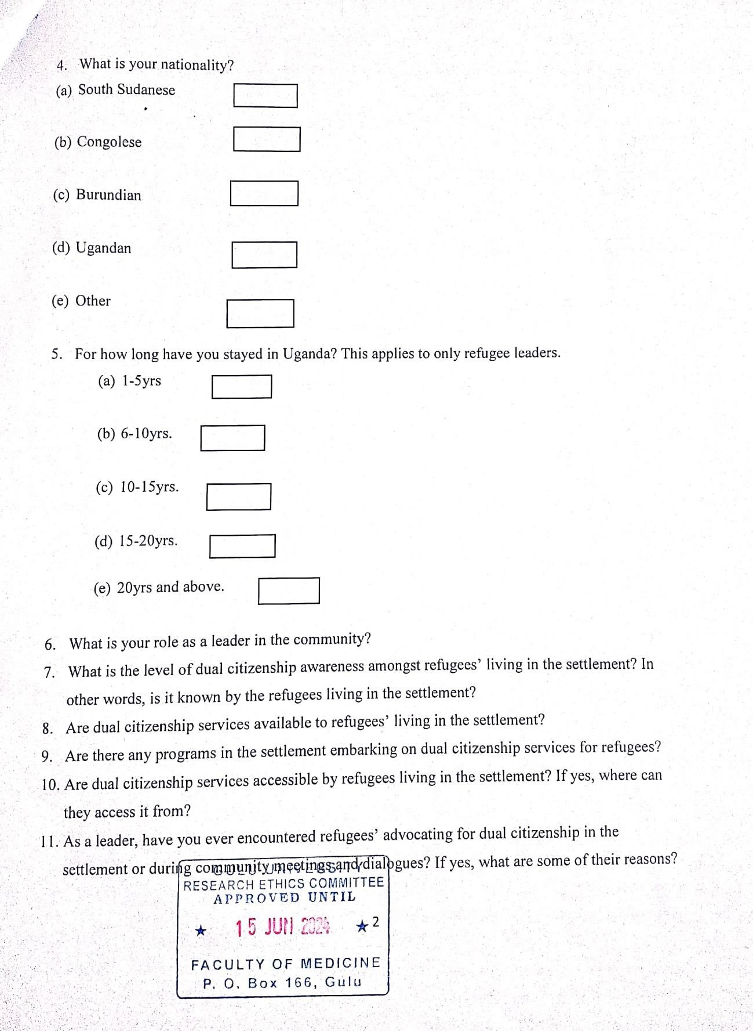
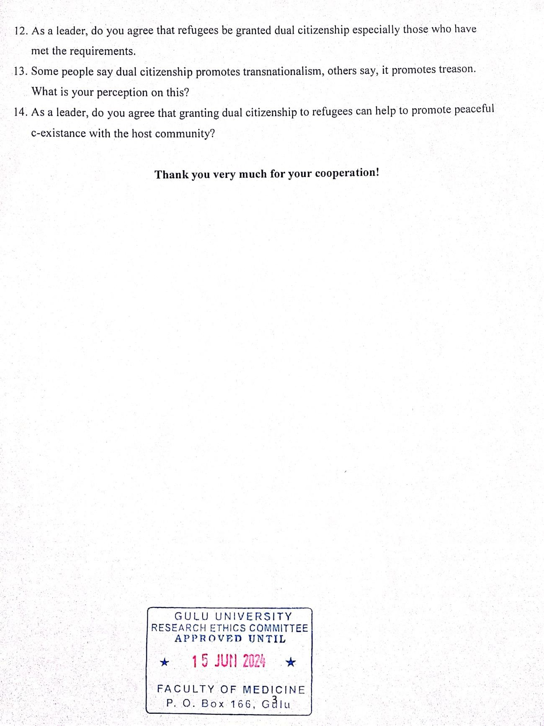

Appendix Seven: GUREC Clearance

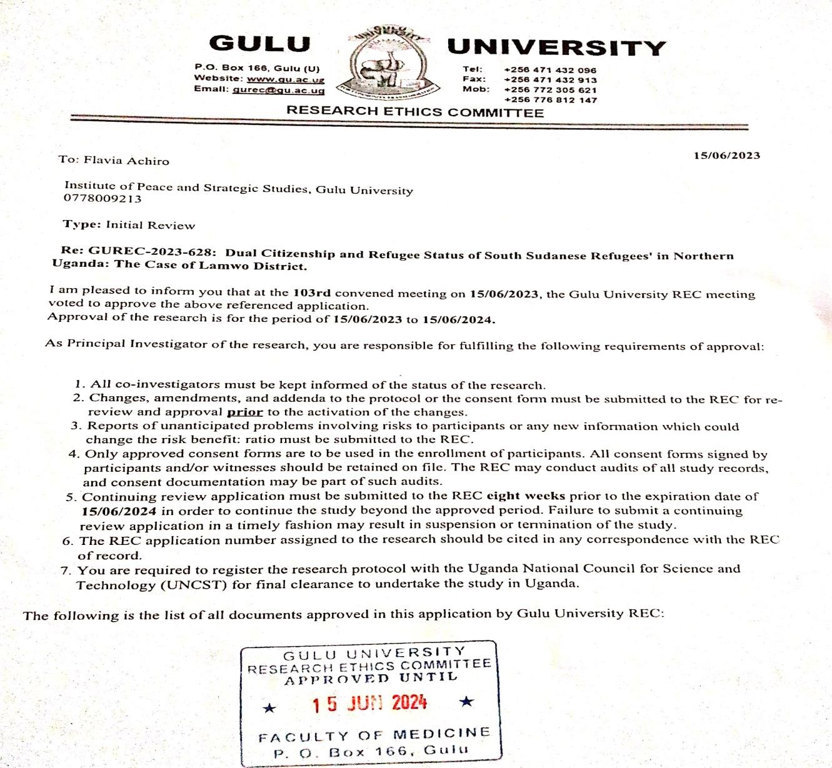
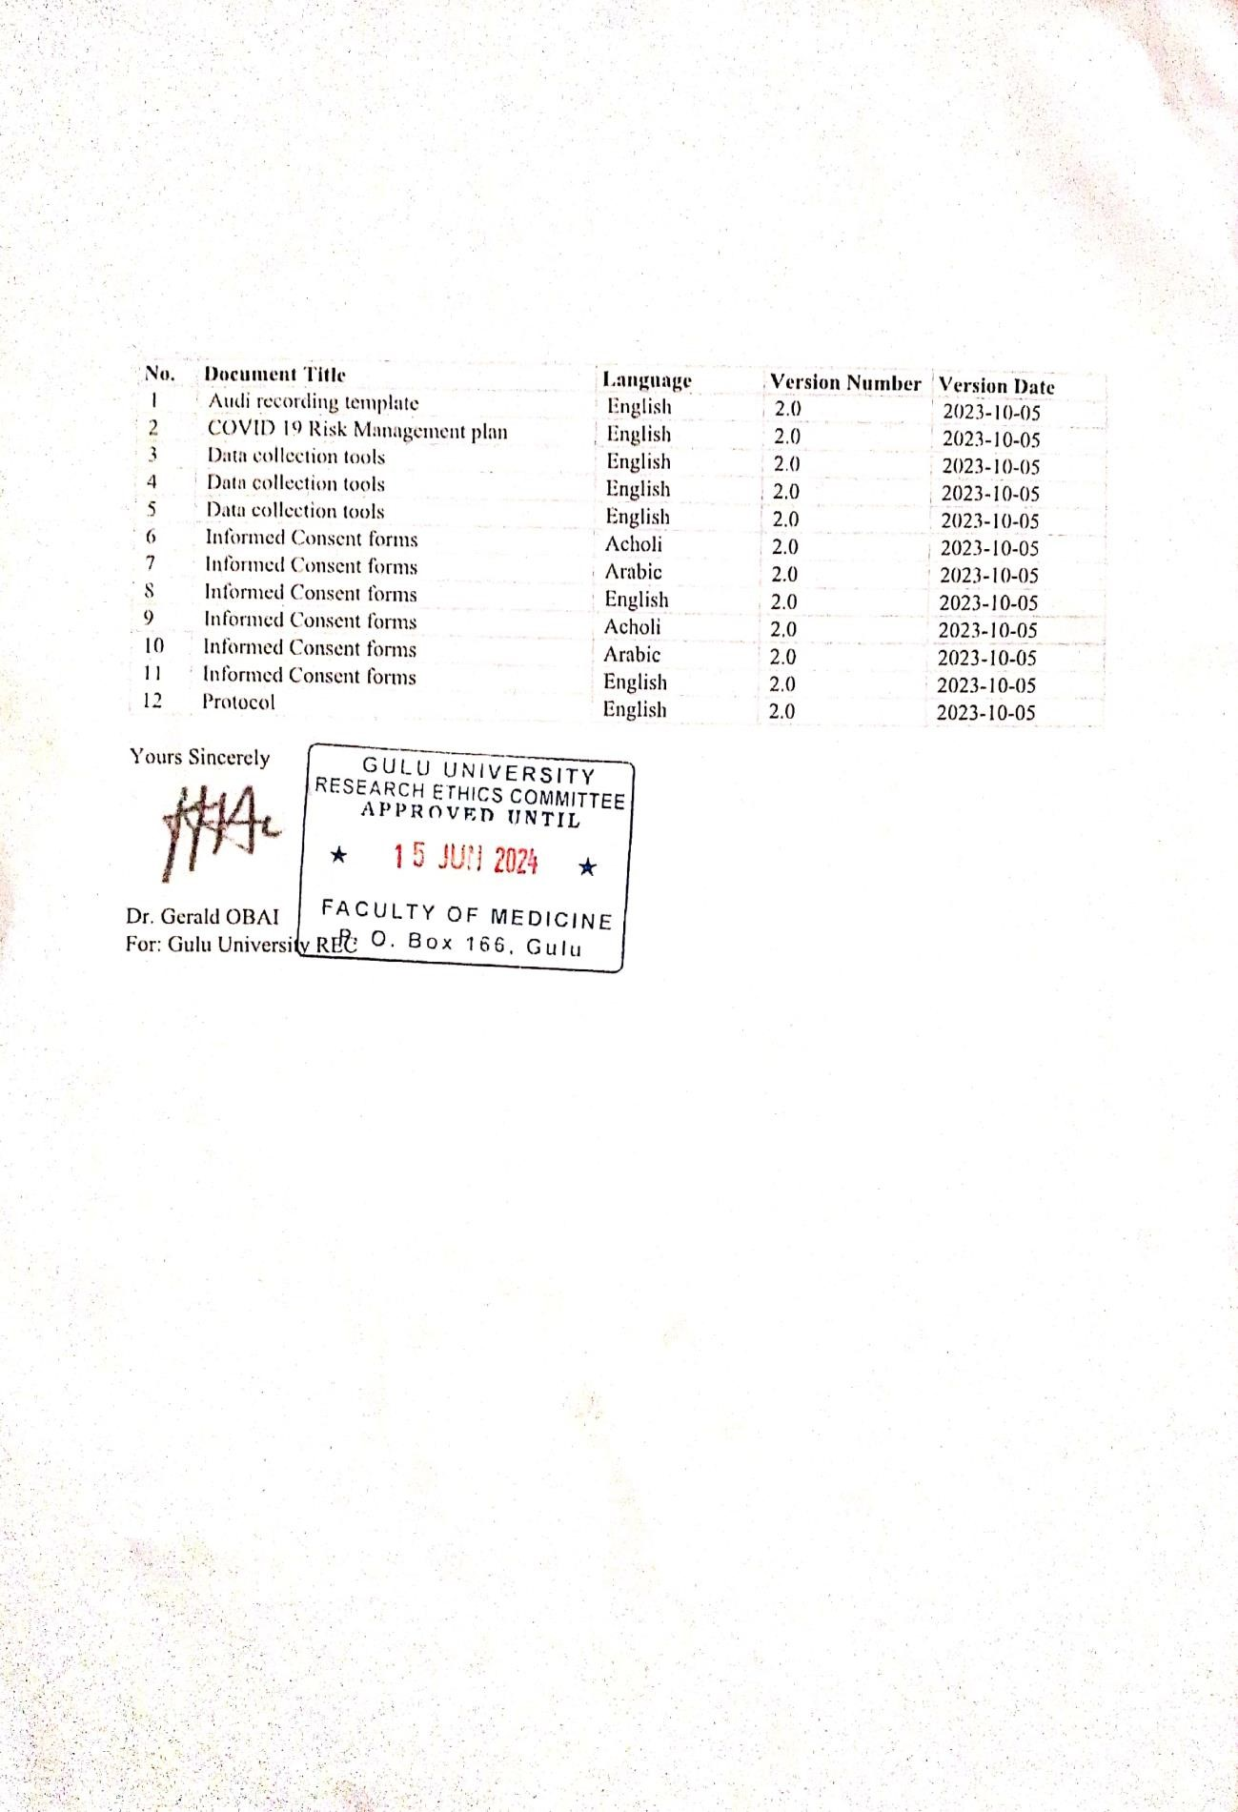

Appendix Eight: IPSS Clearance
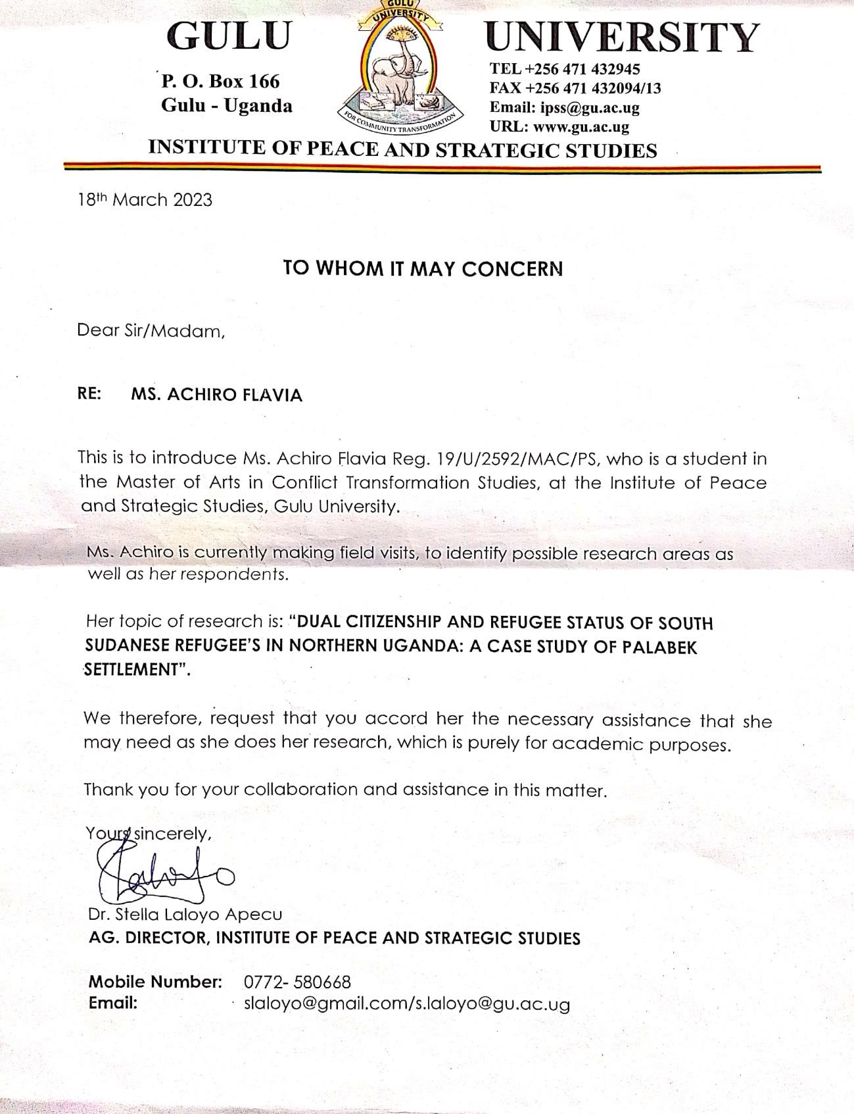

Appendix Nine: Activity Photos
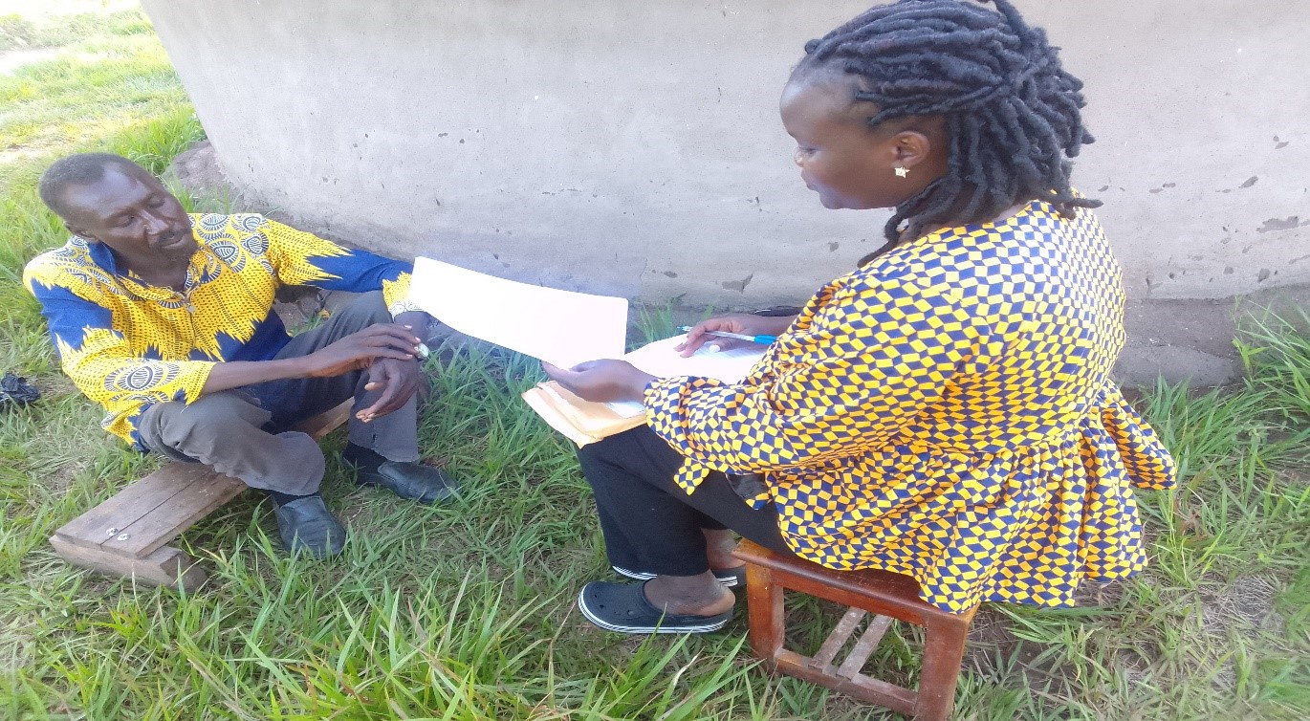
Activity 1: An Interview with Key Informant Refugee Male in Zone 5, Palabek Refugee Settlement.
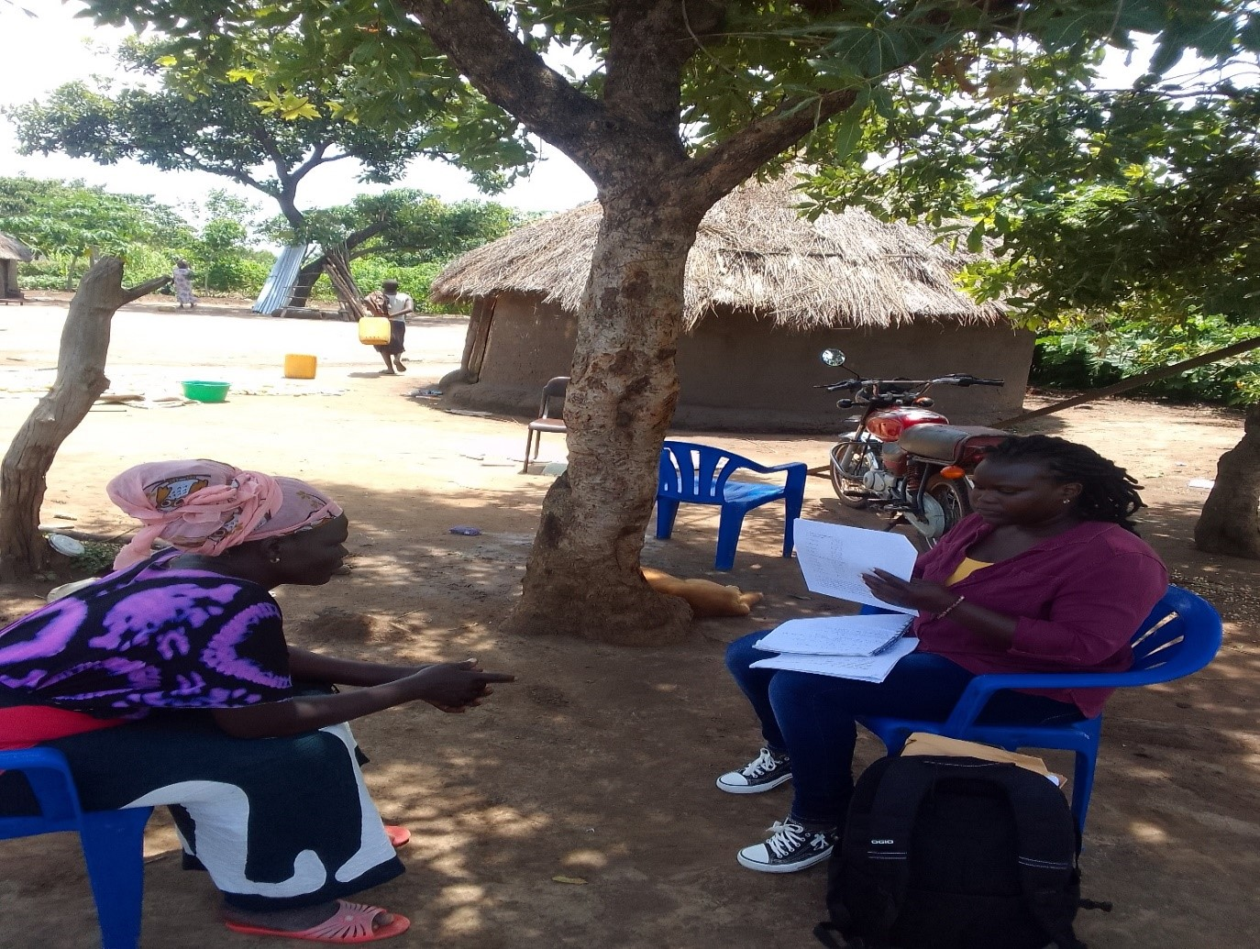
Activity 2: An Interview with Key Informant Refugee Female in Zone 4, Palabek Refugee Settlement.

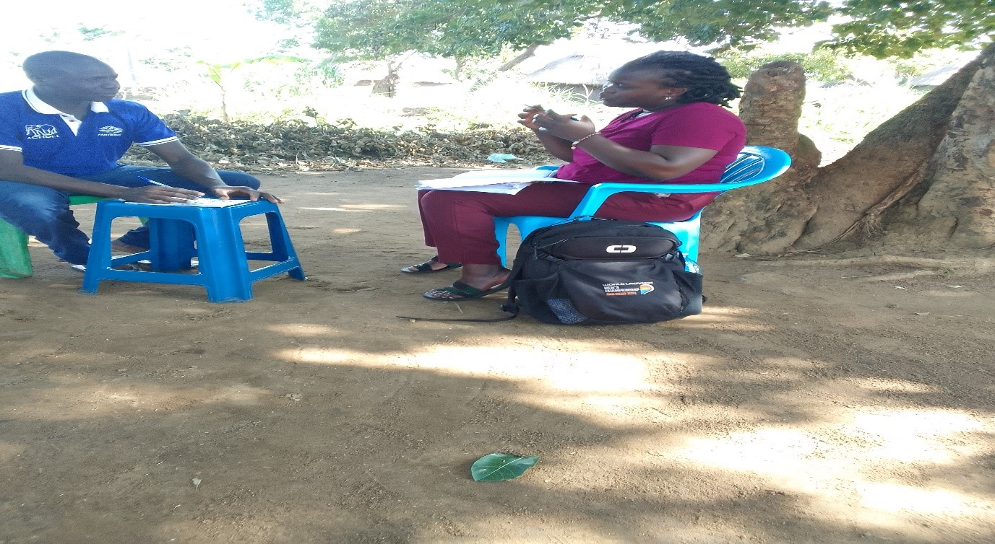
Activity 3: An interview with Key Informant Male in Zone 5, Palabek Refugee Settlement.
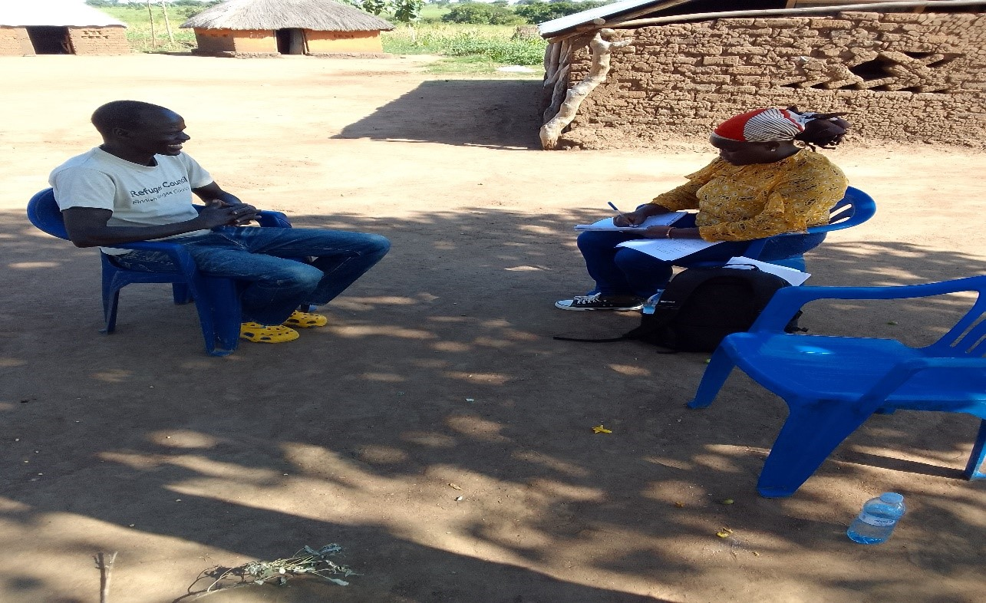
Activity 4: An Interview with Key Informant Refugee Male in Zone 2, Palabek Refugee Settlement.
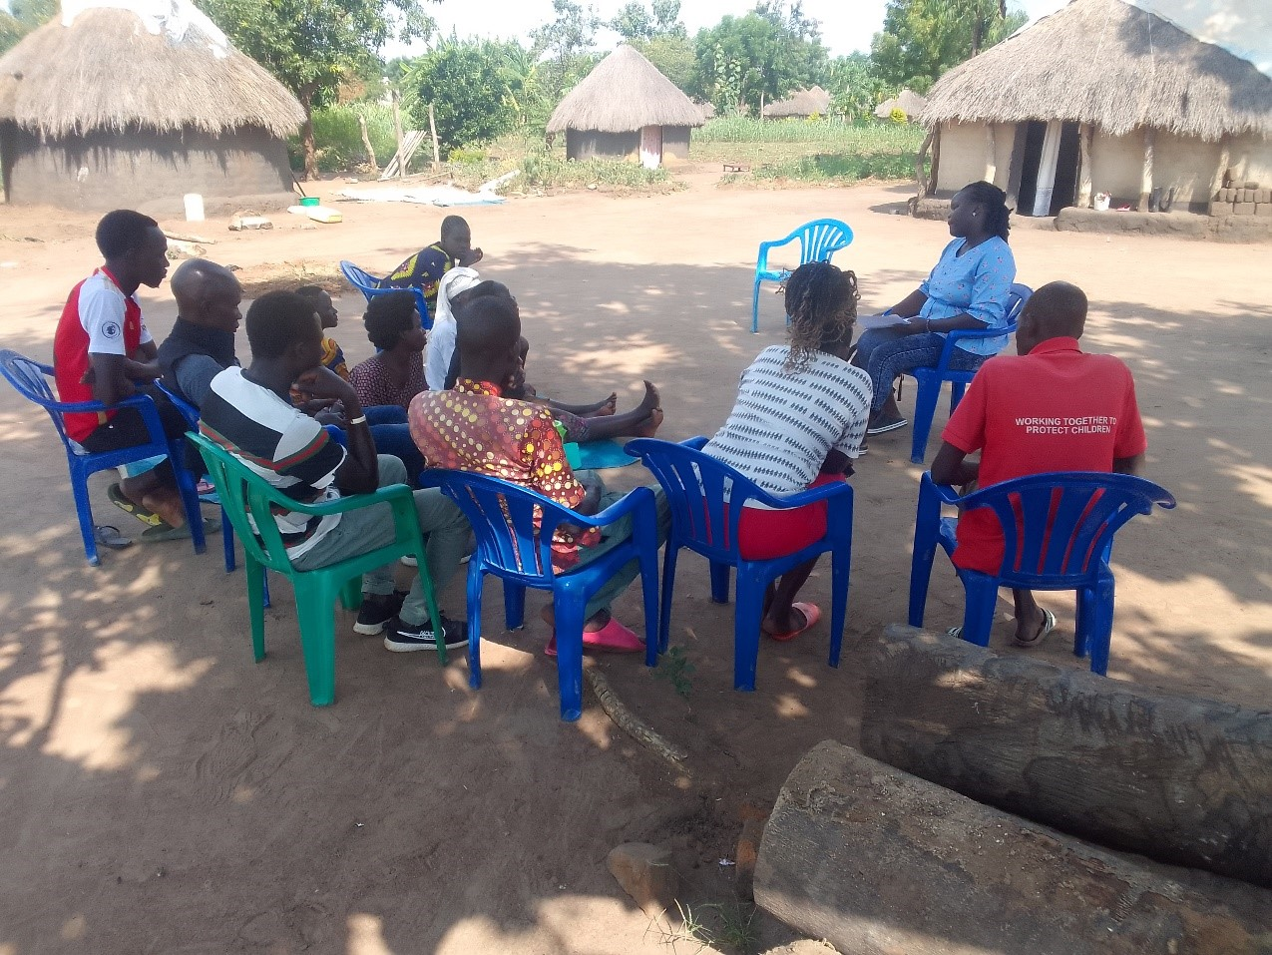
Activity 5: Focus Group Discussions in Zone 4, Palabek Refugee Settlement.

